C

UNDERGROUND NUCLEAR POWERPLANTS IN CONNECTION WITH DAMS
Pierre DUFFAUT
Expert in Geological Engineering (retired)
FRANCE

- INTRODUCTION

Many dams are associated with underground hydro power plants, the design, construction and operation of which are shared in the dam engineering community. From the Fukushima nuclear plant accident, the nuclear community is understanding that only underground siting of reactors deep enough could offer an acceptable safety and security level, provided this option be proved possible [1]. After a short recall of what had been designed, built, operated, which could have been now forgotten, and of the main accidents in nuclear power plants [2], the benefits of siting underground nuclear power plants close to dam reservoirs and hydro plants will be presented, namely pumped storage plants. The caverns for reactors will not strongly differ from caverns for hydro, the dimensions and shapes of them will serve as models a

- SHORT RECALL OF UNDERGROUND NPP HISTORY

2.1. THE EARLY BEGINNINGS

The world first reactor divergence occurred in an ancient quarry under the church of Haigerloch, Germany, in 1945. Among the many research reactors and pilot power plants, some more have been built and operated underground in various countries, among them Sweden, Norway and Switzerland: i) The Swedish reactor R1 has been located in a vault dug 15m below the Royal Institute of Technology, inside the city Stockholm (operated from 1958, dismantled long ago). ii) Norway sited a reactor inside a granite hill in Halden, which provided electric power and steam to a paper mill, close to the sea level from 1967. Though the country has abandoned nuclear power, this facility has been kept in service up today as part of European research programs. iii) In Sweden again the Agesta plant was built inside a granite hill to provide electric power and district heating to a part of Stockholm suburbs (beginning 1968, no longer operated). iv) Switzerland built a pilot power plant inside a hill at Lucens, Vaud, which suffered a partial core melt the next year. thank to its underground location, not any consequence was reported: nobody suffered any damage, nor the environment. The plant was closed and lost, it has been fully dismantled some years later and this event has been fully reported 50 years later!

Table 1: Data about the first underground reactors
Year | Name | Country | Rock type | Rock cover | Water source | Span  m | Height m | Length  m | Power  MWe
1954 | Stockholm | Sweden | granite | 15 | sea | ? | ? | ?
1958 | Siberia | Russia | granite | 250ª | Iénisei | ? | ? | ? | 500?
1964 | Halden | Norway | granite | ~50 | river | 10 | 30 | 26 | 6
1967 | Agesta | Sweden | granite | ~20 | lake | 16,5 | 53 | 40 | 20
1968 | Lucens | Switzerland | molasse | ~20 | brook | 18 | 30^{b} | 18 | 10
1968 | Chooz | France | schist | 80 | Meuse | 18,5 | 41 | 42 | 305

Nobody knew, for many years, that the USSR had begun as soon as 1950 to build UNPP (underground nuclear power plants) in Siberia, to provide power to its military scientific, mining, and industrial complex close to Krasnoyarsk on river Yenisei. As a centre for making atomic bomb and long range missiles, the whole facilities were kept secret. Of three plants, commissioned in 1958, 1961 and 1964, the latest was closed in 2009. They were fully covered by secrecy and very few information is yet available [3].

  - THE 1981 HANNOVER CONFERENCE

At this era of strategic insecurity reported as the Cold War, the government of Germany had performed thorough studies in order to secure future NPP against bombing, either by covering with a rubble mound or siting them in rock caverns. The TMI accident (see below) urged Germany to summon a conference in Hannover the next year, the world only conference dedicated to Underground Siting of Nuclear Power Plants [4]. While most of German contributions presented deeply
2.3. MAIN NUCLEAR ACCIDENTS AND REACTIONS
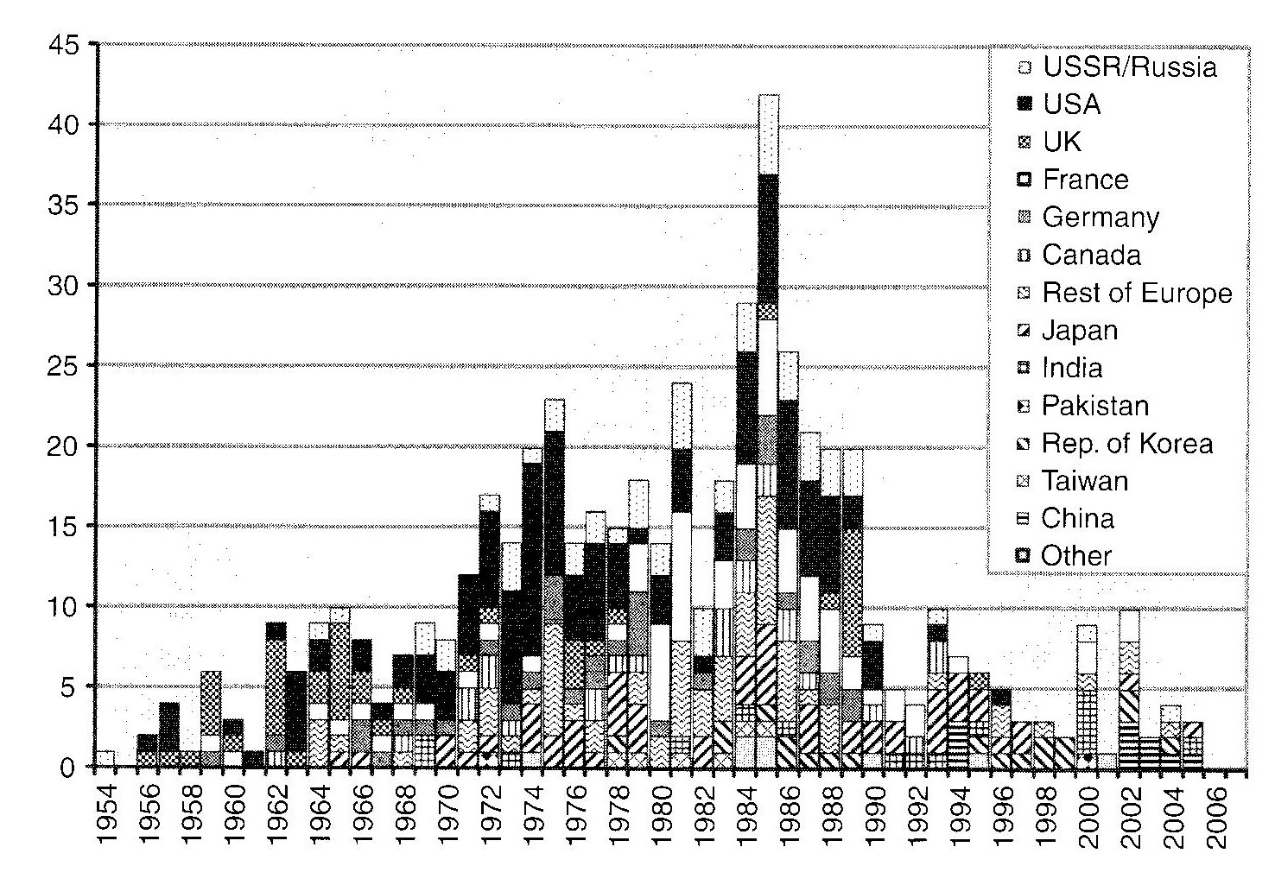
When the Three Mile Island accident occurred, on March 28, 1979, few people had heard of the partial core melt ten years before on January 1969 in the small Lucens plant: the Swiss press and the general public were to wait 40 years more to be fully informed on this accident, which did not bring any inconveniency thanks to the underground siting of the reactor, except the loss of the plant (no harm to personnel, no radioactivity outside).
We must recall that the TMI accident did not produce any fatality in spite of huge population displacements. But it struck the development of NPP in the USA and many more countries, as shown on histogram fig. 1, and probably urged Germany to summon the Hannover conference.
Figure 1: Number of commercial reactors set in operation along years 1954 to 2005, classified by main countries, always in the order of the box legend [5]
Table 2: Data about some huge underground hydroelectric plants, worldwide (names with * are pumped storage plants)
Year | Name | Country | Rock type | Rock cover | Span  m | Height m | Power  MWe
1932 | Le Sautet | France | limestone | ~100 | 32 | 25
1964 | Waldeck 2* | Germany | schists |  |  |  | 480
 | Bourassa | Canada | granite
1988 | Grandmaison* | France | limestone | ~50 | 18 | 31 | 1,820
1971 | Roncovalgrande* | Italy | granite |  |  |  | 1,000
198 | Montézic* | France | granite
1990 | MingTan* | Taiwan | sandstone |  | 22 | 47 | 1,600

Chernobyl (Sakharov and Teller)

Fukushima Daiichi (Fairhurst)

3. GENERAL CRITERIA FOR UNPP SITES

REFERENCES

[1] DUFFAUT P., LEMPÉRIÈRE F., Les centrales nucléaires futures seront-elles souterraines ? Techniques de l’Ingénieur Website, April 23, 2013.
[2] DUFFAUT P., VASKOU P., Geological and Geographical Criteria for Under ground siting of Nuclear Reactors. Proc. Intern. 8th Asian Symp. Rock Mechanics Sapporo, 2014 (under press).
[3] ZVEREV
[4] BENDER F., Underground siting of underground nuclear plants, Proc. Intern. Symp. Hannover. 1981.

ABSTRACT

Many dams are associated with underground hydro power plants. The expertise of excavation and operation of such plants qualifies the underground option for nuclear plants to which the location in depth brings levels of safety and security significantly enhanced. Known examples are recalled (in Siberia and in Europa, among them French Chooz A) and are compared to the main nuclear accidents which future plants have to escape: a partial core melt at Lucens plant, Switzerland, 1975 did not have any more inconveniency than the closure of the plant. Existing nuclear plants keep located on seaside or along large rivers, all sites often far from reliefs and hard competent rocks. The association of a NPP to a hydroelectric plant in mountain landscape could help benefit not enough of gravity cooling water (in normal operation and the more in case of accident) but also of favorable grounds and even of existing transmission lines; incidentally, such a solution could allow to disseminate low output NPP using SMR, small modular reactors, and to relieve the transmission grids. It could also boost anew the interest in pumped storage plants.

RÉSUMÉ

De nombreux barrages sont associés à des centrales hydroélectriques souterraines. L’expérience de ces centrales qualifie l’option souterraine pour des centrales nucléaires auxquelles la localisation en profondeur apporte une sécurité et une sûreté significativement accrues suivant les recommandations de Sakharov et de Teller. Les exemples connus en sont rappelés (en Sibérie et en Europe, dont Chooz A en France), et sont confrontés avec les principaux accidents nucléaires dont il s’agit de prémunir les centrales futures : une fusion de cœur partielle à Lucens, Suisse, en 1969, n’a pas eu d’autre conséquence que l’abandon de la centrale. Les centrales nucléaires existantes sont en bord de mer ou de fleuves à débit important, tous sites où il est rare de trouver des reliefs en terrain favorable pour des centrales souterraines : associer une centrale nucléaire à un site hydroélectrique hors plaine permet de bénéficier non seulement d’eau de refroidissement par gravité (en service normal et surtout en cas d’accident) mais aussi de terrains favorables et même des lignes de transport d’énergie existantes ; une telle solution permettrait notamment de multiplier des centrales souterraines de puissance moyenne avec des SMR, small modular reactors, et de soulager les réseaux de transport d’énergie. Elle relancerait aussi l’intérêt de sites de STEP.

