March 2, 2016

Spencer Walters, Glendora High School student, Azusa, California

interview with

John Shanahan, President of Go Nuclear, Inc. and Environmentalists for Nuclear Energy - USA, Denver, Colorado

websites: go-nuclear.org
efn-usa.org

e-mail: john.shanahan@go-nuclear.org
john.shanahan@efn-usa.org
acorncreek2006@gmail.com

Background

John Shanahan has B.Sc. and M.Sc. degrees in Civil Engineering from the University of Notre Dame in Indiana, USA and a Doctorate of Engineering from the Ruhr University Bochum in Bochum, Germany. Civil Engineers use what scientists and other engineering disciplines discover and develop and make it useful for people.

He worked in design and licensing of Light Water Reactors in the United States from 1970 to 1988. Since 1990, he studied advanced nuclear power technologies, radioisotopes for nuclear medicine, industry, and research, and facts about low dose radiation.

Since 2010, he has been involved with efforts for global public education on these topics. He is connected with about 4,000 professionals in nuclear and fossil fuels for generation of electricity, professionals in nuclear medicine and nuclear science, students, teachers, professors, parents, and leaders in industry and government in 113 countries

He has worked with several hundred leading scientists and engineers around the world learning about and collecting documents and videos for the websites: go-nuclear.org and efn-usa.org. These websites currently have a total of 550 articles, PowerPoint Presentations and videos by over 300 authors. The main topics of the websites are: ENERGY TODAY, ENERGY TOMORROW, RADIOISOTOPES, RADIATION, PEOPLE, and ENVIRONMENT. The goal is to work with people everywhere for public education. Go Nuclear, Inc. and Environmentalists for Nuclear Energy - USA have a total of 17 members on their boards from Canada, France, India, New Zealand, South Africa, and the United States.

QUESTIONS

1. Over the past few years there has been an increase in the use of natural gas. Is cheap natural gas making nuclear energy unappealing? If not, in what ways is nuclear energy a better option?

2. Nuclear Energy has been put on hold for many years now. Why is now the time to change that, and make advances towards making nuclear power international?

3. Many countries around the world are making remarkable advances with Nuclear energy. If Nuclear power plants are cheaper and more effective than ever before, then why hasn't every country taken notable steps towards going nuclear?

4. With nuclear energy there is little room for error. What methods are there for harnessing this nuclear energy 100 percent of the time? How do we avoid meltdowns?

5. How do we handle the waste that comes along with nuclear energy? Is there a safer way to dispose or store the used nuclear fuel rods?

INTERVIEW

1. Over the past few years there has been an increase in the use of natural gas. Is cheap natural gas making nuclear energy unappealing? If not, in what ways is nuclear energy a better option?

Natural gas is a very good energy source. The world has been discovering more and more of this precious resource. Many engineers and scientists recommend that each energy source: coal, oil, natural gas and nuclear be used for its "highest purpose" so that they can serve for as long as possible. Some consumers would prefer to use today's cheapest energy source for all imaginable purposes with no regard for each resources highest purpose and keeping it available for as long as possible for those uses.

The highest purpose means using an energy source for applications that other energy sources do not or cannot do as well. For example, natural gas can be better than coal and oil for cooking, space heating and air conditioning, making huge amounts of fertilizer, and metro car and bus transportation. If natural gas is used for applications that other energy sources can do well, then it will run out sooner and not be available for the things that it does best for as long as possible. An example of unwise use of natural gas is in generation of base load electricity on a large scale. Coal and nuclear can do that very well. Coal can produce serious pollution, as clearly seen in the air in China and India. Coal pollution was once seen in Pittsburgh, Toronto and London. The right kind of coal with the right kind of pollution control technology can produce electricity in an acceptable manner, as is seen in Colorado today. One highest use of nuclear is in generation of base load electricity. There are many other excellent uses of nuclear power, for example in remote areas requiring reliable energy for mining, oil and gas exploration, and delivery of fossil fuels to distant markets. Canada, China and Russia are working to develop this kind of nuclear power

All fossil fuel sources run out and new sources need to be constantly found. This runs in cycles with periods of plenty and periods of shortages as seen from the 1970s to the present. Prices fluctuate significantly. It can be chaotic dealing with wide swings in prices of fossil fuels.

Design requirements are placed on nuclear power plants for extreme natural and man-caused threats. This causes nuclear power plants to be much more expensive. Fossil fuel plants are not required to be designed for these events that most likely never will happen. Therefore they are less expensive. The amazing inconsistency is that it is the same loss of electricity that will cause the population to suffer significantly.

Many countries depend on other countries for fossil fuels. There can be major supply interruptions during periods of geopolitical differences and wartime. It is amazing that one region of the world let itself become heavily dependent for natural gas on a country that has been its enemy up to just recently. If someone had bullied you in grade school all the time, would you want him or her to be your business partner or worse yet your marriage partner? This is the case for natural gas in Europe now.

Advanced nuclear power technology, such as the Integral Fast Reactor from Argonne National Laboratory in Idaho and Illinois and the Fast Flux Test Facility in Washington State can use depleted uranium from enrichment processes and spent fuel from today's commercial nuclear power to provide clean electricity without the need for mining coal or extracting oil or gas to generate electricity for many hundreds of years. No air pollution, no voluminous solid waste residue. Just a very small amount of radioactive waste that only needs minimal storage requirements for a few hundred years. There are many places to safely store this waste. Similar advanced nuclear power technologies have been developed in France, Japan, Russia, and the United Kingdom. Anti-nuclear organizations have stopped the use of these technologies in all but Russia. China will have advanced nuclear power technologies in the next 50 to 100 years. These two countries will not allow themselves to fall under the heels of anti-nuclear organizations who want to crush nuclear power. China and Russia may be the only ones who will have control of nuclear power technologies for the rest of the world. It is already happening. Who is exporting new nuclear power plants?

We may live happily for the moment on short sighted policies for use of energy resources, but it would be better to have a balanced and well planned, long term energy plan that takes into account highest use of each type of energy and equally addresses the challenges of natural disasters, and geopolitical and terrorist problems.

Information is available on both the Go Nuclear, Inc. and Environmentalists for Nuclear Energy - USA websites under the tab, ENERGY TODAY. There are many other sources.

Someone is thinking. How about people in the media and politics?

2. Nuclear Energy has been put on hold for many years now. Why is now the time to change that, and make advances towards making nuclear power international?

The answer to this question rests with another question. Why was nuclear energy put on hold in the United States starting in the late 1970s?

An internationally highly regarded expert in nuclear power says that the best statement of “Why” nuclear power was put on hold is contained in “A Personal Note” at the end of the book ‘The Rise of Nuclear Fear’ by Spencer R. Weart. The problem today arises from the non-proliferation policy of the US government and from the minds of the many bureaucrats who support it.

On December 8, 1953, President Dwight D. Eisenhower addressed the United Nations with his Atoms For Peace Speech and recommended that the world work together to develop the tremendous potential of peaceful uses of the atom for nuclear power, nuclear medicine, and nuclear science.

As soon as President Eisenhower encouraged the world to develop peaceful uses of the atom, anti-nuclear forces began many campaigns to put fear into the hearts of all people about atomic power. And they never stopped.

In the late 1970s, anti-nuclear organizations got President Jimmy Carter in stop the Clinch River Breeder Reactor Project in Tennessee. He single handedly took the first step to stopping advanced nuclear power, which is key to long term use of an energy source for the world for thousands of years. That was a very different course for the United States than that recommended by President Eisenhower.

In the 1990s, President Bill Clinton committed to stop reprocessing of nuclear fuel. This put a full stop to use of advanced nuclear power technologies in the United States. They depend on recycling spent nuclear fuel. We recycle paper, aluminum, glass, plastic, etc. with minimal if any cost benefits Recycling spent nuclear fuel is worth trillions of dollars and can provide up to one hundred times more energy. But the government is planning on putting spent nuclear fuel, which they call nuclear waste, in a hole in the ground. Until this decision is reversed the most important use of nuclear power is on hold in the United States. The rest of the world will ignore this decision. It has to in order to provide their people and economies with a clean, reliable energy for thousands of years. They are not waiting for fossil fuels to run out before developing advanced nuclear power. To deny Americans use of nuclear power is a serious act against our existence. Under other circumstances , this would be met with an appropriate response. But with things as they are now, the public is going along with Presidents Carter and Clinton and ignoring the recommendations of President Eisenhower.

Why is now the time to restart use of advanced nuclear technologies in the United States? We can get by for decades, maybe even a few hundred years on fossil fuels. But we will lose all the knowhow that talented, brilliant scientists and engineers developed following the recommendations of President Eisenhower.

It took the world a long time to recover from the Dark Ages. The United States may not survive as one of the greatest nations on Earth, if we follow the sinister guidance of anti-nuclear groups and politicians who cater to them. We won't be able to restart nuclear power just with skills required for wind, solar or fossil fuels power. Throughout history, totalitarian leaders quickly did away with well educated people. In democracies, elected politicians wait for brilliant, knowledgeable people to fade away.

This interview talks about two presidents, Jimmy Carter and Bill Clinton. Many political leaders on both sides of the aisle are at fault for the United States not having a sound, long range plan for energy resources to be used at their highest purpose.

The photo below shows what life was like in the United States without electricity. Idyllic lifestyle? Maybe. Life without plentiful electricity for billions of people on Earth, NO!

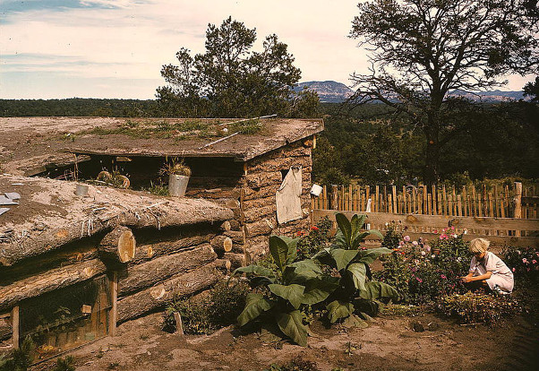

Life in New Mexico without electricity in the early 1900s.
3. Many countries around the world are making remarkable advances with Nuclear energy. If Nuclear power plants are cheaper and more effective than ever before, then why hasn't every country taken notable steps towards going nuclear?

Nuclear power plants in Canada, the United States, Europe and other countries around the world are required to follow the ALARA radiation protection guidelines, (As Low As Reasonably Achievable). This is a direct consequence of the Linear No Threshold Hypothesis and Collective Dose Corollary. This adds tremendously and without benefit to construction, operating and maintenance costs. More meaningful radiation safety guidelines must be adopted to solve this problem. The following websites have lots of information about forming better radiation safety guidelines than LNT, Collective Dose, and ALARA:

- http://radiationeffects.org/
- http://www.x-lnt.org/
- go-nuclear.org
- efn-usa.org

It will take years to make changes to radiation safety guidelines, but they must be made.

Some countries have lower costs for construction labor, technicians and professionals than Canada, the United States and France. Countries all over the world, except the United States and a few similar countries are going ahead with nuclear power.

Government supervision, management, engineering, and operation disciplines around the world must be as responsible as in countries like, Canada, France, South Africa, Spain, and the United States. Management must be vigilant to recognize new risks that were not known at the time of design and construction.

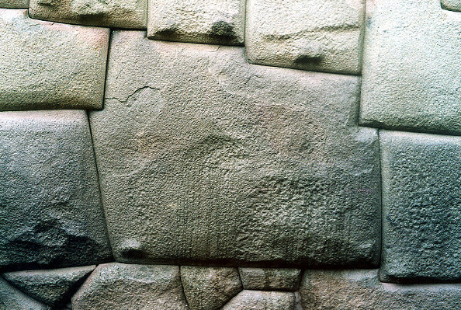

Amazing precision Inca stone construction around 1300 AD, Peru.
4. With nuclear energy there is little room for error. What methods are there for harnessing this nuclear energy 100 percent of the time? How do we avoid meltdowns?

This question is actually one statement that does not acknowledge the risk analysis, design criteria and actual record of over 50 years of commercial nuclear power and two questions. In brief, nuclear power in the West has always been designed by detailed risk analysis, highly trained operators and management and in-depth backup safety systems. Very few, if any other technologies in modern living have such extensive safety measures. And the record proves it. Few other technologies have the safety record that nuclear power in the West has. The media and anti-nuclear organizations can make all the wild claims they want. There is no evidence. Everything we do is more risky than working at or living near a nuclear power plant designed and operated to western standards.

The following life styles and activities are more risky than living near or working at commercial nuclear power in the West:

Riding a bicycle, going to a hospital, sometimes getting medical advice, riding a train, driving or riding a car or bus, going out in the sun, walking, staying home, going to school, going to a theatre or dance hall, surfing, sailing, waterskiing, snow skiing, mountain biking, living or working in a high rise building, going on a cruise, living in high earthquake areas, living in hurricane areas, living in tornado alley, living within a few feet elevation of sea level, living in flood zones of rivers, going to amusement parks, touring wild animal reserves, taking a ferry, being in the military, following some religions, bad eating habits, bad drinking habits, smoking, getting mosquito bites, going near bee hives, wasp hives, fire ant homes, lounging in your backyard in Florida, having sex, using your private swimming pool, horseback riding, having a gun, doing drugs, using the Internet improperly, excessive eating of fast foods, deserts, and sweets, driving a car above the speed limit, exceeding safe driving limits in bad weather, driving while drinking, living downwind from a coal-fired power plant or steel mill, living downstream from the fly-ash pond of a coal-fired power plant or steel mill, etc. For birds, it is deadly to fly near wind turbines and solar tower power plants. For people, it is stressful and risky living near wind turbines.

Many of us do some of the above at least several times in life. There aren't too many of us living in monasteries and convents these days. It takes some people a long time to grow up.

Nuclear power is safer than all these activities and essential for the world to benefit from modern living for hundreds, thousands of years. Zero deaths from radiation from nuclear power plants designed and operated to western standards, including Three Mile Island and Fukushima. No other activity mentioned above beats zero fatalities over fifty years of operating nuclear power plants to western standards. We recognize these more risky activities by common sense. How many people have common sense? How many people believe the media and what their friends say about nuclear power?

How do we avoid meltdowns?

The single most effective way to avoid meltdowns is to follow the practices of the Institute of Nuclear Power Operations, INPO, and the World Association of Nuclear Operators, WANO. These organizations recognize that OPERATIONS is the real important phase for safety – You can easily crash an excellent machine if you operate it stupidly, but an expert crew can make a third-rate machine hum like a top-rate creation.

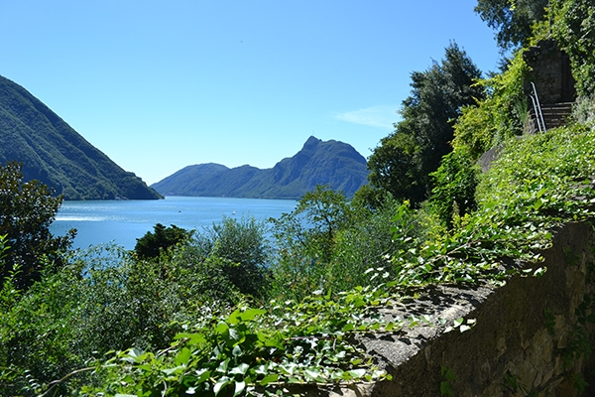

The olive tree walk from Gandria to Lugano on Lake Lugano, Switzerland
It can be a beautiful world. We need to bring prosperity and peace around the world through more use of nuclear power, nuclear medicine and nuclear science.

5. How do we handle the waste that comes along with nuclear energy? Is there a safer way to dispose or store the used nuclear fuel rods?

The planning and paying for waste storage in the United States has been a complete waste of time and money and a disgraceful political failure. That is what President Obama's Blue Ribbon Committee said in 2011.

The media talks about huge volumes of nuclear waste. The federal government writes reports saying they don't know what to do with depleted uranium and spent fuel.

Scientists and engineers around the world have solved the problem of "nuclear waste." Russia is pursuing advanced nuclear technologies that solve the nuclear waste "problem." Use depleted uranium and spent nuclear fuel in advanced technology nuclear power plants such as the Integral Fast Reactor developed by Argonne National Laboratory. This can produce about 100 times more power and results in minimum waste compared with all other activities of life. See the main tab: ENERGY TOMORROW on go-nuclear.org and efn-usa.org websites. Read the book by Dr. Charles Till and Dr. Yoon Chang: PLENTIFUL ENERGY - The Story of the Integral Fast Reactor. The complex history of a simple reactor technology., with emphasis on its scientific basis for non-specialists. This book can be read by high school students, teachers, college students, professors, experts in all energy fields, and political leaders. They will all get the same message. Use this nuclear power.

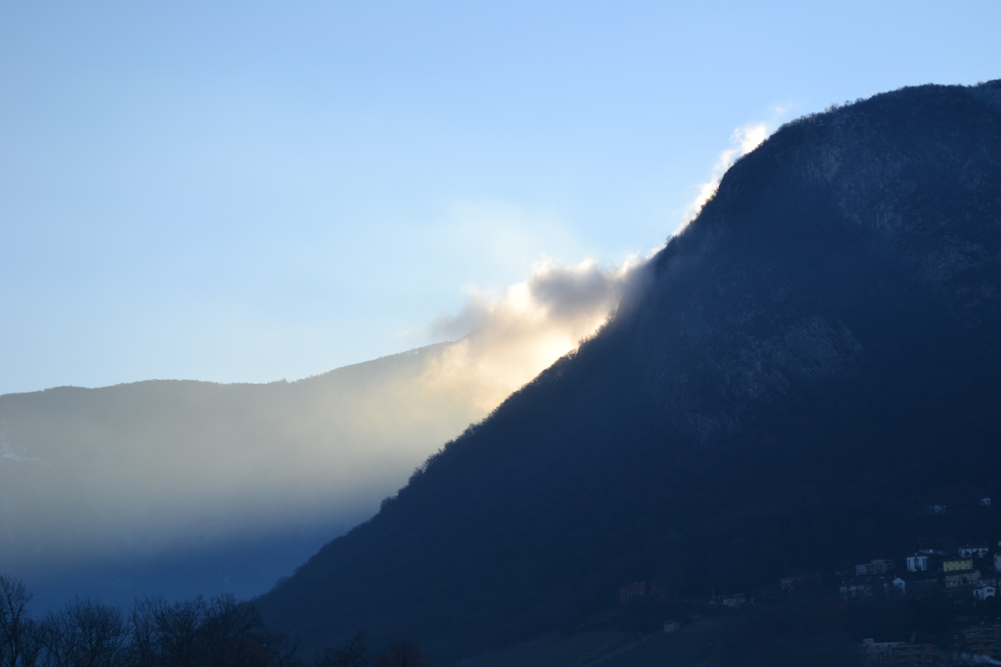

Nuclear power from the sun seen in a cloud at sunrise with Monte San Salvatore in the foreground, Gentilino, Switzerland, January, 2016

