RADON MINES NEAR BOULDER, MONTANA
August, 2015

By:

- Bruno Comby, nuclear engineer and worldwide researcher about high levels of naturally occurring radiation. President of Environmentalists for Nuclear – International. Houilles, France.

- John Shanahan, civil engineer. President of Environmentalists for Nuclear – USA. Denver, Colorado, USA. Website: efn-usa.org

Photos 2015

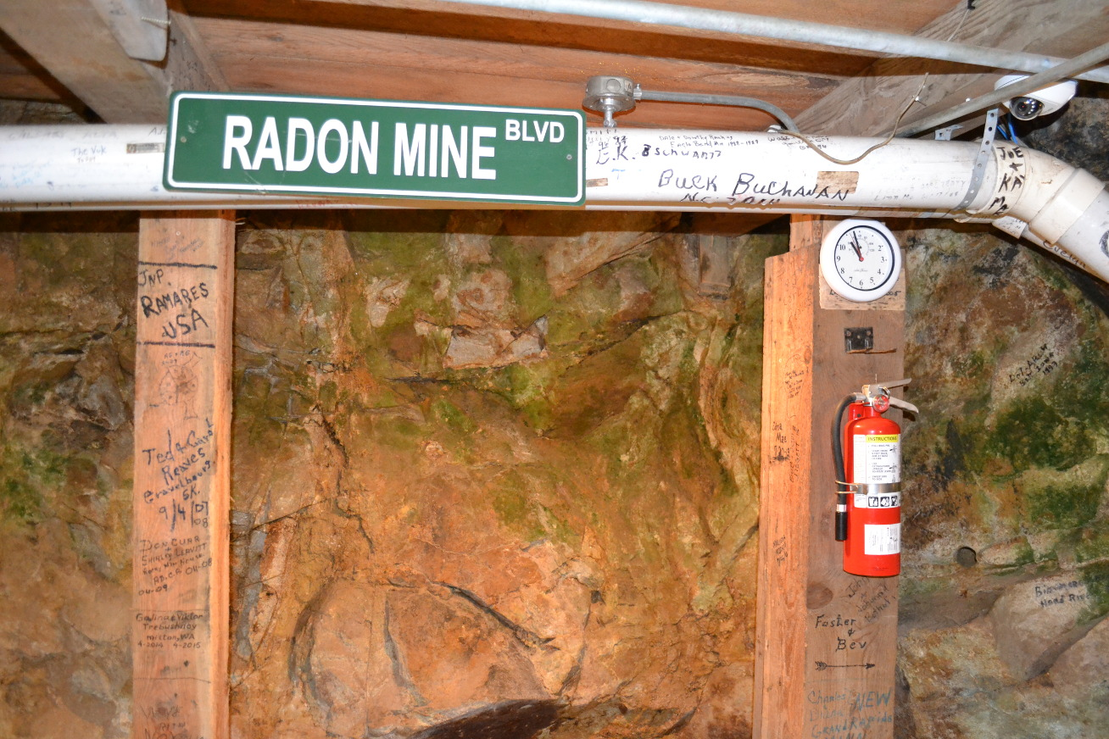
Free Enterprise Radon Mine, Boulder, Montana
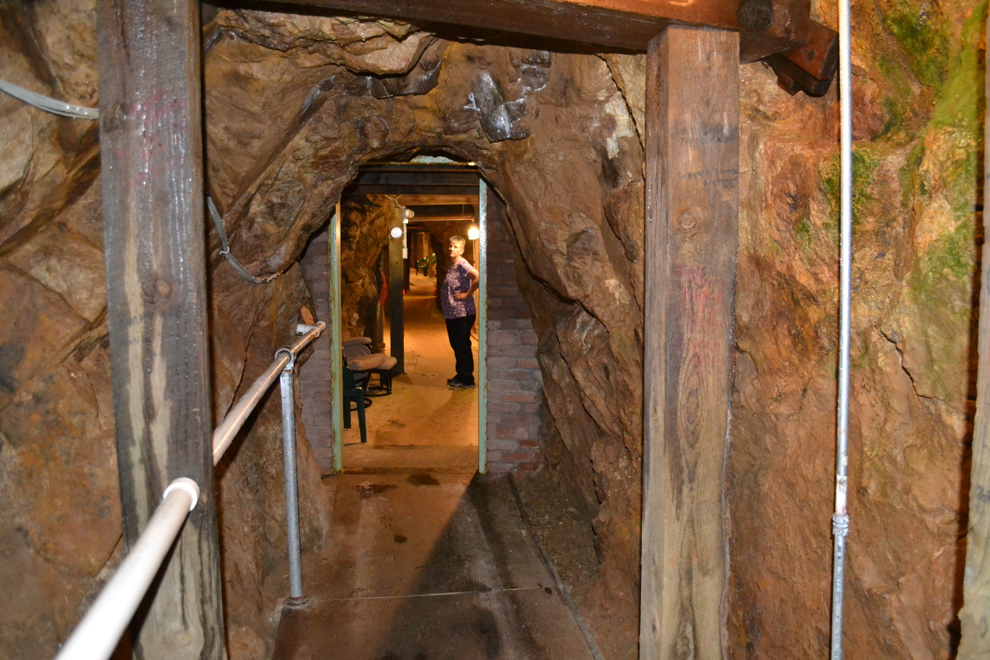
Free Enterprise Radon Mine, Boulder, Montana
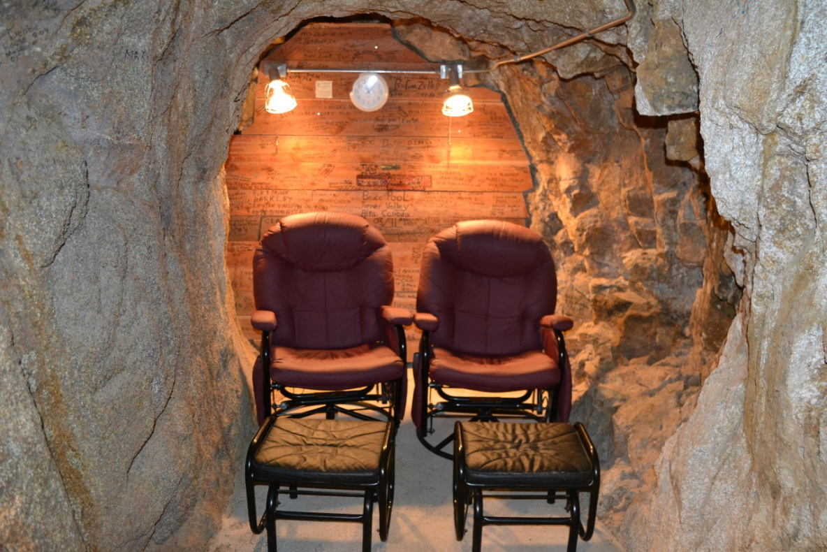
Free Enterprise Radon Mine, Boulder, Montana

Click here and here for short video interviews by radiation research scientist, Bruno Comby with Free Enterprise Radon Health Mine Owner, Patricia Lewis and frequent mine visitor, Alan Jang.
Click here for a short photo report about natural radon levels around the world that are much higher than the upper limits set for building basements by the U.S. Environmental Protection Agency.

Newspapers early 1950s

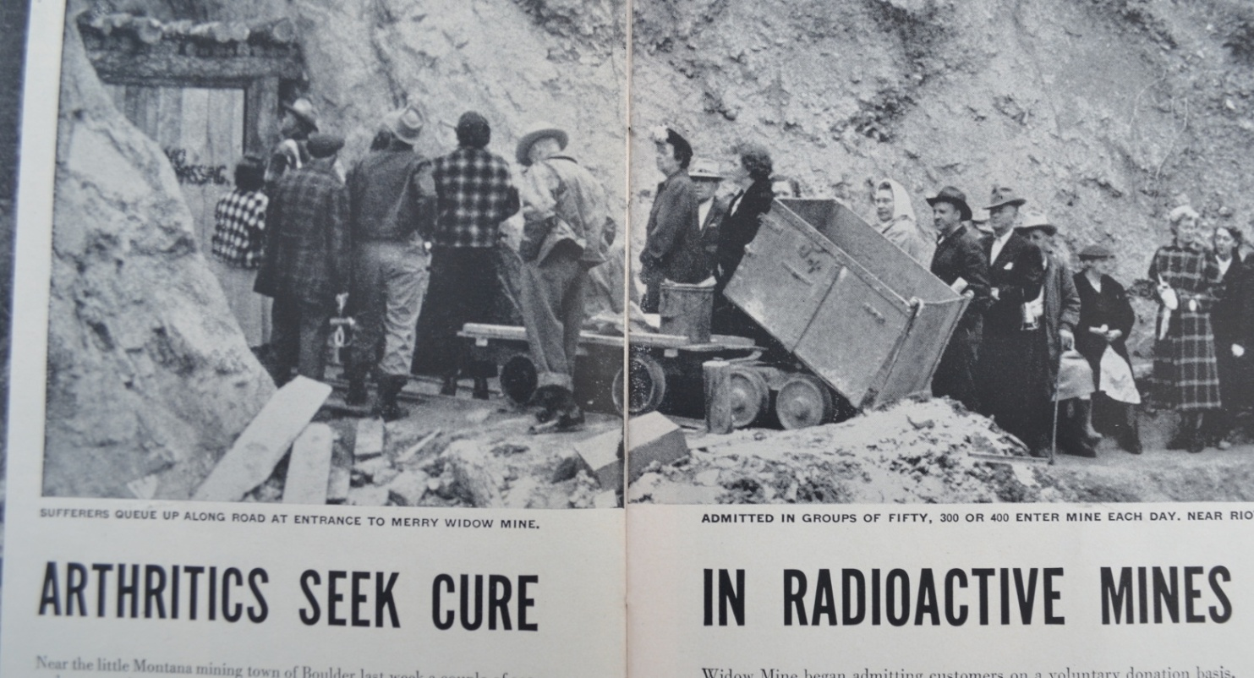

Merry Widow Radon Mine – Basin, Montana

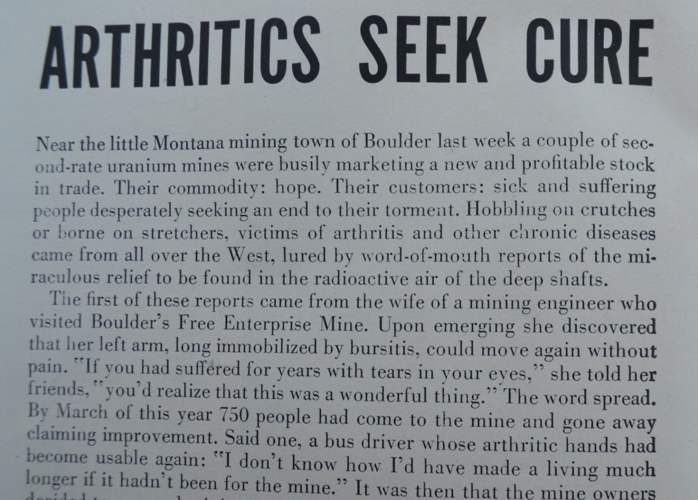

Free Enterprise Radon Mine – Boulder, Montana
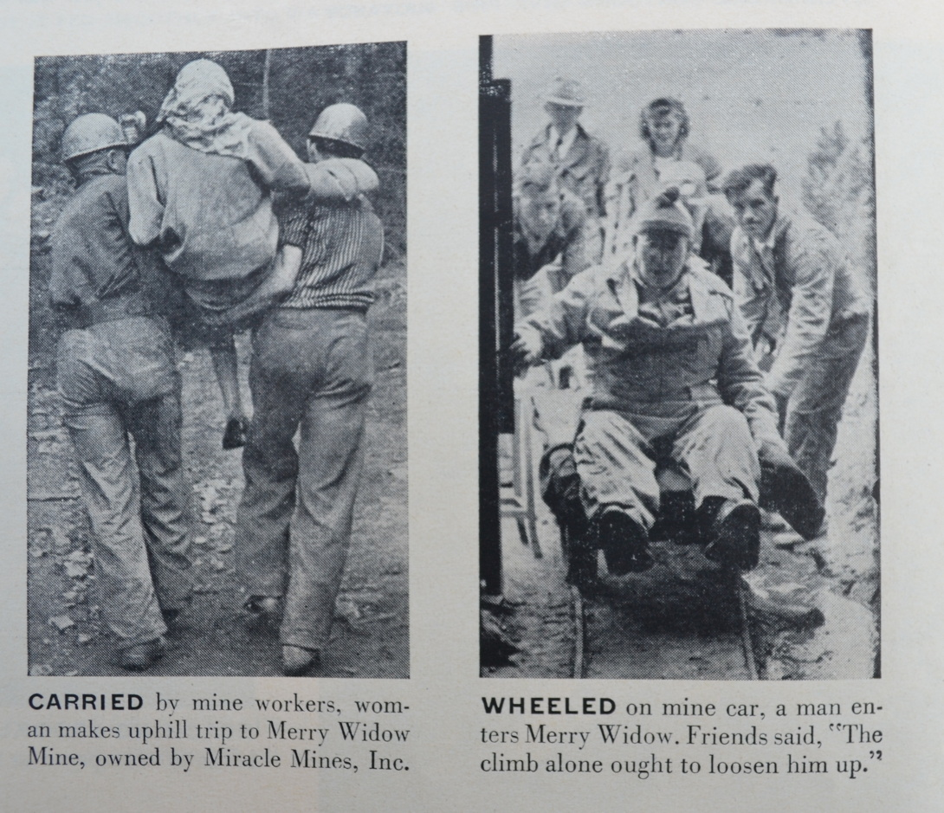

Merry Widow Radon Mine – Basin, Montana

The Montana Radon Mines were very popular in the 1950s before development of drugs for arthritis. They are still popular in the 2010s for people who prefer them to the drugs and for cases of diseases where drugs don’t work for certain people. This mine is owned by a Korean-American couple from Seattle. Many Korean-Americans from the Seattle area come for week long stays. Being in the mine is a different feeling. There is only silence. Then you come upon a group of people sitting silently in the semi-darkness with their hands and feet immersed in ice cold radon laced water seeping from the walls. One local woman has a very sick boy who is more comfortable in the mine than out. She moved to Basin to be close to the mine.

The U.S. Environmental Protection Agency sets upper limits of radon in home basements at levels one hundred times LOWER than the levels in these mines. You won’t be given a mortgage, if the levels in your home exceed these minuscule amounts. Otherwise you are forced to put in an expensive, high tech basement ventilation system. The EPA is protecting you? The Yellow Pages for Steamboat Springs, Colorado are full of companies ready to measure very low levels of radon gas in the basement of your ski condo and install a ventilation system for several thousand dollars. This is forced on people who are getting a mortgage. Makes a lot of sense for some!

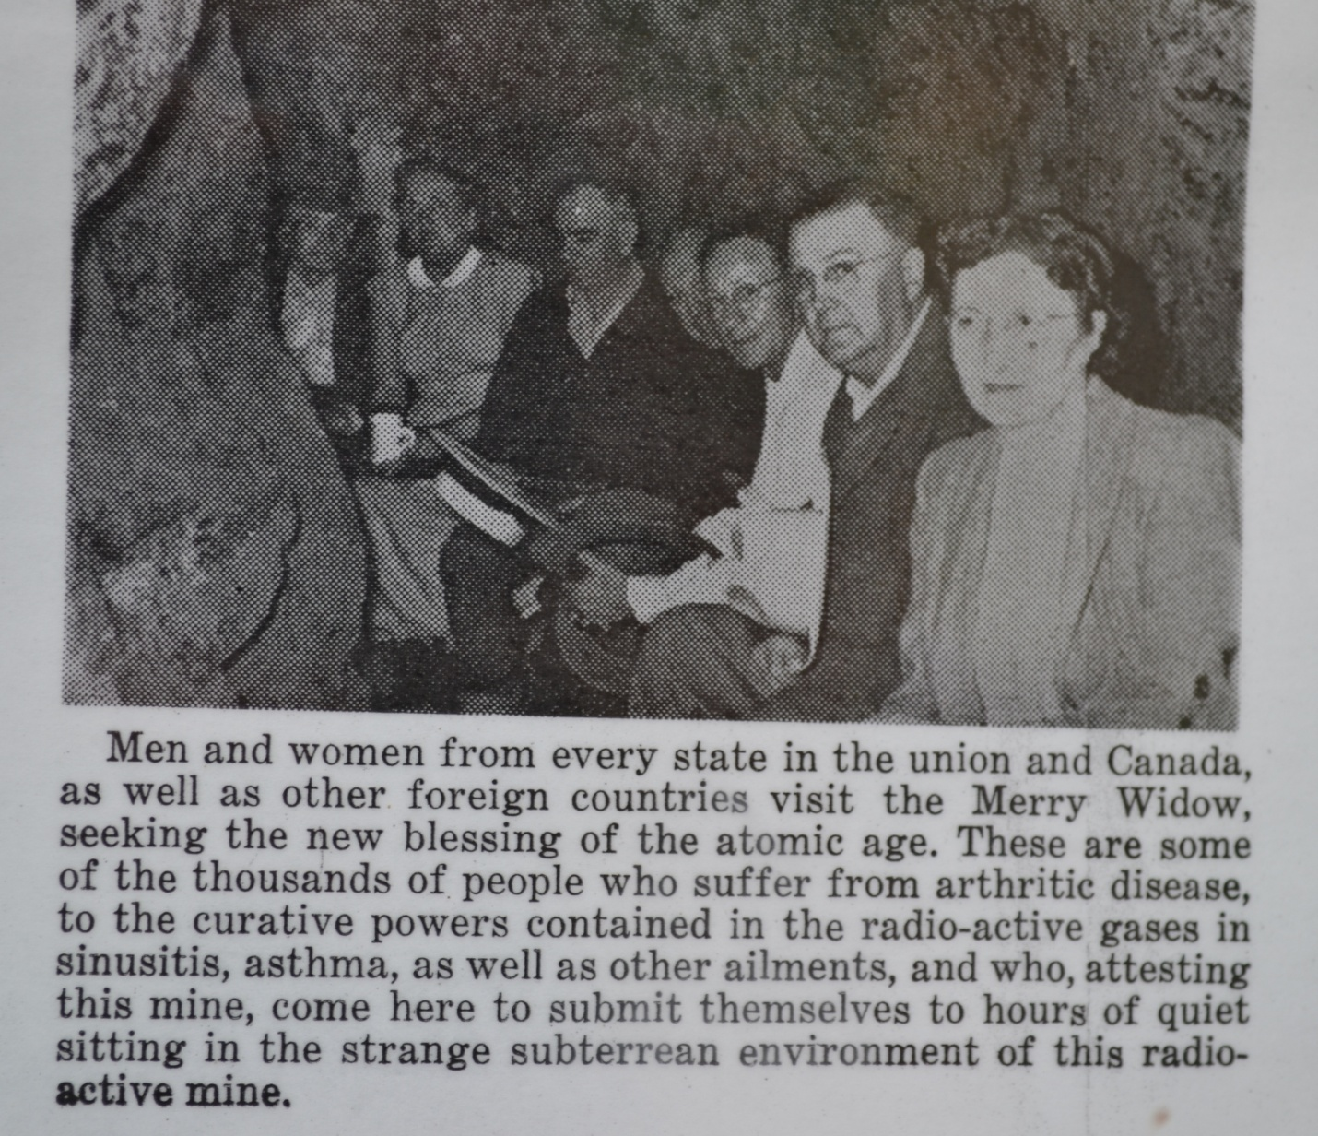

Merry Widow Radon Mine – Basin, Montana, 1950s

