Chernobyl : The Effects on Public Health ?
André Aurengo , Chief of the Nuclear Medicine Department at the La Pitié-Salpêtrière Hospital in Paris
Because of its public health, ecological and industrial consequences, the Chernobyl accident has become a myth which serves as the focus of many fears, justified or not.
No one can question the seriousness of the event, but after fifteen years there is still no agreement about the effect it has had or will have on public health. For example, the total number of deaths attributed to Chernobyl varies from less than a hundred to several millions, and congenital malformations from negligible to cataclysmic. To exaggerate the numbers to absurd levels is just as dishonest as to minimise them.
Beyond disinformation, widely broadcast for one motive or another, and despite the fact that one cannot easily refute arguments set forth with the heat of passion, we believe it is important and even urgent not to let psychosis run wild. It is our purpose to show that there are scientific criteria which can be used to evaluate doses of ionizing radiation, the health effects of exposures and the risks. Even using data which are incomplete and perhaps not totally reliable, several group appraisals, especially the studies conducted by UNSCEAR and IPSN, based on the analysis of hundreds of valid publications and official records, lead us to draw some conclusions regarding the public health consequences of the accident and to set upper and lower numerical limits to them.
What do we know about the effects of ionizing radiation?
Some orders of magnitude
We are continuously irradiated by the radioactive isotopes present in our bodies (about 8000 Bq), by cosmic rays and by radioactive elements in the ground beneath our feet, in particular, radon, the gaseous radioactive daughter of uranium. In France, the resulting "natural ionizing (background) radiation" varies from 2,5 mSv/year in Paris to 5 mSv/year in Brittany and in the Massif Central (a mountainous region in the south-central part of France.) The annual dose exceeds 20 mSv in some parts of the world. To this we must add medical irradiation which is very unevenly distributed but estimated to average about 1 mSv/year and industrial irradiation, about 10 microSv/year. The dose due to a chest X-ray is about 0.5 mSv, a week's vacation in the mountains at 1500 meters (5000 feet) adds 0.01 mSv and an airplane trip from Paris to New York adds 0.03 mSv. Rules of the European Community limit the irradiation of the public resulting from non-medical human activities to 1 mSv/year, and the irradiation of occupationally exposed workers to 100 mSv in 5 years.
Some effects are known but it is hard to attach numbers to them
Ionising radiation has both deterministic and stochastic effects.
Deterministic effects are observed for doses over 700 mSv ; for a given dose they always occur and their severity increases with the dose, up to lethal doses.
Stochastic effects occur at random, and the probability of radiation-induced cancers and congenital malformations increases with the dose.
Radiation-induced cancers occur only for doses over 100 mSv for adults and in the range of 50 to 100 mSv for young people.
Concerning the risk of radiation-induced cancer at low doses (below 200 mSv), there is ongoing controversy over the existence of a threshold below which there would be no effect and over the relation between dose and probability of radiation-induced cancer at low dose (is it linear or linear-quadratic?).
The risk of cancer
Our knowledge of the risk of cancer due to ionising radiation is mainly based on the long-term study of 120 321 survivors of Hiroshima and Nagasaki who received significant doses (from 5 mSv to 3 Sv with an average of 200 mSv) at a high dose rate (1 Sv/second). The follow-up study shows that the probability of developing cancer increases more or less linearly with dose for solid tumors (between 200 mSv and 3 Sv), and follows a linear-quadratic rule for leukaemia. Among the 120 000 survivors, in the half-century since Hiroshima and Nagasaki, one estimates that there have occurred 334 more cancers than in a matched non-irradiated population, and 87 more cases of leukaemia. ICPR used the Hiroshima-Nagasaki data to set radio-protection rules which, for prudence and simplicity, are based on a linear-no-threshold (LNT) law. This straightforward model is justified by its simplicity, but it cannot be applied to the calculation of cancer probabilities for low doses or for low dose rates. The improper use of the simple LNT law as if it had been scientifically proven has led to vast exaggerations of the danger of weak ionising radiation.
Thyroid Cancers
Radiation-induced thyroid cancers are caused by external irradiation or by the subject's ingestion of radioactive iodine isotopes. The radio-iodine is strongly concentrated in the thyroid gland so that the dose to the thyroid is 200 times greater than that delivered to other organs. For the same contamination, the dose to a young person's thyroid is higher than an adult's, and the foetus is sensitive starting with the third month of pregnancy.
For a young child and the fœtus, radio-induced thyroid cancers have been observed from 100 mSv upwards, received at high dose rate. The estimate of risk is based on data from the Hiroshima-Nagasaki study and from follow-up studies of children who had had radio-therapy.
These studies all deal with high doses and high dose rates and the data probably cannot be applied generally. For equal doses, the relative risk would be 2 to 10 times smaller for much lower iodine-131 dose rates. Short-lived radio-iodine isotopes, such as I-132, which, for the same dose, have a dose rate much higher than I-131, may have played an important part in causing thyroid cancer in the former Soviet Union. The relative risk of radiation-induced thyroid cancer decreases with age and becomes insignificant after the age of 20.
The adult thyroid is not very sensitive to radiation and we hardly ever see radiation-induced thyroid disease in an adult. Scintigraphic examinations of the thyroid have been performed on some 34 000 adullts, using iodine-131 with an average dose to the thyroid of 1.1 Gy, and the procedure has been shown to be totally harmless.
Similarly for children we have seen no radio-induced thyroid disease after scintigraphic examination, but we have only 500 cases.
It is to be emphasized that the dose to the different organs (which is very poorly known in the case of the Chernobyl accident) is only one of the parameters needed to estimate the risk of radiation-induced cancer. Other important factors are the dose rate, the nature of the ionizing radiation and its homogeneity, as well as the age and sex of the subject and such things as genetic predisposition.
There are many difficulties in the analysis of Chernobyl
Effects on public health may be calculated from data on contamination, from the doses received and from the risk, all three of which are likely to be very roughly known; or they may be evaluated on the spot, either by epidemiological studies or by examining medical registers.
A very simple computation leads to very high estimates when risks are improperly modeled by the LNT relationship, because low risks are attributed to low doses but then multiplied by a very large population. This is like saying it is as dangerous to have one grain of lead fall on the head of one million people as one anvil on a few persons.
The contaminated area is not well mapped
The explosion and fire at the Chernobyl reactor N°4 injected into the atmosphere about 4 x 10¹⁸ Bq of rare gases, 8 x 10¹⁶ Bq of cesium-137 and 2 x 10¹⁸ Bq of short-lived radioactive iodine (iodine-131: T = 8 days, iodine-132: T = 2.4 hr and iodine-133: T = 20,8 hr). The areas heavily contaminated lie principally in northwestern Ukraine, in the southern part of Belarus, and nearby areas of Russia. People there were exposed to external irradiation due to the proximity of radioactive material and to internal contamination from eating contaminated food and inhaling radioactive particles.
Because the pattern of rain and wind was irregular, the distribution of the contamination is complex. It was relatively accurately determined only for long-lived cesium-137; in view of its 30-year half-life, measurements could be made long after the accident.
Contamination maps for iodine-131 deduced from the cesium-137 data are only very approximate.
Epidemiological studies can be misleading
The ability of an epidemiological study to detect an increased cancer risk depends upon its statistical power, which depends on the size of the studied population and the duration of the study (i.e the total person-years) as well as on the natural occurrence of the disease under study. If the result is negative, one can only conclude that the risk is below a certain threshold, but never that the risk is non-existant. For example, in statistical tests being done at a 5% confidence limit, it is likely that one test in 20 will show a positive result simply by chance. The results of epidemiological studies must, therefore, be considered cautiously, in the light of our general knowledge of radio-pathology and by comparing the results of several inquiries. These difficulties, common to all studies of risk, lead us to say that it is impossible to distinguish between a zero risk and a non-zero risk, and consequently we may speak only of a significant or an insignificant public health risk.
Medical registers are efficient tools
Public health registers for cancer are theoretically the best way to evaluate the consequences of this accident. In the countries of the former Soviet Union there are many registers of uncertain reliability, one for general medical follow-up which has followed 659 292 persons since 1986, specialized registers for malignant hemopathies and thyroïd cancers, and registers devoted to military liquidators.
In France, we have 13 registers for "general" cancers and the specialized register of thyroid cancers in the Champagne-Ardennes region. These registers cover about 15% of the French population. For youngsters, a national register for leukaemia was created in 1995, and a national register of solid tumors has recently been opened.
In Ukraine, Belarus and Russia : one catastrophe may hide another.
For inhabitants of former Soviet Union, one has to distinguish three populations:
- The 600 000 Chernobyl liquidators, who worked on the site of the accident and who mainly suffered from external irradiation, averaging 100 mSv with a maximum of 10 Sv);
- The evacuated population (116 000 at first and another 220 000 later on) who suffered from external irradiation averaging 20 mSv with a maximum of 380 mSv as well as an internal contamination averaging 10 mSv, with thyroid irradiation of 500 mGy. The internal contamination of children by radioactive iodine was especially serious.
- Seven million people still living in areas contaminated by cesium-137. They presently receive a highly variable external irradiation depending on soil contamination (from 1 to 40 mSv/year). Their internal contamination may be significant if they eat contaminated food.
The immediate consequences
Three persons died of trauma. During the emergency operations about 600 persons were irradiated; among them 134 exhibited acute irradiation syndrome; 28 of the most heavily exposed died. (Table I)

Table I
Doses and early deaths among most exposed liquidators
Dose mSv | Total number | Number of deaths
800 - 2 100 | 41 | 0
2 200 - 4 100 | 50 | 1
4 200 - 6 400 | 22 | 7
6 500 - 16 000 | 21 | 20
Total | 134 | 28

Thyroid cancer in children and young persons
In view of the lack of reliable data on contamination, thyroid irradiation is much debated: 17 000 young people are supposed to have received a thyroid dose greater than 1 Sv, 6 000 greater than 2 Sv and 500 greater than than 10 Sv.
We know that the consequences of an accidental contamination by radioactive iodine can be avoided by keeping people indoors, by early administration (within 3 hours) of a dose of stable iodine which prevents radioactive iodine from being absorbed in the thyroid gland, by not drinking or eating contaminated water, milk and other food and by evacuation from contaminated areas. In fact, evacuation was late and no measures seem to have been taken to urge people to stay indoors. Stable iodine was distributed only after a fourteen-hour delay in Ukraine and after three to six days in Belarus; distribution was only partial, and some towns such as Gomel were never supplied.
As early as 1990 it had become clear that there would be a substantial increase in the number of thyroid cancers among young people who were less than 15 years old or in utero when the accident occurred (Figure 1).

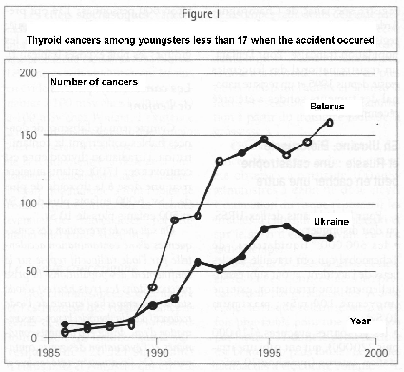
To date, nearly 2000 thyroid cancers have appeared among these youngsters. They are papillary cancers, the least serious kind of thyroid cancer, although more severe than natural cancers. They are accompanied by cervical ganglionic metastases which are not serious in 90% of the cases, and with pulmonary metastases which are much more serious in 30% of the cases. Particular mutations of the RET gene, involved in thyroid carcinogenesis, are found much more frequently in these radiation-induced cancers than in spontaneous cancers.
An early and appropriate treatment leads in all cases to a normal survival for several decades and, in the absence of pulmonary metastases, a recovery rate of about 95%. After a difficult start, when international help was essential, these cancers are now quite well taken care of. The main shortcomings were inadequate screening and, in some cases, the poor quality of surgery. Ten youngsters are said to have died from thyroid cancer (unofficial figures which can hardly be verified); this can only be attributed to inadequate care. For comparison purposes, among 39 young persons (from 6 months to 33 years) treated for spontaneous papillary cancer at the La Pitié Hospital in Paris and followed for an average of 13 years, no fatality has occurred which could be attributed to cancer.
Among youngsters subjected to radiotherapy, one observes some radiation-induced thyroid cancers, which peak 25 to 30 years after irradiation. The evolution of post-Chernobyl thyroid cancers seems to be different, and a plateau is already evident. It is impossible to forecast the number of cases still to come, but they may be very numerous. To identify and treat new cases in time, it would be necessary to institute an early and systematic screening by annual ultrasound examination of the exposed youngsters (about 200 000 in Belarus and 70 000 in Ukraine), but this is far from being realized. The economic situation in Ukraine and Belarus is such that adequate care for these cancers cannot be provided without help from the West.
Frequency of thyroid cancer among youngsters born after 1987 is back to pre-Chernobyl levels.
Leukaemia
According to the Hiroshima-Nagasaki data, one should have observed an excess of cases of leukaemia among the liquidators within six to eight years after accident. As a matter of fact an increase in the number of cases of leukaemia is observed in Ukraine, Russia and Belarus, but also for forms of leukaemia which are never radiation-induced and in non-contaminated areas as well. The follow-up of Russian liquidators between 1986 and 1997, shows six times as many cases of chronic myeloid leukaemia (possibly radiation-induced) as before 1986, but also three times as many cases of chronic lymphoid leukaemia (never radiation-induced). Among 65 cases of leukaemia detected among liquidators in eleven years for 1 011 833 person-years, ten or so are possibly due to irradiation.
During the period from 1986 to 1991 in the most contaminated zones in Ukraine a possible excess of about ten leukaemia cases was reported among youngsters who were up to 14 years old at the time of accident. Later rates are back to normal. This excess was not observed in Belarus.
Except for these observations, no excess of leukaemia has become evident, not even among adults evacuated from or living in contaminated areas.
Other cancers
Overall there is no significant increase in the number of other cancers, but some peculiar instances were reported: an overall excess of cancer among Russian liquidators not working in nuclear industry (898 cancers observed versus 847 forecasted in 8 years for 704 375 person-years); an excess of breast cancer among female liquidators (38 cancers observed in 1991-1999 versus 31 forecast for 5332 women) and, possibly, an excess of breast cancer among evacuated women and among women living in contaminated areas. All these data must be taken with caution because the excesses are barely above random fluctuations and because the frequency of breast cancer is clearly increasing in all countries due to improved screening.
Any increase in adult thyroid cancer is difficult to detect because of the bias introduced by better screening. For liquidators, evacuated people and residents of contaminated areas, an increase in thyroid cancers is clear (see Table II), but it is not obvious that it is due to contamination. First of all, the number of cancers normally expected is very small, because adult thyroid cancer is a relatively rare disease. On the other hand, a study of the dose-effect relationship in liquidators paradoxically shows that the risk of thyroid cancer decreases when the dose to the thyroid increases. Lastly, for residents, the increase is identical in the most contaminated region (Gomel) and in the least contaminated (Vitebsk). These elements suggest that improved screening plays a dominant role in this apparent increase of thyroid cancer.

Table II
Adult differentiated thyroïd cancers in former Soviet Union
 | Period | Persons - years | Expected Cancers | Observed cancers
Liquidators | 1990-1993  1994-1997 | 263 084  314 452 | 3  5 | 13  24
Evacuaees | 1990-1993  1994-1997 | 208 805  200 077 | 6  7 | 23  43
Contaminated areas | 1990-1993  1994-1997 | 654 501  556 631 | 22  19 | 24  48

Non malignant diseases
A very large number of non-specific pathologies (asthenia, anaemia, sensitivity to infection, cardiovascular disorders) have been described and sometimes attributed to ionizing radiation. Taking into account the doses received, these pathologies cannot be the result of irradiation. Like psychic disorders and suicide, they arise from the major psychological trauma suffered by the liquidators and evacuated people as well as from anxiety and the badly deteriorated socio-economic conditions in the contaminated areas.
Heart disorders attributed to the chemical toxicity of cesium-137 were reported in unrefereed confidential communications. The work was done without even a minimum of methodological precautions and they are just not credible. We mention them only to express our solidarity with their author, Professor Bandazhevsky, who has the right to make a mistake without incurring the serious legal proceedings he is facing in Belarus.
An increased incidence of thyroid nodules and of thyroiditis, a thyroid pathology which may lead to hypothyroidism, has been reported and seems to be confirmed in areas where thyroid contamination was the strongest.
Digestive pathologies (acute diarrhoea, fibrosis) and a decrease of spermatozoid mobility and of fertility index were also reported among employees of the power station and liquidators.
Congenital malformation
The birth rate has greatly decreased in Ukraine and in Belarus; it is only about half of what it was fifteen years ago. Any possible increase of congenital malformations cannot be determined either by simple counting because they occcur naturally in 2 to 5% of pregnancies; or by comparing their incidence before and after 1986, because the quality of data taking may have changed in unknown ways. The register of malformations in Belarus shows an overall increase which began before 1986, with no difference between the contaminated and non-contaminated areas. Conversely, a 1997 study shows an increase of congenital malformations of the foetus after abortion. Three studies, covering more than 20 000 pregnancies in three regions of Russia, looked for a variation of the rate of abnormality (malformations, prematurity, newborn infant mortality) related to local contamination. They give contradictory results and only the decreased birth rate is systematically found.
Radiation-induced congenital malformations are well known and the procedure to be followed in case of accidental irradiation of a pregnant woman is well established: irradiation during first week leads to spontaneous abortion; later, most authors agree that no particular measure is indicated for doses to the embryo or to the foetus smaller than 50 mSv, and that therapeutic abortion is recommended if dose exceeds 200 mSv. Between these two limits, practice depends on the context. In the most contaminated areas of northern Ukraine, 99,9% of women received less than 100 mSv accumulated dose from 1986 to 1997, that is, less than 7 mSv for the duration of a pregnancy. These figures show that the massive epidemic of malformations, which some alarmist media would like to have us believe, is simply impossible.
Indirect consequences
In terms of public health, it is the indirect consequences of the Chernobyl incident which have had the most serious impact. Because of the vast area contaminated (150 000 km² - 60 000 square miles - contaminated with more than 37 kBq/m²), because of the enormous amount of money which had to be spent and because of its major political impact, the accident greatly disturbed an already precarious health organisation in three countries which were already in total political, economic and financial disarray.
Taking into account our knowledge, it is impossible to answer the question: What is the total number of deaths caused by this accident? However, if one compares the total number of observed cancers to the number of cancers naturally expected among Belarussian and Ukrainian liquidators, one notices that the excess of cancers is small. One even observes fewer cancers in Belarus than notherwise expected! We are far from the slaughter sometimes proclaimed. (Table III).
Even if the number of excess cancers could have been predicted, the survival of the patients would depend on early diagnosis and on the therapeutic methods available, which in turn depend on the economic level of the country. Only massive and well supervised international help will be able to mitigate the consequences of this catastrophe.

Table III
Total number of naturally expected and observed cancers among the liquidators
 | Person-years | Expected cancers | Observed cancers
Belorus | 314 204 | 1 352 | 1 195
Ukraine | 1 155 072 | 2 708 | 2 992

Controversy in France over the effects of Tchernobyl
The radioactive cloud crossed France from east to west, from 30 April to 5 May 1986, producing a contamination mostly due to iodine-131 which disappeared in a few weeks' time, and by cesium-137 which is still present in significant quantities in some areas. One can evaluate two doses:
- an overall effective whole-body dose. The highest effective doses received in France were in the range of 0.4 mSv for the year 1986 and, if integrated over the sixty years from 1986 to 2046, 1.5 mSv. These doses are small compared to natural irradiation which is about 2.5 mSv/year in Paris and 5.5 mSv/year in Clermont-Ferrand.
- a dose to the thyroid coming mainly from food contaminated with iodine-131 consumed in May and June 1986. According to an evaulation by IPSN, this dose is in the range of 0,5 to 2 mGy for an adult and 6,5 to 16 mGy for a 5-year-old child. These figures are very sensitive to the consumption of fresh cow or goat milk, and the IPSN assessment gives an average value 100 to 1000 times lower than for children in the Chernobyl area. But these evaulations probably underestimate the dose received by a few youngsters who may have a very unusual diet, while overestimating the average for the country as a whole.
For both these doses, one observes a geographic distribution which decreases significantly from east to west (see Figure. II).

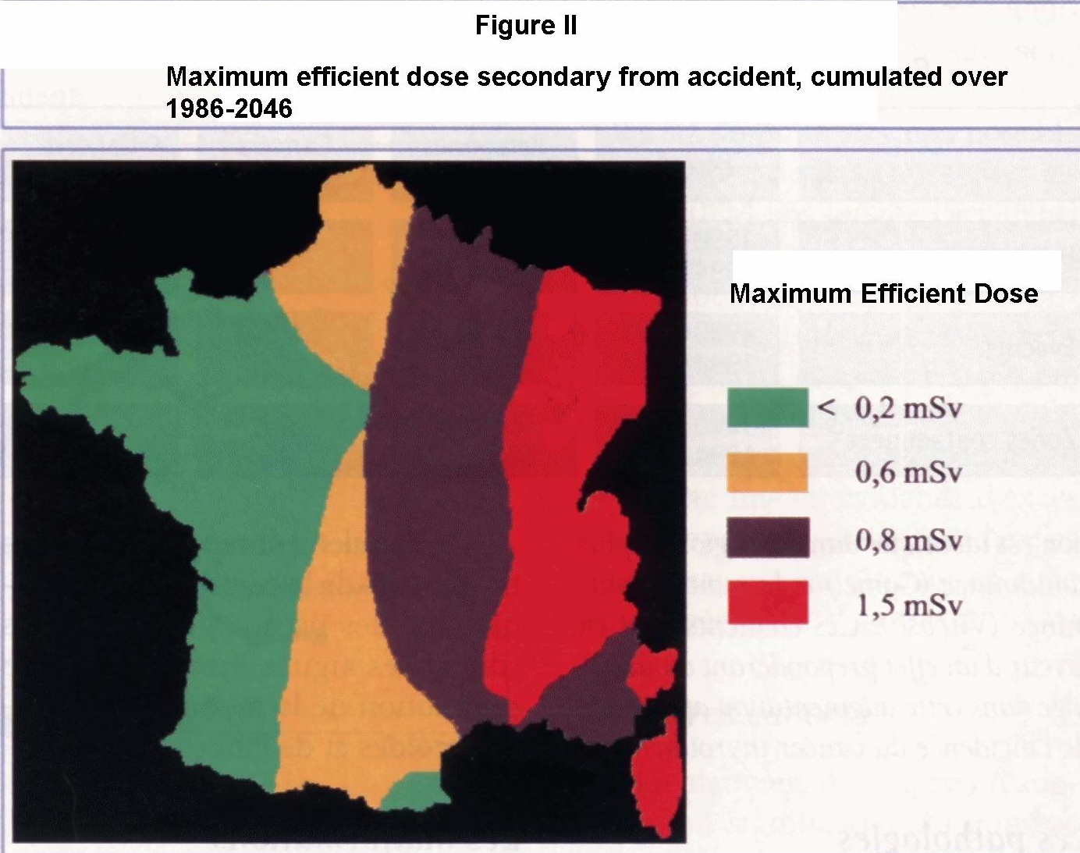

Thyroïd cancers
The incidence of thyroid cancer in France has increased significantly since 1975 (Figure III). There were 2600 new cases in 1995, i.e. 1% of cancers. This increase, which is observed among adults as well as young people, is the origin of the polemical hypothesis (and related complaints lodged with the government) that the Chernobyl accident might be responsible for the increase, and the suggestion that the public health authorities failed to take precautionary measures in 1986.

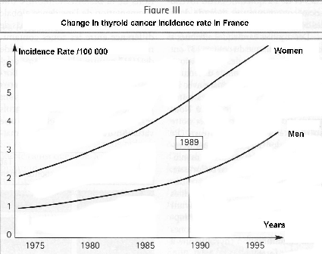
It is worth recalling here that thyroid nodules are extremely frequent (occurring in 40% of women 40 years old and in 50% in persons older than 60), and so are micro-cancers less than 1 centimeter in diameter. Most of them are undiscovered and do not progress. Systematic analyses of the thyroid gland among adults who died without any peculiar thyroid pathology shows small seats of thyroid cancer in 6 to 28% of cases. So the incidence of thyroid cancer is only apparent and essentially linked to screening and especially to the spread of ultrasound examinations in the 1980s. The spatial resolution of this technique, a few millimeters, enables practitioners to identify nodules which in 90% of the cases would not appear through palpation or scintigraphic studies. Many micro-cancers of multi-nodule goitres are also discovered in the anatomo-pathological studies of excised tissue, for they are now more frequently operated on than 20 years ago. In the Champagne-Ardennes records, the rate of micro-cancer increases from 4.3% in the period 1966-1976 to 37% in the period 1996-1999, while the proportion of tumours greater than 4 cm (1.6 inch) goes down from 42% to 22%.
Many facts are at variance with the belief, widespread even in the non-specialist medical community, that the Chernobyl accident is the origin of this increase:
- the increase began around 1975, at a rate of about 7%/year for papillary cancers, with no break after 1986 (thyroid cancers identified before 1989 cannot be linked to Chernobyl);
- a similar increase is observed in developed countries, even those not affected by the Chernobyl fallout (USA);
- the increase concerns adults of all ages but not youngsters, as shown by the Champagne-Ardennes records (Table IV). This is consistent with the fact that there are no hidden micro-cancers among youngsters;
- no study has ever shown an increase of adult thyroid cancer due to iodine-131, even for much higher doses;
- the increase between the five-year periods 1982-1986 and 1992-1996 is greater in some less contaminated areas (Calvados x 4.3) than in other much more contaminated areas (Haut-Rhin x 2);
- among analysed subjects, the RET gene mutations, frequently observed among irradiated youngsters in former Soviet Union, are not more frequent than for natural cancers;
- changes in diagnosis and therapeutic practices, which are the subject of a current study, are probably sufficient to explain the observed increase.

Table IV
Differentiated thyroïd cancers among young people (less than 15 years old)
Year | 1986 | 1987 | 1988 | 1989 | 1990 | 1991 | 1992 | 1993 | 1994 | 1995 | 1996 | 1997 | 1998 | 1999
Belarus | 3 | 4 | 6 | 5 | 31 | 62 | 62 | 87 | 77 | 82 | 67 | 73 | 48
Ukraine | 8 | 7 | 8 | 11 | 26 | 22 | 49 | 44 | 44 | 47 | 56 | 36 | 44
Russia | 0 | 1 | 0 | 0 | 1 | 1 | 3 | 1 | 6 | 7 | 2 | 5 | - | -
Champagne-Ardennes | 0 | 1 | 1 | 0 | 0 | 0 | 1 | 1 | 0 | 0 | 1 | 0 | 0 | 0

IPSN has evaluated the number of excess thyroid cancers in France due to the accident. They estimate that the excess may be in the range of 0.5 to 22 cases for the decade 1991-2000 (to be compared with an expected 97 +/- 20 spontaneous cases) and in the range of 6.8 to 54.9 for the quarter-century 1991-2015 (to be compared with an expected 899 +/- 60 spontaneous cases). This estimate must be viewed with great caution. In particular, it is based on the LNT relationship which, as we explained earlier, is inadequate.
Moreover, the greatest excess of cancers given above were calculated on the basis of studies of young people who were externally irradiated, thus irradiated in a manner very different from the irradiation of the thyroid by iodine-131. For the external iradiation, the doses were 10 to 60 times greater, the dose rates were 10³ à 10⁵ times greater and the external irradiation was much more homogeneous than the iodine-131 irradiation.
Conscious of the limitations of their study, the authors themselves conclude: "Taking into account the methodological limits mentioned above and the question of whether there is any risk at low doses, it is also possible that the risk of an excess of thyroid cancer, at dose levels considered here, is nil"
Other thyroid diseases
In view of the doses to the thyroid in France, it is inconceivable that hyperthyroidism, hypothyroidism, nodules or chronic thyroiditis might be attributed to the Chernobyl accident. Hyperthyroidism is never radiation-induced, hypothyroidism occurs only in subjects who have received a dose largely exceeding 1000 mSv, while nodules and chronic thyroiditis are difficult enough to discern in the former Soviet Union, even assuming that they exist.
Other cancers
Similarly, cesium-137 contamination, which can produce only a negligible irradiation compared to the background, cannot be the cause of radiation-induced pathologies, especially cancers or leukaemia.
It has been calculated that 15 days camping on the most contaminated area would lead to a 0.015 mSv dose and picnic of a youngster eating food spattered with mud a 0.001 mSv dose. A gastronomic hunter-gatherer, eating contaminated boar and mushrooms every day, would receive a yearly excess dose of 1 mSv, the excess dose a Parisian would get if he were to spend six months in Clermont-Ferrand.
To restore confidence
The French health authorities of 1986, and in particular SCPRI, have been reviled ever since for not taking the necessary preventive measures, as other European countries had, and even for having deliberately hidden the truth from the French public in order to protect the interests of the "nuclear lobby".
Without joining in a debate which is not strictly medical, let us note that newspapers reported as early as May 2nd: "The director of SCPRI announced yesterday that an increase in radioactivity had been recorded all over the country." This did not keep the press from writing ten days later, on May 12th : "A radioactive lie: French scientific authorities have hidden from the public the passage of a radioactive cloud over our territory between April 30th and May 4th." The main concern of French authorities seem to have been to avoid a panic which, for example, led to a considerable number of unjustified abortions in certain countries.
Today we ask whether an epidemiological inquiry on thyroid cancers in France would be of any relevance. Only such an inquiry will permit us to put people’s mind at ease by showing that in all likelihood the Chernobyl accident had no perceptable consequences on French territory. But an epidemiological study will be meaningful only if it can separate out the effect of improved screening for cancer. The latter is likely to be much greater than the effect it seeks to discover.
In conclusion, we would say that the consequences of the Chernobyl accident in France are probably negligible. Obviously it would be better to prove it, but the epidemiological studies launched by the Government may not be able to supply an absolute proof, due to statistical uncertainties. On the other hand, in Ukraine, Belarus and Russia the consequences, mainly indirect, are nevertheless very serious and justify an effort of international solidarity which remains very parcimonious compared to needs. This duty of international solidarity goes hand-in-hand with the right to know what happened at Chernobyl.
Glossary
Becquerel - Bq : the unit of radioactivity - 1 Bq = one disintegration per second.
Gray - Gy Unit of absorbed dose - 1 Gy = energy transfer of 1 joule per kilogramme
Sievert : Unit of effective dose. The Sievert was created for radioprotection purposes; it is a measure of the risk due to ionising radiation. It is a weighted average of mean doses absorbed by the various organs or tissues, using coefficients characteristic of each type of radiation (alpha, beta and gamma) and coefficients depending on each organ or tissue.
ICRP : International Commission on Radiation Protection (a private self-perpetuating body)
IPSN : (French) Institute for Nuclear Protection and Safety
SCPRI : (French) Central Service for Protection against Ionizing Radiation (which has become OPRI : Office for Protection against Ionizing Radiation)
UNSCEAR : United Nations Scientific Committee on the Effects of Atomic Radiation.

About the Author
Born on April 4th 1949, a graduate of the Ecole Polytechnique in 1967, Interne des Hôpitaux de Paris (member of the medical staff of the municipal hospital system), Doctor of Medicine, Doctor of Science and University Professor, André Aurengo is Chief of the Nuclear Medicine Department at the La Pitié-Salpêtrière Hospital in Paris. This Department specializes in thyroid pathology and its doctors have have treated, cured and followed up over 4000 thyroid cancer patients, one of the largest cohorts in the world.
André Aurengo and his team have visited Ukraine on several occasions. In the La Pitié Hospital they have treated 33 Ukrainian youngsters who suffered from thyroid cancer after the Chernobyl accident. André Aurengo is vice-chairman of the Radioprotection Department of the Conseil supérieur d’hygiène publique de France (Higher Council for Public Health), member of the French delegation to UNSCEAR and a corresponding member of the French Académie Nationale de Médecine.

References
_AURENGO A., DELBOT T., LEENHARDT L. et aI. Prise en charge de 29 enfants atteints de cancer de la thyroïde à la suite de l'accident de Tchernobyl. Bulletin de l’Académie nationale de médecine, 1998,182 : 955-979.
_IPSN/InVS. Évaluation des conséquences sanitaires de l'accident de Tchernobyl en France : dispositif de surveillance épidémiologique, état des connaissances, évaluation des risques et perspectives. _Rapport IPSN/InVS. Décembre 2000.
_IPSN. Tchernobyl quinze ans après. Dossier de presse IPSN. Avril 2001.
_LEENHARDT L., AURENGO A. Post-Tchernoby/ thyroid carcinoma in children. Baillière’s Clinical Endocrinology and Metabolism 2000, vol. 14, 4 : 667-677.
_MENEGOZ F., CHERIE-CHALINE L. Le cancer en France : incidence et mortalité. Situation en 1995, évolution entre 1975 et 1995. Ministère de l'Emploi et de la Solidarité, Secrétariat à la Santé et réseau FRANCIM, Paris, La Documentation Française, 1999.
_RON E., LUBIN J. H., SHORE R. E. et al. Thyroid cancer after exposure to external radiation : a pooled analysis of seven studies. Radiat Res 1995,141 : 259-277.
_UNSCEAR 49e session, Vienne. Annexe G : Exposures and effects of the Chernobyl accident. Maiy2000.
_UNSCEAR 50e session, Vienne. Radiation-related cancer resulting from the Chernobyl accident. April 2001.

Original in French, English translation by Jacques FROT and Berol ROBINSON

