Cover
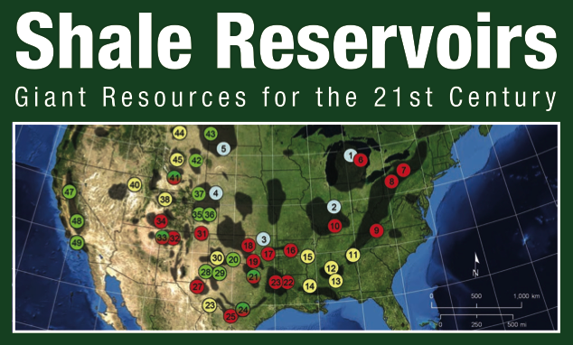
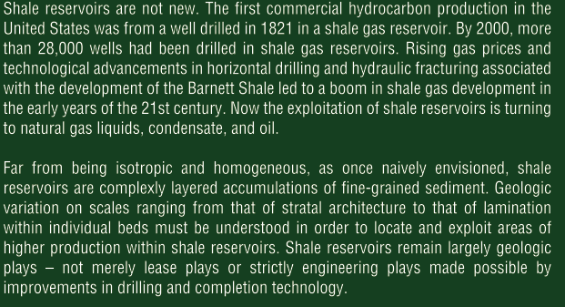

Table of Contents
Copyright ........................................................... ii BookEditorial ........................................................ iii AbouttheEditors...................................................... iv NotetotheReader..................................................... ix Introduction. ......................................................... 1
-1-Extended Abstract—Shale Resource Systems for Oil and Gas
Daniel M. Jarvie 5
-2-Extended Abstract—Pore-to-regional-scale Integrated Characterization Workflow for Unconventional Gas Shales
Roger M. Slatt, Paul R. Philp, Younane Abousleiman, Prerna Singh, Roderick Perez, Romina Portas, Kurt J. Marfurt, Steven Madrid-Arroyo, Neal O’Brien, Eric Eslinger, and Elizabeth T. Baruch 11
-3-Extended Abstract—A Method for Evaluating the Effects of Confining Stresses and Rock Strength on Fluid Flow along the Surfaces of Mechanical Discontinuities in Low-permeability Rocks
Milton B. Enderlin and Helge Alsleben 15
-4-Extended Abstract—The Appalachian Basin Marcellus Gas Play: Its History of Development, Geologic Controls on Production, and Future Potential as a World-class Reservoir
William A. Zagorski, Gregory R. Wrightstone, and Douglas C. Bowman 19
-5-Extended Abstract—Resource Assessment of the Marcellus Shale
Richard Smosna and Kathy R. Bruner 21
-6-Extended Abstract—Geologic Model for the Assessment of Technically Recoverable Oil in the Devonian–Mississippian Bakken Formation, Williston Basin
Richard M. Pollastro, Laura N. R. Roberts, and Troy A. Cook 25
-7-Extended Abstract—Ancient Microbial Gas in the Upper Cretaceous Milk River Formation, Alberta and Saskatchewan: A Large Continuous Accumulation in Fine-grained Rocks
Neil S. Fishman, Jennie L. Ridgley, Debra K. Higley, Michele L. W. Tuttle, and Donald L. Hall 29
-8-Extended Abstract—Carbonate Lithologies of the Mississippian Barnett Shale, Fort Worth Basin, Texas
Kitty L. Milliken, Ruarri J. Day-Stirrat, Petro K. Papazis, and Christian Dohse 35
-9-Extended Abstract—Lithology of the Barnett Shale (Mississippian), Southern Fort Worth Basin, Texas
Philip J. Bunting and John A. Breyer 41
-10-Extended Abstract—Shale Wedges and Stratal Architecture, Barnett Shale (Mississippian), Southern Fort Worth Basin, Texas
Rachael M. Monroe and John A. Breyer 47
-11-Extended Abstract—Lithologic and Stratigraphic Variation in a Continuous Shale-gas Reservoir: The Barnett Shale (Mississippian), Fort Worth Basin, Texas
John A. Breyer, Philip J. Bunting, Rachael M. Monroe, and Michael B. Steed 53
-12-Extended Abstract—Outcrop-behind Outcrop (Quarry): Multiscale Characterization of the Woodford Gas Shale, Oklahoma
Roger M. Slatt, Nichole Buckner, Younane Abousleiman, Rafael Sierra, Paul R. Philp, Andrea Miceli-Romero, Romina Portas, Neal O’Brien, Minh Tran, Robert Davis, and Timothy Wawrzyniec 59
-13-Extended Abstract—Seismic Stratigraphic Analysis of the Barnett Shale and Ellenburger Unconformity Southwest of the Core Area of the Newark East Field, Fort Worth Basin, Texas
Elizabeth T. Baruch, Roger M. Slatt, and Kurt J. Marfurt 63
-14-Extended Abstract—Petrophysics in Gas Shales
Eric Eslinger and Robert V. Everett
CD-ROM MATERIAL
Chapter1–Part1 . 69
Shale Resource Systems for Oil and Gas: Part 1—Shale-gas Resource Systems
Daniel M. Jarvie
Chapter1–Part2 . 89
Shale Resource Systems for Oil and Gas: Part 2—Shale-oil Resource Systems
Daniel M. Jarvie
Appendix... 120
Appendix to Chapter 1
Daniel M. Jarvie
Chapter 2. 127
Pore-to-regional-scale Integrated Characterization Workflow for Unconventional Gas Shales
Roger M. Slatt, Paul R. Philp, Younane Abousleiman, Prerna Singh, Roderick Perez, Romina Portas, Kurt J. Marfurt, Steven Madrid-Arroyo, Neal O’Brien, Eric Eslinger, and Elizabeth T. Baruch
Chapter 3 151
A Method for Evaluating the Effects of Confining Stresses and Rock Strength on Fluid Flow along the Surfaces of Mechanical Discontinuities in Low-permeability Rocks
Milton B. Enderlin and Helge Alsleben
Chapter 4. 172
The Appalachian Basin Marcellus Gas Play: Its History of Development, Geologic Controls on Production, and Future Potential as a World-class Reservoir
William A. Zagorski, Gregory R. Wrightstone, and Douglas C. Bowman
Chapter 5.. 201
Resource Assessment of the Marcellus Shale
Richard Smosna and Kathy R. Bruner
Chapter 6 205
Geologic Model for the Assessment of Technically Recoverable Oil in the Devonian–Mississippian Bakken Formation, Williston Basin
Richard M. Pollastro, Laura N. R. Roberts, and Troy A. Cook
Chapter 7 258
Ancient Microbial Gas in the Upper Cretaceous Milk River Formation, Alberta and Saskatchewan: A Large Continuous Accumulation in Fine-grained Rocks
Neil S. Fishman, Jennie L. Ridgley, Debra K. Higley, Michele L. W. Tuttle, and Donald L. Hall
Chapter 8 290
Carbonate Lithologies of the Mississippian Barnett Shale, Fort Worth Basin, Texas
Kitty L. Milliken, Ruarri J. Day-Stirrat, Petro K. Papazis, and Christian Dohse
Chapter 9 322
Lithology of the Barnett Shale (Mississippian), Southern Fort Worth Basin, Texas
Philip J. Bunting and John A. Breyer
Chapter 10 344
Shale Wedges and Stratal Architecture, Barnett Shale (Mississippian), Southern Fort Worth Basin, Texas
Rachael M. Monroe and John A. Breyer
Chapter 11 368
Lithologic and Stratigraphic Variation in a Continuous Shale-gas Reservoir: The Barnett Shale (Mississippian), Fort Worth Basin, Texas
John A. Breyer, Philip J. Bunting, Rachael M. Monroe, and Michael B. Steed
Chapter 12 382
Outcrop-behind Outcrop (Quarry): Multiscale Characterization of the Woodford Gas Shale, Oklahoma
Roger M. Slatt, Nichole Buckner, Younane Abousleiman, Rafael Sierra, Paul R. Philp, Andrea Miceli-Romero, Romina Portas, Neal O’Brien, Minh Tran, Robert Davis, and Timothy Wawrzyniec
Chapter 13 403
Seismic Stratigraphic Analysis of the Barnett Shale and Ellenburger Unconformity Southwest of the Core Area of the Newark East Field, Fort Worth Basin, Texas
Elizabeth T. Baruch, Roger M. Slatt, and Kurt J. Marfurt
Chapter 14 419
Petrophysics in Gas Shales
Eric Eslinger and Robert V. Everett

extraits
Chapter 4
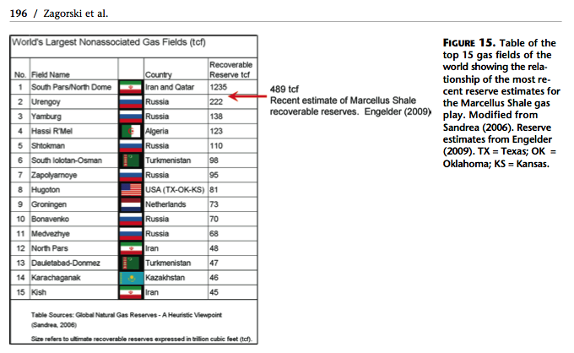

chapter 5
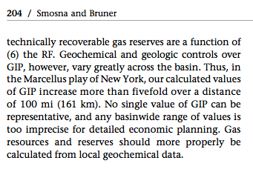

Chapter 6
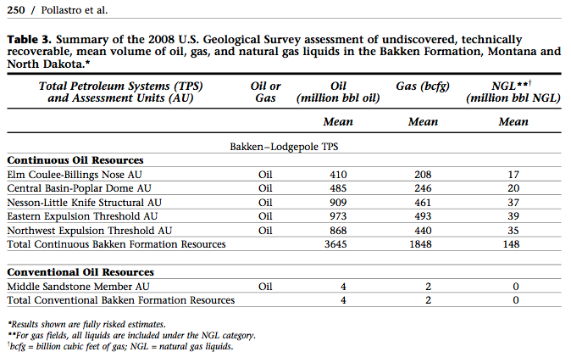

chapter 14
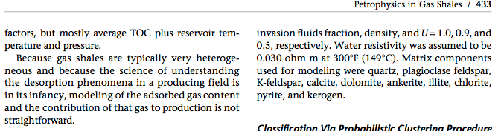

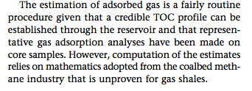

extended abstracts

-1
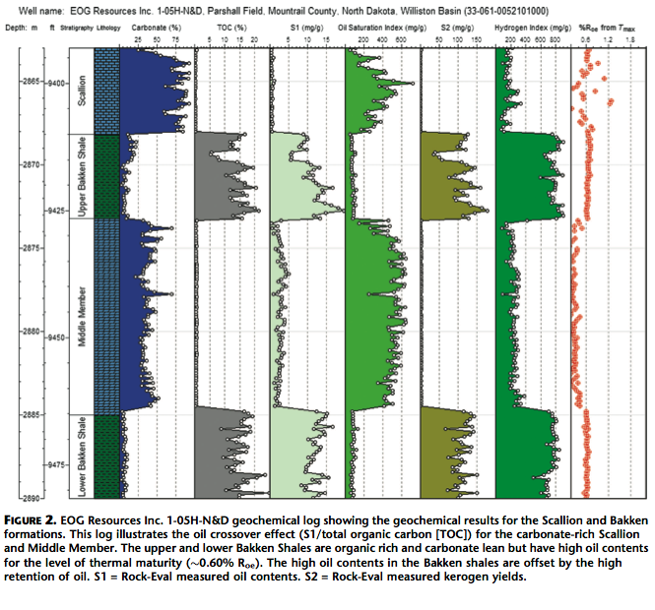

-4
the premier shale plays in North America, rivaling other established shale plays in terms of production rates, economic potential, and total extent. The modern era of Marcellus Shale production in the Appalachian Basin began in October 2004 when the Range Resources 1 Renz unit well in Washington County, Pennsylvania, was completed using a large Barnett Shale style water frac. The play has attracted independents, major oil companies, and international interest. The Marcellus Shale has a prospective area of approximately 114,000 km2 (44,000 mi2). Since 2004, coinciding with the initial Marcellus discovery in Washington County, Pennsylvania, more than 7100 Marcellus wells have either been permitted or drilled through June 2010 in the Appalachian Basin, and activity is expected to escalate during the next several years.
The GIP estimates for the Marcellus play range from 40 bcf/mi2 to more than 150 bcf/mi2. This compares favorably with those of other prominent shale plays. The current development of the Marcellus Shale appears to be associated with areas with GIP values of greater than 50 bcf/mi2
The reserve potential is enormous, with estimates ranging from 50 to more than 500 tcf, defining the Marcellus as a major world-class hydrocarbon accumulation. Engelder and Lash (2008) provided early recognition of the world-class potential of this resource. The reserve potential for the top 15 gas fields ranges from 40 to 1400 tcf.

-5
Recent published assessments of gas in place (GIP) for the Marcellus Shale range over an order of magnitude from 20 to 150 bcfg/mi2 and from 168 to 2455 tcfg for the total play.

-6
The first oil discoveries in the Bakken occurred in the early 1950s at Antelope field in McKenzie County, North Dakota (LeFever, 1991), on the Nesson anticline, one of the Williston Basin’s largest and most petroleum-productive structures (Figure 1B). Since 2000, two significant discoveries have greatly heightened the level of Bakken exploration, production, and future recoverable resource potential: (1) the Elm Coulee field, Richland County, Montana, in 2000; and (2) the Parshall field, Mountrail County, North Dakota, in 2006 (Figure 1B).
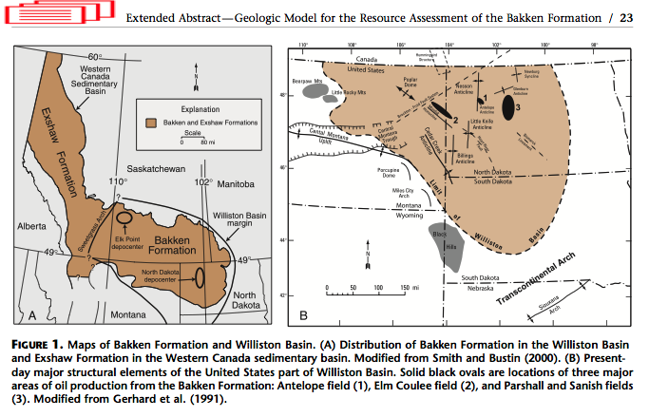

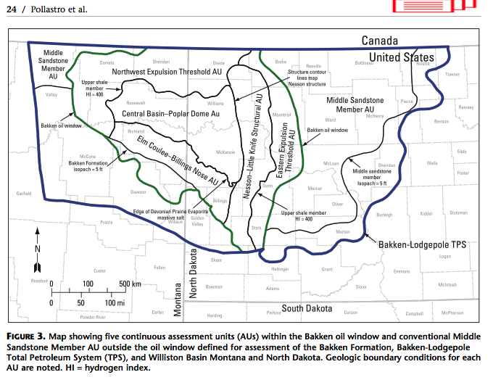

-9
Many operators consider the dark organic-rich mudrocks that comprise shale reservoirs to be homogeneous, widespread, and continuous stratigraphic units. However, significant lithologic and stratigraphic variation is probably present in most shale reservoirs. The success of fracture stimulation techniques in the Barnett Shale (Mississippian) in the Fort Worth Basin must at least, in part, reflect the highly siliceous nature of the shale. More typical clay- rich shales in other basins are likely to be more ductile and less brittle. Such subtle variation, which is not readily apparent from macroscopic inspection of core or cursory examination of well logs, probably explains the need to develop different completion techniques for each shale reservoir. Understanding lithologic and stratigraphic variation within shale reservoirs is the key to optimizing completion techniques and maximizing the recovery of natural gas.

-13
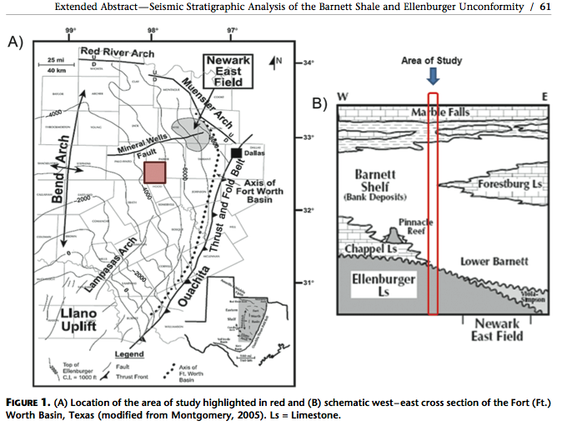

-Introduction
‘‘Where oil is first found, in the final analysis, is in the minds of men.’’
Wallace E. Pratt, 1952
‘‘Several times in the past we have thought that we were running out of oil, when actually we were running out of ideas.’’
Parke A. Dickey, 1958
In the early 1970s, most exploration geologists the United States considered subeconomic or margin- ally economic petroleum resources such as coalbed methane, shale gas, and tight-gas sands as unconventional resources (Law and Curtis, 2002). Tax incentives and federally funded research beginning in the late 1970s helped make these resources economically viable in the last two decades of the 20th century. Economics aside, two important geologic attributes characterize most unconventional petroleum re- sources (Law and Curtis, 2002). Conventional petroleum systems are buoyancy-driven accumulations found in structural or stratigraphic traps, whereas most unconventional systems exist independent of a water column and are generally not found in structural or stratigraphic traps.
in
Shale reservoirs are not new. The first commercial hydrocarbon production in the United States was from a well drilled in a fractured shale gas reservoir in 1821 by William A. Hart to supply gas for lighting the town of Fredonia, New York (Roen, 1993). The well produced from the Upper Devonian Dunkirk Shale.
By the year 2000, more than 28,000 wells had been drilled in shale-gas reservoirs and these wells were producing nearly 380 BCF of natural gas annually (Hill and Nelson, 2000). At that time, the principal shale-gas systems in the United States were the Antrim Shale (Devonian) of the Michigan basin, the Ohio Shale (Devonian) in the Appalachian basin, the New Albany Shale of the Illinois basin, the Barnett Shale (Mississippian) in the Fort Worth basin, and the Lewis Shale (Cretaceous) in the San Juan basin (Curtis, 2002). Rising gas prices and technological advancements in horizontal drilling and hydraulic fracturing associated with the development of the Barnett led to a boom in shale-gas development in the early years of the 21st century.
Steward (2007) details the development of the Barnett Shale play from the first well drilled by Mitchell Energy specifically targeting the Barnett in 1981 to the merger of Mitchell Energy and Devon Energy in 2002. A boom followed — lease prices in some areas of the Barnett play briefly surpassed $30,000 per acre. Development of the Fayetteville Shale in the Arkoma basin followed almost immediately in 2003 and 2004. The frenzy spread with the drilling of the first well in the Haynesville Shale (Jurassic) in northwest Louisiana and East Texas in 2006. At the same time, a sleeping giant was awakening east of the Mississippi with drilling in the Marcellus Shale and other eastern shale-gas reservoirs. Petrohawk opened the Eagle Ford Shale (Cretaceous) play in South Texas in 2008 with the discovery of Hawkville (Eagle Ford) field in La Salle County. Prospective shale-gas plays also emerged in Canada with EOG, EnCana, and Apache pursuing the Muskwa Shale in the Horn River basin of British Columbia. Reserve estimates from the Marcellus Shale and other eastern shale-gas plays in the Appalachian basin have led to increases in domestic reserves almost unimaginable just a decade ago.
The Energy Information Agency (EIA) of the Department of Energy began tracking shale gas separately from other gas resources in 2008. In 2009, the United States produced 26.01 TCF of natural gas with 3.38 TCF coming from shale-gas reservoirs. Proved re- serves of shale gas reached 60.6 TCF by year-end 2009 out of a total proved natural gas reserves of 283.9 TCF. The EIA Annual Energy Outlook 2011 estimates the United States has 2552 TCF of technically recoverable unproved natural-gas resources with 827 TCF in shale gas reservoirs. The 2010 report estimated only 347 TCF of technically recoverable unproved gas resources in shale reservoirs. Although the dramatic increase in shale-gas resource estimates has generated some controversy and been questioned by several experts, the United States apparently has an abundant supply of natural gas at current rates of usage — almost 23 TCF annually. The International Energy Outlook 2010 projects shale reservoirs to provide 26% of United States domestic supply of natural gas by 2035.

Oil production from the Bakken Formation (Devono-Mississippian) in the Williston basin has increased, although most production is from carbonate reservoirs in the Middle Bakken, not necessarily the shales in the Upper and Lower Bakken. In 2008 the United States Geological Survey estimated technically recoverable reserves of oil in the Bakken in North Dakota and Montana to range from 3 to 4.3 billion barrels. This estimate is 25 times higher than the estimate made in 1995. However, the Bakken (and the Niobrara) might best be considered hybrid or conventional petroleum systems rather than unconventional petroleum systems (Hill et al., 2011). Production is mainly from low quality carbonate reservoirs, not shale. In contrast, oil production from the Barnett Shale and Eagle Ford Shale is mainly from shale reservoirs. It seems improbable, but what if oil reserves in domestic shale reservoirs alter the domestic energy supply as much as gas reserves in shale reservoirs have?

