Nuclear Power Seen from the View Point of an Environmentalist

Presentation given at Ottawa, March 19th, 2003 (text #1)

by B. Comby
President of EFN, Association of Environmentalists For Nuclear Energy, www.ecolo.org ⁽¹⁾

Abstract : Some environmental organizations, exploiting irrational fears or following political agendas, rather than basing their action on scientific facts, tend to oppose nuclear energy, but not all of them do so however. Nuclear reactors use very little uranium (or thorium) as fuel which is widely distributed in the Earth's crust. They produce very little waste, which are confined, and are or can be recycled. They produce large amounts of energy without contributing significantly to global warming. Nuclear energy therefore has some great benefits for the protection of the environment. In fact, the use of properly designed and well managed nuclear energy is quite clean. This paper presents the view point of Bruno Comby, a world-famous environmental author, who is the founder and President of the Association of Environmentalists For Nuclear Energy (www.ecolo.org), which now gathers more than 5000 members and supporters with local correspondents in more than 40 countries.

__________________________________________

“I personally believe that mankind needs nuclear energy. It must be developed, but with absolute guarantees of safety.”

ANDREI SAKHAROV⁽²⁾

Today, many environmental organizations oppose nuclear energy. They offer many reasons to explain why nuclear energy would be dangerously unsafe, unclean, even anti-democratic; and why it should be considered as an energy with no future.

I am an environmentalist and for the last 20 year I have devoted my life to promoting a better life-style and to the protection of the environment; and I have some knowledge in the field of energy. I propose a new view point, based on solid scientific and environmental facts, rather than on irrational dogmas or political agendas. My point is to show that, for environmental reasons, well-built and well-operated nuclear energy is in fact very ecological and should be a central pillar to supply the planet's energy needs in a clean manner. Nuclear fission will satisfy the thirst for energy of the industrial countries and at the same time help to conserve fossil hydrocarbon resources for higher uses than just to be burned as fuel.

While many environmental groups continue to criticize nuclear energy, and even influence political decisions of some countries, this new environmental view point leads to the conclusion that nuclear fission is in fact the safest and cleanest energy available, that it will be absolutely necessary in the 21st century, and that it should be more actively developed to satisfy the world's energy needs.

The world's population is growing and the planet's energy needs are increasing also
Today the world has 6 billion inhabitants, and a quarter of the world's population in the richest countries consumes three quarters of the energy, leaving the remaining one quarter to satisfy the needs of three-quarters of the population. This is not a stable situation and is bound to change. We may expect to see rapid industrial development of China and India, and continued development in Southeast Asia, in South America and even in Africa. The world population is increasing constantly and may well double by 2050. Taken together, the industrialization and development of non-industrial countries and the increase in world population will dramatically increase the global consumption of energy, the use of fossil fuels and the production of carbon dioxyde dumped into the atmosphere. The world is thirsty for more energy and this growth is inevitable, even if developed countries were able to reduce their energy consumption by adopting stringent conservation measures. The question is to determine how to produce enough energy to satisfy the world's needs, in a sustainable manner, without harming our environment, without heating up the atmosphere and without putting the planet at risk.

The different types of energy available
Fossil energies (coal, oil and gas) are the most widely consumed sources of energy today. World reserves of oil and gas will last for decades at the present rate of consumption, while coal will last for a few centuries. They contribute massively to the greenhouse effect, especially coal. Fossil fuels cannot, alone, face the growing needs of humanity. The top priority should be to reduce our dependance on these energies.
Hydro-electric power is renewable, but there are only a limited number of suitable sites: most of them are already developed and so the potential for the future is very limited. With the world-wide increase in consumption, the share of hydraulic energy is expected to decrease in the 21st century, even if we assume that all possible sites are developed. Hydraulic dams also have a strong impact on the environment, often flooding entire valleys, and they are not without risk of major accident. Although nuclear energy and hydraulic dams now produce similar amounts of electricity, dam failures have killed many more people than nuclear accidents. For example, the failure of the dam at Malpasset in France on December 2nd, 1959, set loose a 40-meter high wave which entirely destroyed the village of Malpasset and flooded the city of Frejus, 30 kilometers downstream. In a few minutes it killed 429 people -10 times more than the nuclear accident at Tchernobyl.

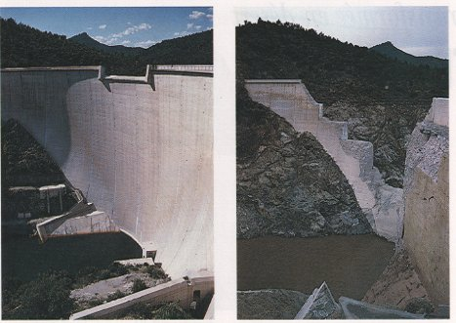

Other renewable energies (solar, wind, etc.) an contribute to some small extent, and they should be encouraged, for suitable applications. They are dilute in space and variable in time, and cannot be counted on to contribute significantly to the needs of our industrial societies. They produce watts or kilowatts, the biggest wind turbine produces 3 megawatts at full power, while the economy is consuming gigawatts and terawatts. Solar and wind energies can be well adapted for low-temperature heating and local low intensity domestic electrical power, but they are not very interesting for generating electricity to be distributed on the grid. For domestic hot water, for example, solar heating by direct circulation of water in pipes exposed to the sun is quite adequate. In the tropics, and in some of the poorest countries such as Madagascar, simple solar cookers could replace firewood and help slow deforestation.

Nor are solar and wind energies ecologically acceptable on an industrial scale. A global "life cycle analysis" of different types of energy systems shows that solar and wind are largely disqualified because of the amount of energy and construction materials needed to develop such installations over large surfaces, not to speak of the effect on the landscape.

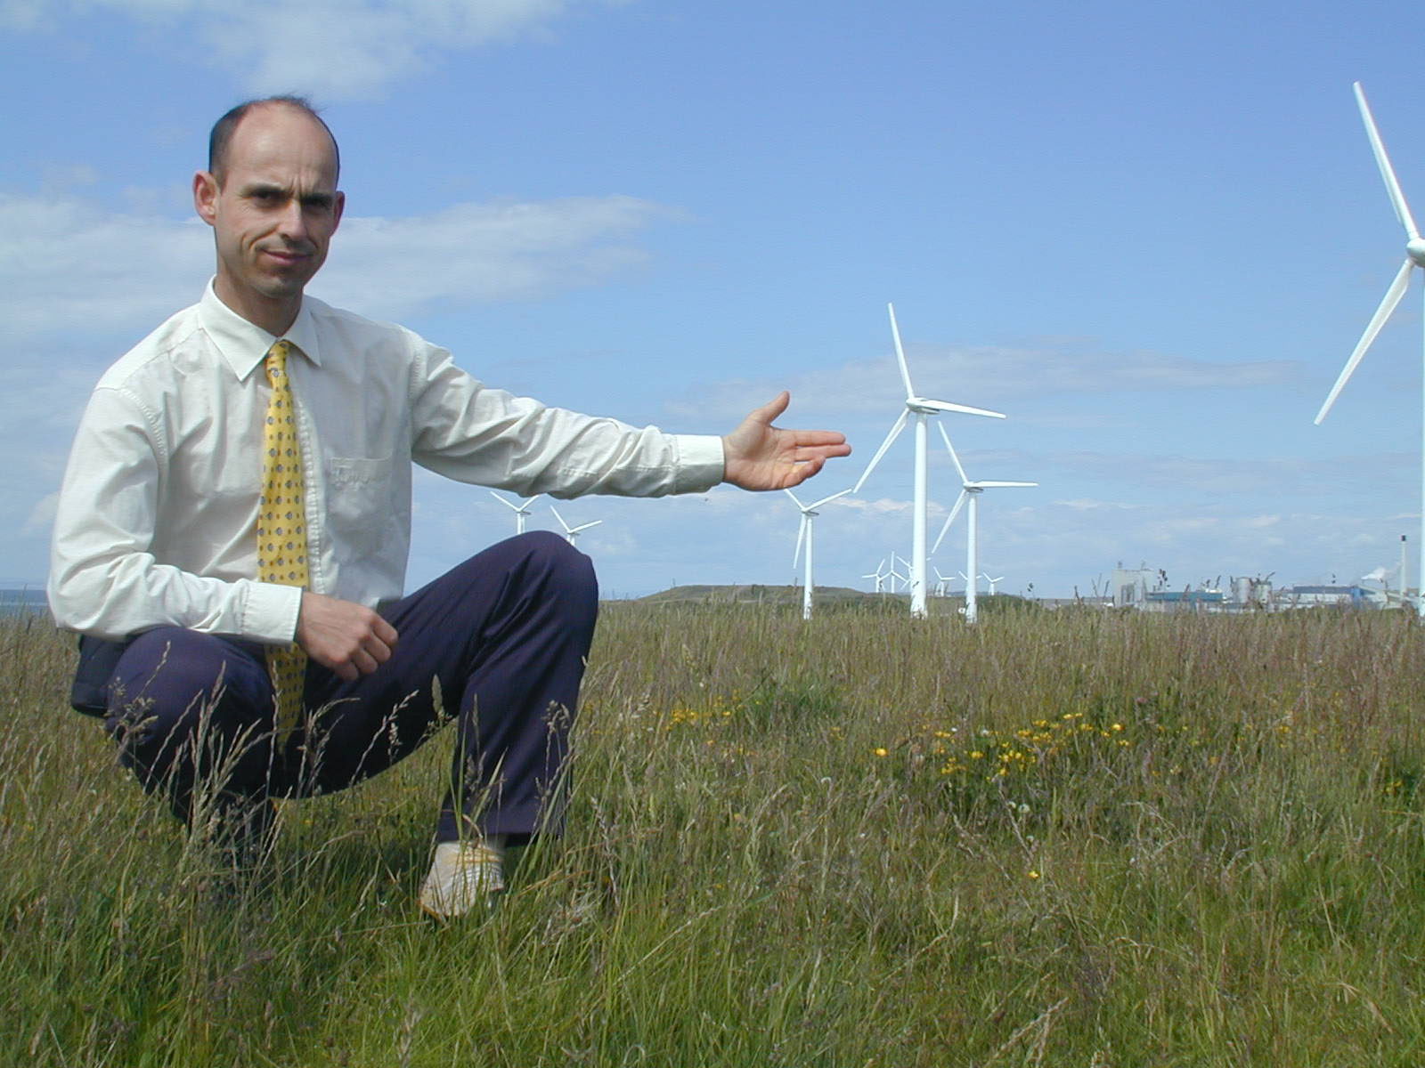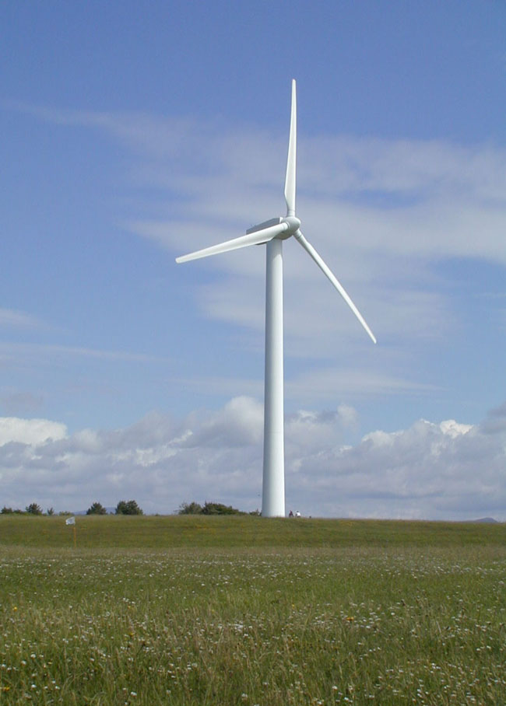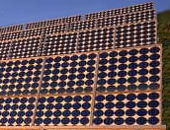
Renewable energies other than hydraulic should be encouraged, but they produce only small amounts of non-constant energy. The only alternative to produce significant amounts of clean energy is nuclear energy.

Radioactivity in nature
Radioactivity exists everywhere in nature. We are exposed continuously to natural radiation coming from the sun, to cosmic radiation from the heavens, to telluric radiation from the earth beneath our feet, and even to the internal radiation of our own body. The radioactivity of the average adult body is about 10 000 becquerels, due to naturally occurring carbon-14 and potassium-40; it produces about 0.17 mSv/year of ionizing radiation.

The natural background radiation varies considerably from place to place. The average is about about 2 mSv/year. But in some areas, such as Guarapari in Brazil, the radiation can be locally as high as 400 times the average. In Ramsar, in northern Iran, some people are exposed to natural radioactivity at the level of 260 mSv/year. No adverse effect has ever been attributed to this high natural background, and indeed some believe there may be positive effects. For half a century, from the discovery of Xrays and radioactivity in the 1890s until Hiroshima in 1945, radiation therapy had a secure place in the medical armamentarium. Even plutonium exists in nature, where it is continually produced by cosmic ray neutrons bombarding the uranium in the Earth's crust.

Although the highest levels of natural radiation do not seem harmful in any way, we must nonetheless be careful to protect the population and nuclear workers from exposure to very high levels of radioactivity.

The high density of nuclear power
One gram of uranium or plutonium or thorium yields as much energy as one ton of oil. Nuclear energy is therefore much more concentrated than chemical energy - by a factor of one million. This is often seen as a danger, but this "factor of one million" also implies considerable ecological benefits : to produce a given amount of energy, the volume of fuel is one million times smaller, and the volume of the waste produced is also one million times smaller; it is therefore much easier to handle, to reprocess and eventually to dispose of.

Nuclear waste
Nuclear waste is produced in very small amounts (compared to fossil energy waste), and it is, by definition, self-degradable over time, which is not the case for toxic stable chemical substances. Because the volume of nuclear waste is small, it can be easily confined and stored, rather than being ejected into the biosphere. Nuclear waste can and should be reprocessed, and the ultimate radioactive waste - only about 3% of the used fuel for PWR's - can be safely stored underground in a carefully chosen repository. The uranium deposits at Oklo in Gabon, which were critical nuclear reactors two billion years ago, show us that the fission products hardly migrate at all in the soil. Ethically, we must find a safe way to dispose of these small volumes of initially highly radioactive waste, and morally it is our duty that this be done by the same generation which builds and operates the NPP's and benefits from it's electricity.

For ecological reasons, spent nuclear fuel should not be considered as waste; it should be reprocessed, as is the practice in France, Great Britain, Russia and Japan.

This cylinder represents the volume of high-level vitrified long-lived radioactive waste resulting from the nuclear fuel that would produce enough electricity to meet the needs of a typical family in all-electric housing with modern conveniences - heating, cooking and other household appliances - for about 30 years. Nuclear waste is not discharged into the environment, but carefully confined. If it is buried deep underground, it is harmless to man and to the environment. Nuclear waste is very compact and its radioactivity decreases very rapidly in the first years.

The example of France
In France, 80% of the electricity is nuclear. As an environmentalist, I am very proud to be a citizen of the country with the greatest production of nuclear electricity. We are among the cleanest of all developed countries. A French citizen ejects into the atmosphere about half the amount of carbon dioxyde as a German or a Dane -- Danish windmills don't produce enough energy to significantly reduce their emissions - and three times less than an American. Every year, thanks to France's 58 nuclear reactors, 200 million tons of CO2 are NOT injected into the earth's atmosphere. France shows the world the extent to which nuclear energy can contribute to the protection of the environment.

Informing the public
There are still many myths about nuclear energy. It is essential for the future, and for a cleaner planet, that the public be better informed; and much remains to be done in this area. But this information should be deliverd in a complete, reasoned and straightforward manner. Environmental organizations can and should play a major role in this regard, because they are the most appropriate organizations when it comes to speaking about the environment; however they should avoid manipulating the public opinion with scary highly unrealistic scenarios as some anti-nuclear organizations often do. It is now a vital issue for all mankind; as Dr Yumi Akimoto nicely writes, the time has come to "dispel the many myths surrounding atomic energy that have been created by international intrigue and power struggles, individual ambition and sensationalism, and release ... (citizens) ... from the misunderstandings and confusion created by scientists and statesmen with narrow views." (3)

Conclusion
Well-built and well-operated nuclear reactors are a very safe and very clean source of energy for the future. We must be sure that our reactors are safe, that no one is exposed to high levels of radiation and that no nuclear materials are diverted to military use. But people must learn that they need not fear the small quantities of radioactivity which may escape, trivial compared to the natural background which has bathed the whole of the universe since the very beginning of its existence. James Lovelock, author of the Gaia Theory and one of the founders of modern environmentalism, has written "Life began nearly four billion years ago under conditions of radioactivity far more intense than those that trouble the minds of certain present-day environmentalists. Moreover, there was neither oxygen nor ozone in the air so that the fierce unfiltered ultra-violet radiation of the sun irradiated the surface of the Earth. We need to keep in mind the thought that these fierce energies flooded the very womb of life. I hope that it is not too late for the world to emulate France and make nuclear power our principal source of energy. There is at present no other safe, practical and economic substitute for the dangerous practice of burning carbon fuels." (4)

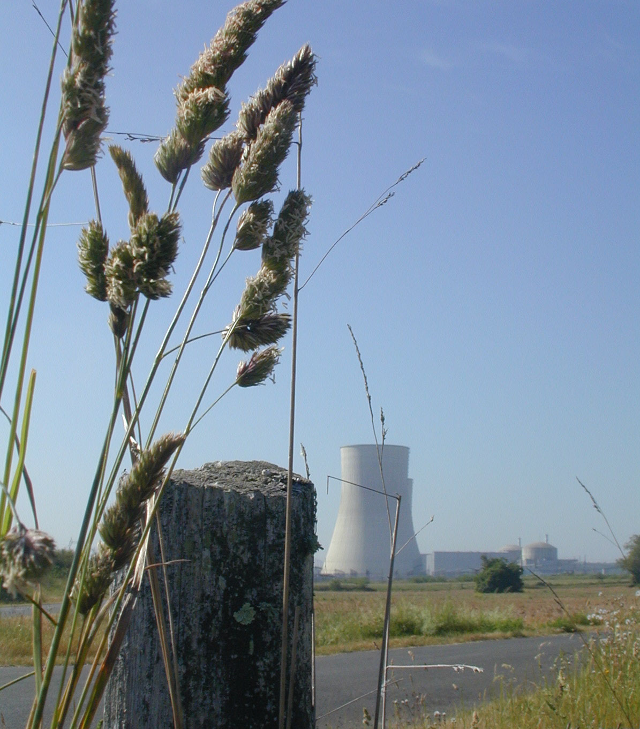 The Civaux nuclear power plant in France.

____________

NOTES :

(1) EFN : Association of Environmentalists For Nuclear Energy - www.ecolo.org - EFN is a non-governmental, non-political international organization gathering more than 5000 members and supporters in more than 40 countries.

(2) Andrei Sakharov, in his foreword to “The Truth about Chernobyl,” by Grigori Medvedev, translated from the Russian by Evelyn Rossiter, I. B. Tauris & Co Ltd, London - New York (May 1989). Jacques Frot has moderated this absolutist statement writing "Engineers and environmentalists should work toward Sakharov's objectives of absolute nuclear safety, theoretically and practically inaccessible, but the permanent goal of responsible industry." Epigraph in the book "Environmentalists For Nuclear Energy", TNR Editions, Paris, 2001.

(3) Dr Yumi Akimoto, in his introduction to the Japanese edition of the book "Environmentalists For Nuclear Energy", published in Japan by ERC SHUPPAN Publishing Co., April 2002.

(4) Professor James Lovelock, in his preface to the book "Environmentalists For Nuclear Energy", TNR Editions, Paris, 2001 (detailed presentation of the book at : www.ecolo.org)

