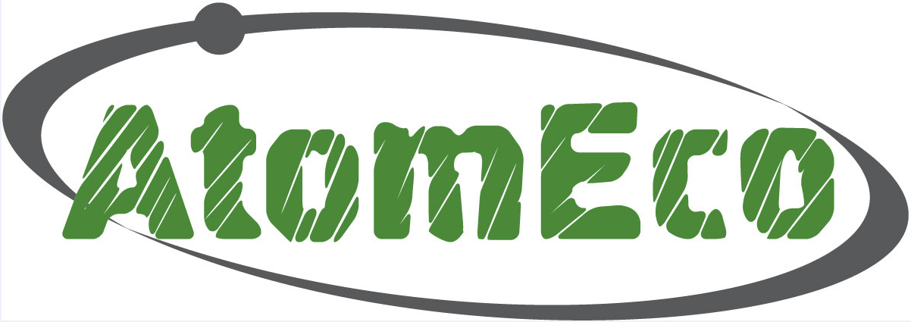

Atomeco-2011 Conference Delegate’s Memo

Dear Atomeco-2011 Conference Delegate!

Thank you for the cooperation and please be reminded that Atomeco-2011 International Forum will be held on October 31 – November 1, 2011 in Moscow World Trade Centre at the address: entrance 4, 12 Krasnopresnenskaya embankment, Moscow, Subway stations: Vystavochnaya, Ulitsa 1905 Goda (For directions, please, refer to the Forum’s website http://atomeco.ru/english/place).

The Conference will be held in parallel with the Exhibition «Atomeco-2011», and all Conference delegates will have free access to the Exhibition venue.
- Conference and Exhibition working hours: October 31 – November 1, from 10:00 till 18:00;
- Conference Participants registration: October 31 – November 1, from 09:00 till 16:00 at the Registration Desk;
- Conference Plenary Session: October 31 from 10:00 till 12:00 at the Conference Hall №1;
- Forum Opening Ceremony: October 31 on 12:00;
- Evening Reception will be held on October 31 from 18:30 at Evropeysky Restaurant (1st floor, MWTC). Please see the invitation to the Reception in the Conference Delegate’s Briefcase.

A welcoming coffee-break will be served for the Conference Delegates on October 31, from 9:00 till 10:00; coffee-breaks and lunches will be also served during the Conference days.
Please, refer to an updated Conference Programme on the Forum’s website: http://atomeco.ru/english/conference2011/programme2011
Please, be aware that all Conference participation fees must be paid in full by the time the Conference starts. Attendees who failed to pay the participation fee will not be allowed to the Conference.
After the registration, you will be issued Delegate badge allowing you to pass all the Forum venues. Conference Delegate’s Briefcase with Conference papers will also be given to each Delegate at the Registration Desk. To get a Conference Delegate’s Badge, please, provide an ID or business card. Please, be sure to submit signed originals of the Application Agreement as stamped and provided with banking information.
Please, forward the organizers an electronic version of your presentation! It may be handed out to our manager in the Conference Hall where the presentation will take place.

Please, contact our responsible managers to solve arising issues on site:

Manager | Area of responsibility | Phone
Diana ALIEVA | Conference participation organization, Collection of presentations | +7 963 674 29 57
Anna ANTONOVA | Conference participation payment, contract payment, act of executed work preparation | +7 926 334 59 99

We wish you successful work at the Conference!
Sincerely yours,
Atomeco-2011 Forum Directorate

How to get to Moscow World Trade Centre

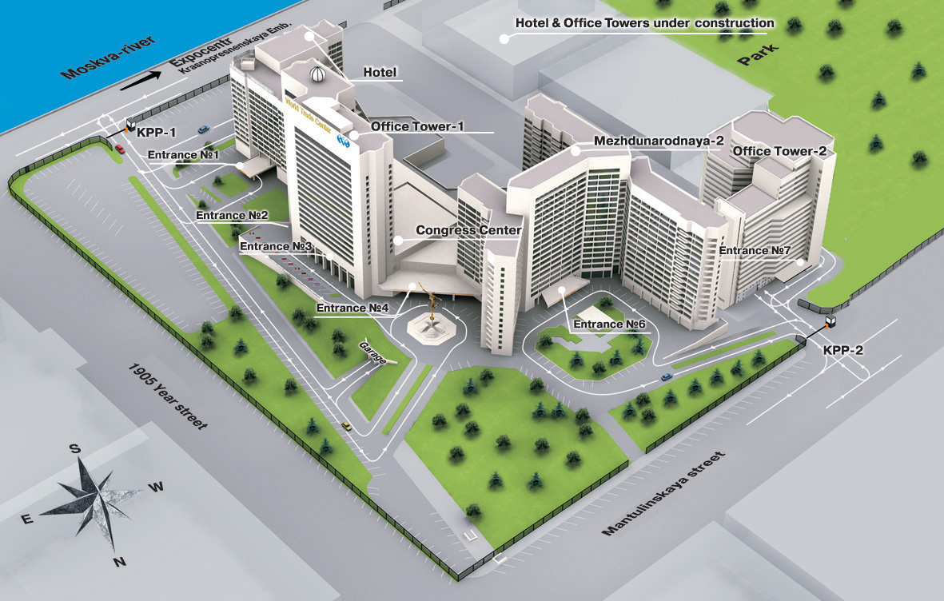

Atomeco-2011 Floor Plan: Exhibition and Conference Halls

