The 'ECO House':

Producing 99% less CO₂ From HOME HEATING

From "Green Building: What Solutions?"
Symposium hosted by: Françoise DUTHEIL, President of 'RADICAL ECOLOGY'
Abstract with the help of Claire BRAZILLIER, Annie WALLET and Simone BRUNET
RADICAL ECOLOGY, FRENCH SENATE, PALAIS DU LUXEMBOURG, 27 January 2009
Translated by Stephen Stretton with help from Google.
Original authors' rights reserved

Bruno Comby built a home to meet ecological criteria, with very low power consumption, cost competitive, but with all the comforts of a modern house. This house is located in the Paris suburb of Houilles.

Bruno Comby wanted an ecologically friendly house: thermally efficient, comfortable and easy to build by companies and artisans using commonly-available building materials. He designed a home which can be built by normal workers and masons. His house looks like an ordinary house with virtually no differences in visual appearance, apart from a few details that only specialists will notice.

The heat losses of a standard dwelling are split as follows:
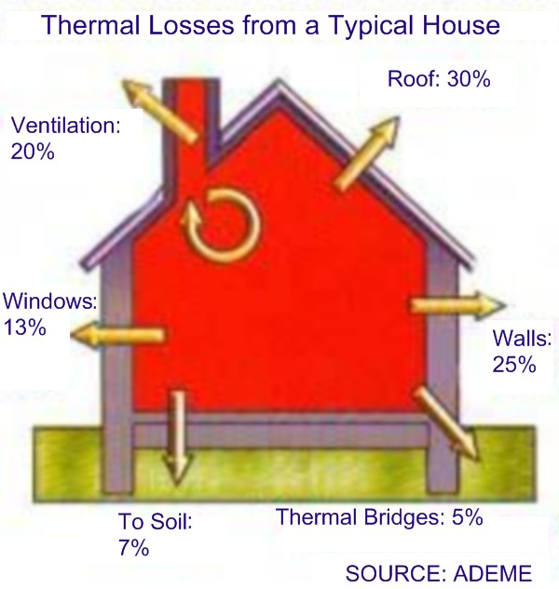
So designers must consider each of these different areas in order to minimize losses.

Taking as reference the calculation of typical heat losses consistent with the thermal regulations currently in force in France (RT2005), here are the details of in energy savings made by the choices selected for the eco-house:

- Insulation under the roof, with 30 cm of glass wool of high quality two-layer cross between and under rafters, equivalent to 45 cm of glass wool, instead of regular 15 cm of glass wool in ordinary roof: the effectiveness of the insulation being multiplied by 3, total heat savings of 2/3 of 30% = 20%
- Insulation of exterior walls of the house with 10 cm of high performance glass wool equivalent to 15 cm of traditional glass wool instead of regular 8 cm + building with bricks of type Monomur MURBRIC POROTHERM whose thermal conductivity is about 10 times less than that of breeze bocks, laid with thin joints of 1 mm can also save on mortar and laying time ; the savings due to better wall insulation are 70% of 25% = 17.5%
- Double flux ventilation : recovers over 90% of heat from the ventilation air (20% of total heat loss), a saving of 90% of 20% = 18%
- Glazing insulation compared to double glazing 4/16/4, with treatment which absorbs infra-red and a layer of argon between two panes to improve insulation; the extra cost compared to double glazing is low and allows a saving in the house’s total heat use of approximately 30% of 13% = 4%
- Reduction or elimination of thermal bridges using insulation by adding about 8 cm of extruded polystyrene placed at the junction between exterior walls and inside walls or floors: a saving of 40% of 5% = 2%.
- Better insulation of ground floor and basement: saving of 40% of 7% = 3%
- Canadian well (circulating the ventilation air underground at 3 meter depth in a 20cm diameter pipe , 100 meter long running underground before letting the ventilation air enter the house): allows almost free air conditioning in summer and a significant reduction in heat loss in winter (about half the heat loss by ventilation), a figure to be reduced to 1% (only half of 2% in our case with a double-flux ventilation), another 1%.

The total reduction in the house’s heat losses resulting from this type of construction therefore adds up to 65.5% regardless of the heating mode chosen.

This is an energy saving factor of 3 – regardless of the mode of heating (heat pump, fire wood, electricity, gas, or coal), the house consumes three times less energy.

Heating side, the choice fell on a heat pump with an excellent coefficient of performance of 5 for maximum energy savings.

As a result of these cumulative choices : construction techniques and the choice of a superior heat pump for heating, this green house consumes 3 x 5 = 15 times less energy than the same house built in accordance with the standards currently in force.

As for CO₂, electricity in France is almost entirely nuclear and hydro, reducing CO₂ emissions from electricity by more than 90%. The total emissions of this house from heating are therefore less than one hundredth of the standard CO₂ emissions of a modern house compliant to the most recent French thermal regulations (RT 2005).

There is a possibility of transforming the house into positive net energy generation, by installing a few solar panels on the roof.

Links & Contact details: Bruno Comby
- Author of numerous books on public health and prevention: http://www.comby.org
- Bruno’s green house web site: http://maison.ecolo.org
- President of the Association of Environmentalists For Nuclear: www.ecolo.org
- The entire presentation of this GREEN HOUSE given for RADICAL ECOLOGY at the FRENCH SENATE, posted in PDF format, with numerous photos and diagrams, can be found at : http://www.ecolo.org/conferences/some_conferences/speech_senat_2009/
- Presentation (in French): http://tinyurl.com/c46hlq

Bruno Comby, 55 rue Victor Hugo, F-78800 Houilles, France
Phone : +33 1 30 86 00 33 or +33 6 11 84 88 00
bruno@ecolo.org

