The Black Sea Medal 2006 awarded to Mrs. Gül Göktepe,
an outstanding environmental scientist and “NGO Champion”

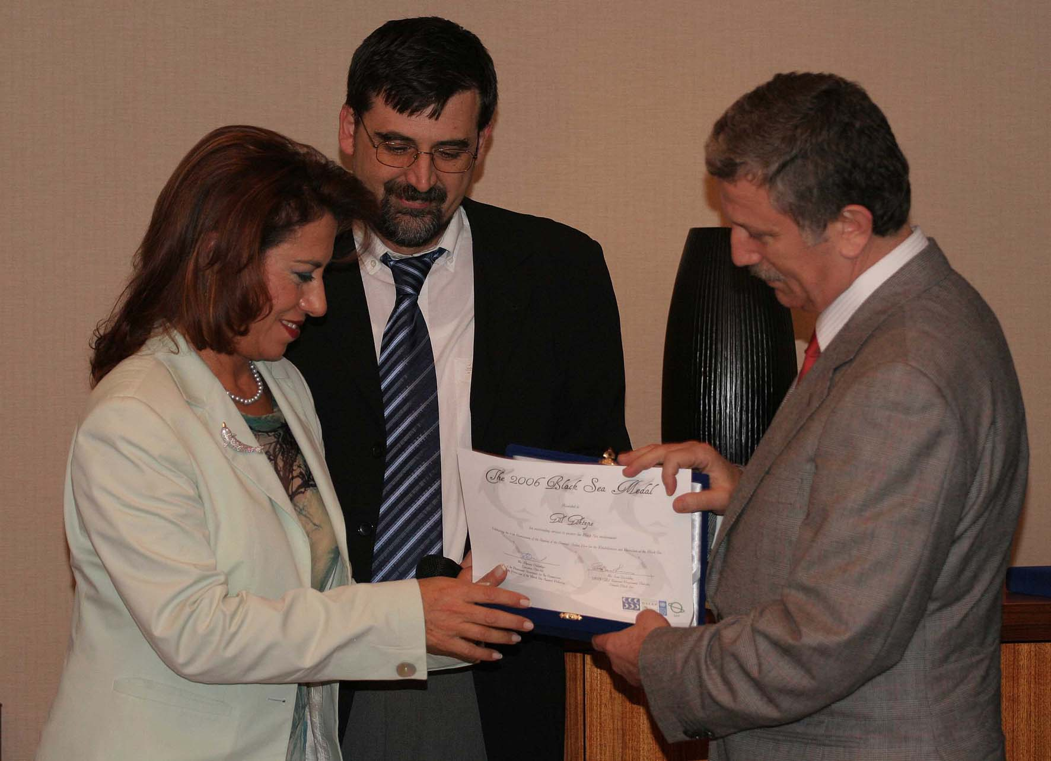
Mrs. Gül Göktepe, a distinguished Turkish environmental scientist (and a member of EFN – www.ecolo.org), was awarded the Black Sea medal by the Black Sea Commission on the Protection of the Black Sea Against Pollution and the Black Sea Ecosystem Recovery Project, which is managed by the UNDP and funded by the Global Environment Facility (GEF).

Mrs. Gül Göktepe received this medal mainly because she is well known for her intense involvement with the Black Sea Environmental Programmes during the past ten years.

She has contributed to regional activities as a scientist, for pollution assessment, as well as to local and community activities as a volunteer with several environmental NGO’s, for increasing public awareness and communication about pollution and the importance of protecting the environment in the Black Sea region.

She received the Black Sea Medal from Mr. Osman Pepe, Turkish Minister of Environment & Forestry at a special award ceremony held in Istanbul on 31 October 2006 – the International Black Sea Action Day 2006.

In her "normal" job, Mrs. Göktepe is a government research scientist who specializes in the area of energy, nuclear power, nuclear safety, environmental risk assessment and marine radioactivity.

This international reckognition of Mrs. Göktepe’s outstanding work for the protection of the environment is a good example showing that a person working in the nuclear field can also be an outstanding environmentalist, and vice-versa that there are dedicated outstanding environmentalists working in the nuclear field.

Dr Resat Uzmen
Local correspondent of EFN in Turkey - www.ecolo.org



MEDIA RELEASE

Date : 31.10.2006

Celebrating International Black Sea Action Day 2006.

Black Sea Medals Awarded for Services to Protect the Environment
Six people from each of the six countries bordering the Black Sea have been awarded the first-ever Black Sea Medals for outstanding services to protect the Black Sea environment.

The Black Sea Medal recognizes the positive contribution each of these individuals has made towards national and regional efforts to protect the Black Sea environment. This award is also designed to celebrate the 10th Anniversary of the Strategic Action Plan for the Protection and the Rehabilitation of the Black Sea signed by all coastal countries on October 31 1996.

The Medals have been awarded by the Black Sea Commission on the Protection of the Black Sea Against Pollution and the Black Sea Ecosystem Recovery Project, which is managed by the UNDP and funded by the Global Environment Facility (GEF). All recipients will receive their Black Sea Medal’s at a special award ceremony to be held in Istanbul on 31 October - International Black Sea Action Day 2006.

The winners include a range of people from different sectors including the media, NGO’s, science and government:
- Turkey, Gül Göktepe, Scientist and NGO Champion
- Romania, Cristian Lascu, Editor of National Geographic Romania & Environmental Educator
- Georgia, Merab Sharabidze, A Champion for Regional Cooperation
- Ukraine, Dr. Yaroslav Movchan, A Driving Force Behind the Strategic Action Plan for the Protection and Rehabilitation of the Black Sea
- Bulgaria, Lyubomir Stoyanov, A Regional Champion for Environmental Safety in the Black Sea
- Russian Federation, Dr. Leonid Yarmak, A Regional Champion for Integrated Coastal Zone Management

Turkey, Gül Göktepe – Scientist and NGO Champion
In her “normal” job Gül Göktepe is a government research scientist who specializes in the area of energy, nuclear energy, nuclear safety, environmental risk assessment and marine radioactivity. In this capacity she has done a great deal to inform the Turkish public on the health risks associated with the many different pollutants entering the Black Sea.

However, for the past 10 years, Gül has been a member of the Turkish Environmental & Woodlands Protection Society (TURCEK) and she has taken a leading role in helping to increase public awareness of efforts to protect the Black Sea.

Gül says it was her role as a mother and an environmentalist that really inspired her to move beyond the confines of her chosen career as a government scientist.

“No matter how hard you strive in science and governmental work it became clear to me that it was never going to be enough to save the Black Sea. There seemed to be such an obvious need for creating awareness of the plight of the Black Sea environment and the desperate need for greater public action,” she says.

Gül believes there needs to be greater commitment to improving environmental management and decision-making by both the government and civil society.

“Governments need keep the promises made in international conventions and ensure the declarations and plans they have signed, including Black Sea Strategic Action Plan, are turned into concrete actions. For example, it is clear that all governments in the region need to make greater progress in prioritizing investments in domestic solid waste disposal and wastewater treatment plants,” she says.

But Gül also says that action will only occur if people embrace their roles as responsible citizens and find ways to get more involved in the decision making process rather than blaming others.

“We all need to communicate with our decision-makers and follow the activities of our governmental, non-governmental and international organizations. We all need to take responsibility for oobserving, good, bad and ugly scenes more carefully. And we all need to feel that we are responsible as individuals for taking action to prevent further pollution and damage to the environment,” she says.

Gül says there are two things that she loves most about the Black Sea. The first is the rich biological diversity and natural beauty of the marine environment. The second is the warmth and determination shared the many different peoples and nationalities that live along the Black Sea coast.

She says this rich marine environment is something precious that must be preserved for the future generations of all nations sharing the Black Sea.

“We can never give up the hope that we and our children can all one day share in a better and healthier Black Sea,” she says.

