Health Effects of Low Level Radiation
When will we acknowledge the reality?

Jerry M. Cuttler
Mississauga, Canada
jerrycuttler@rogers.com

Summary

The 1986 April 26th Chernobyl event was the worst nuclear power accident—it killed 31 people. Its significance was exaggerated immensely because of the pervasive fear of ionizing radiation that has been indoctrinated in all of humanity. In reality, our environment includes radiation from natural sources, varying widely in intensity, to which all living things have adapted. The effect of radiation on organisms is primarily on their damage control biosystem, which prevents, repairs and removes cell damage. Low doses stimulate this system, while high doses inhibit it. So low doses decrease the incidences of cancer and congenital malformations; high doses have the opposite effect. Efforts by radiation protection organizations to lower exposures to (human-made) radiation to as low as reasonably achievable (ALARA) provide no benefit. They only create inappropriate fear—barriers to very important applications of nuclear technology in energy production and medicine.

Keywords: Chernobyl, radiation hormesis, LNT hypothesis

At the 20th anniversary of the Chernobyl disaster, the media commemorated the event with many stories designed to draw attention to its causes and consequences. The most important element was our fear of radiation. Did the media expose the fraud of the linear-no-threshold (LNT) hypothesis of radiation carcinogenesis (and congenital malformations)—the principal cause of this fear?

Radiation biologists and medical practitioners have known, since the discovery of X-rays in 1895, that low doses of radiation stimulate all organisms, usually resulting in beneficial health effects.^{[1]} They also observed that high doses are harmful and defined limits (e.g., 0.2 R/d in 1934 and 0.3 R/wk in 1951).^{[2]}

By 1955, the ICRP rejected this threshold concept in favour of a concept of cancer and genetic risks kept small compared with other risks in life. It assumes that no radiation level higher than natural background can be regarded as absolutely safe, as it continues to seek a practical level that involves negligible risk.^{[2]} The basis for this assumption is epidemiological evidence of excess cancer incidence among British radiologists and the survivors of the atomic bombings at Hiroshima and Nagasaki (H-N).

There is no evidence in the H-N survivors of excess congenital malformations; there is no evidence of excess cancer deaths in the dose range (0 to 0.5 Gy).^{[3]} The ICRP addresses the lack of low-dose evidence by its LNT hypothesis, which extrapolates a straight line from the H-N high-dose data through the no-evidence range to zero dose. A risk reduction factor (2 to 10) is used for chronic exposures. Physics and mathematics are used, but not biology. Applying this model to calculate excess cancer deaths in large populations exposed to low doses produces alarming results.

Evidence has been presented that cancer mortality of British radiologists decreased below that of other physicians after dose control measures were introduced in 1920.^{[4,5]} Evidence has been presented that cancer mortality of the H-N survivors is lower than unexposed groups.^{[3]} And many thousands of scientific publications provide evidence of improved health and reduced risk of cancer and congenital malformations following low-dose exposures.^{[1,3,6,7,8,9,10]} There is no evidence that an acute exposure below 0.1 Gy increases risk.^{[11,12,13]} The ICRP appears to disregard the on-going accumulation of evidence that contradicts the LNT model, as it advocates a precautionary approach to avoid exposure to any amount of radiation.

Many scientists support this attitude. Physicians are taught the LNT ideology, and they advise their patients accordingly. High doses of radiation to destroy tumor cells are acceptable, however low doses to prevent, detect or cure serious diseases are shunned because of fear of the hypothetical risks. Government authorities follow “international standards” of ever-tightening dose constraints, which fuel the radiation scare and make society highly vulnerable to terrorist “dirty bombs”. It has become very difficult to change perceptions about radiation.

What is the basis for this unscientific behaviour? The phenomenon of low dose stimulation and high dose inhibition (hormesis) has been known from the late 1800s; however it fell into disrepute because of its early and close association with the controversial medical practice of homeopathy.^{[14]} The LNT hypothesis appeared soon after the H-N bombing, at a time when many scientists were agonizing over their roles in developing the A-bomb. There was intense political activity to stop bomb development, testing and production. Greatly exaggerating the consequences of exposure to (human-made) radiation was understandable and did produce the desired results.^{[15]} International agreements and controls were established, which resulted in major reductions of stockpiles and risks of nuclear weapons proliferation.

However, the anti-nuclear activity has expanded to encompass opposition to nuclear energy and nuclear medicine.^{[16,17]} The economic, environmental and political dimensions of what is happening are very significant. Arising in the 1970s, environmental ideologies have become a dominant influence in society. Naïve scientists cannot fathom why environmentalists oppose nuclear energy, which produces relatively small amounts of “waste” that are well managed (and can be recycled). A primary concern is the risk of exposure to low level radiation, after many thousands of years.

By far the greatest exposure to low level radiation is radon gas from natural uranium in the environment. A scientific test of the LNT model, as normally used, disproved the hypothesis—cancer mortality decreases as radon concentration increases.^{[18]} Instead of discarding (or modifying) the LNT hypothesis, the test was criticized by the defenders of the hypothesis, and the authorities^{[19]} continue to accept ICRP recommendations.

Figure 1. Comparing average annual dose: natural versus human-made radiation^{[20]}

Scientists are not satisfied with data; they want an explanation of the mechanism of the radiation hormesis dose-response relationship. Pollycove and Feinendegen have provided this.^{[21]} For more than 15 years, biologists have known that the greatest cause of cell damage (many orders of magnitude greater than any other cause) is the normal oxygen metabolism. All living organisms have a very powerful damage control biosystem that prevents, repairs and removes cell damage, or they could not exist. A low dose of radiation (0.001 to 0.3 Gy) produces a small amount of damage. This triggers increased damage control system activity, which deals not only with the trivial radiation damage, but also with the much larger endogenous cell damage, resulting in less cancer overall. Hormesis is overcompensation to a disruption in homeostasis. Conversely, a high dose of radiation decreases the activity of this biosystem (more cancer). It is the effect of the radiation on the damage control biosystem that determines the response. The cell damage caused by the radiation is not important.

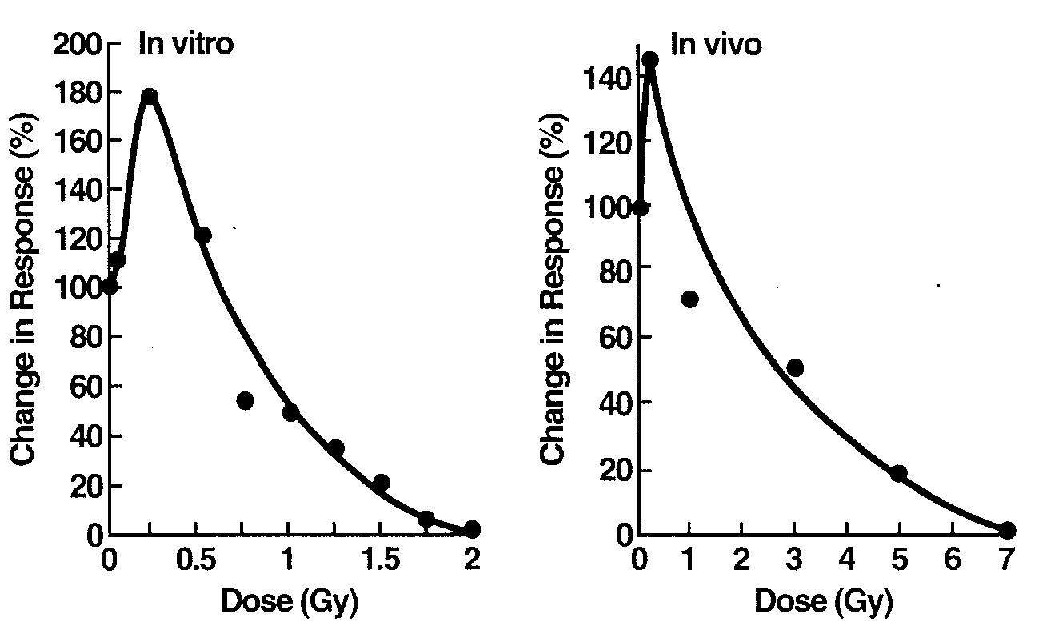

Figure 2. Immune system response to radiation. Mouse splenic cells primed with antigenic sheep red blood cells.^{[10]}

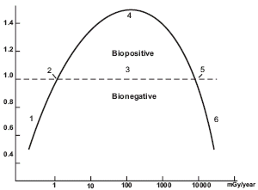

Figure 3. Idealized, complete dose-response curve.^{[6]} The ordinate indicates approximate responses compared with the controls. The abscissa suggests mammalian whole-body exposures as mGy/year. The numbered areas are: (1) deficient, (2) ambient, (3) hormetic, (4) optimum, (5) zero equivalent point, and (6) harmful.

The recent Chernobyl Forum^{[22]} determined that:
- 31 reactor staff and emergency workers died (28 within four months from high radiation)
- another 19 of the 106 who recovered from acute radiation exposure died during the following 18 years (conforms to normal mortality of ~1%/yr)
- the surrounding population and most of the cleanup workers received doses comparable to doses many people receive from background radiation
- 4000 expected cancer deaths (based on the LNT model)
- no radiation-induced increase in mortality
- 4000 cases of thyroid cancer identified in the screening begun immediately after; nine deaths.

Rockwell points out^{[23]} that the nuclear community agonizes over its inability to communicate its message to the public, but it cannot overcome a basic problem. “Our credibility is continually undermined by ostensibly authoritative statements that no amount of radiation is small enough to be harmless and that a nuclear casualty could kill as many as hundreds of thousands of people. That message we have communicated, and therefore the public and the media are not wholly to blame for the resulting public fear of radiation and all things nuclear. We cannot expect people to believe our assurances of safety so long as we acquiesce in terrifying messages to the contrary. … Although the case is persuasive that the worst realistic nuclear casualty is less harmful than that of nuclear power’s serious competitors, the evidence has not yet been assembled into an overall documented statement and evaluation. … The action urgently needed now is to prepare the case, and then discuss it within our own ranks. … Until that happens, the status quo will prevail.”

References:

- Calabrese EJ, Baldwin LA. “Radiation Hormesis: Origins, History, Scientific Foundations.” Human & Exp Tox 19(1):2 (2000)
- Clarke RH. “Progress Towards New Recommendations from the International Commission Radiological Protection.” J Brit Nucl En Soc, Nuclear Energy 40(1):37 (2001)
- Kondo S. Health Effects of Low-Level Radiation. Kinki University Press, Osaka, Japan (1993) also Medical Physics Publishing, Madison, WI
- Smith PG, Doll R. “Mortality from all Causes Among British Radiologists.” Br. J Radiol 54:187-194 (1981)
- Cameron JR. “Radiation Increases the Longevity of British Radiologists.” Br J Radiol 75:637-638 (2002)
- Luckey TD. Radiation Hormesis. CRC Press (1991)
- “Sources and Effects of Ionizing Radiation. Adaptive Responses to Radiation in Cells and Organisms”. UNSCEAR 1994 Report to the General Assembly with scientific annexes, Annex B
- Liu S-Z, Liu WH, Sun JB. “Radiation Hormesis: Its Expression in the Immune System.” Health Phys 52:579 (1987)
- Liu S-Z. “Nonlinear Dose-Response Relationship in the Immune System Following Exposure to Ionizing Radiation: Mechanisms and Implications.” Nonlinearity in Biology, Toxicology and Medicine 1(1):71-92 (2003)
- Makinodan T, James SJ. “T Cell Potentiation by Low Dose Ionizing Radiation: Possible Mechanisms.” Health Phys 59(1):29-34 (1990)
- Health Physics Society. “Radiation Risk in Perspective.” Position Statement January 1996, and reaffirmed March 2001 http://www.hps.org/documents/radiationrisk.pdf
- Jaworowski Z. “Radiation Folly.” Environment & Health: Myths & Realities, Ed. Okonski K, Morris J, Int. Policy Press (2004). Chap.4:69-86. http://www.policynetwork.net/main/article.php?article_id=622
- French Academy of Sciences – French National Academy of Medicine. “Dose-Effect Relationships and Estimation of the Carcinogenic Effects of Low Doses of Ionizing Radiation.” March 30, 2005 http://www.wonuc.org/lowrad/cbulletin.htm
- Calabrese EJ. “Historical Blunders: How Toxicology Got the Dose-Response Relationship Half Right.” Cellular and Molecular Biology 51:643-654 (2005)
- Jaffe S. “Foundations | Pauling, Meselson, and Socrates”. The Scientist 17(20):11 (2003). (Ava Helen & Linus Pauling Papers at Oregon State University) http://www.the-scientist.com/yr2003/oct/upfront3
- Cuttler JM. “What Becomes of Nuclear Risk Assessment in Light of Radiation Hormesis?” Proc of 25th Ann Conf Can Nucl Soc, Toronto, June 6-9, 2004 http://www.ecolo.org/documents/documents_in_english/risk-cuttler_04.doc
- Cuttler JM, Pollycove M. “Can Cancer be Treated with Low Doses of Radiation?” J Am Phys Surg 8(4):108 (2003). Available at: http://www.jpands.org/vol8no4/cuttler.pdf
- Cohen BL. “Test of the Linear-No Threshold Theory of Radiation Carcinogenesis for Inhaled Radon Decay Products.” Health Phys 68:157-174 (1995)
- Tubiana M, Aurego A. “Dose-Effect Relationship and Estimation of the Carcinogenic Effects of Low Doses of Radiation: the Joint Report of the Académie des Sciences (Paris) and of the Académie Nationale de Médecine.” Int J Low Rad 2(3/4):TBA (2006) available at http://www.wonuc.org/lowrad/dub011-ok.pdf
- Rockwell T. Creating the New World: Stories & Images from the Dawn of the Atomic Age, 1st Books Library, Bloomington, Indiana (2003) ISBN: 1-4107-0333-9, Fig 7.1, pp.150
- Pollycove M, Feinendegen LE. “Radiation-Induced versus Endogenous DNA Damage: Possible Effects of Inducible Protective Responses in Mitigating Endogenous Damage.” Human & Exp Tox 22:290 (2003)
- IAEA Digest Report. The Chernobyl Forum. (2005) http://www.iaea.org/NewsCenter/Focus/Chernobyl/pdfs/05-28601_Chernobyl.pdf
- Rockwell T, “The Realism Project: It’s time to get real.” American Nuclear Society, Nuclear News. Dec. 2004, pp10-12

