SMALL-SCALE NUCLEAR POWER
FOR NON-UTILITY APPLICATIONS.
THE NUCLEAR GAS TURBINE

G.A.K. Crommelin
Captain (Engineering)
Royal Netherlands Navy (retired)
Huzarenlaan 15, 7215 ED Joppe
The Netherlands
E-mail: gulian.crommelin@planet.nl
Professor Dr.Ir. H. van Dam
De Melkpotte 21
2631 PW Nootdorp
The Netherlands
h.vandam@tnw.tudelft.nl

Ir. W.F. Crommelin
Van der Capellenstraat 54
2593 XE The Hague
The Netherlands
E-mail: w.f.crommelin@zonnet.nl
L. Neut
Nassauplein38
1815 GV Alkmaar
ljneut@hetnet.nl

KEYWORDS:
well-proven, inherently safe, controlled by the laws of physics,
small-scale nuclear energy conversion.

ABSTRACT
Based upon the use of state-of-the-art technologies and existing metallic materials can the gas turbine join the Nuclear Renaissance? Our answer is YES! This paper will discuss the latest thoughts and ideas about the possibilities of a NUCLEAR GAS TURBINE: The combination of a gas turbine with an inherently safe, well-proven nuclear heat source. Keywords are: a Naturally safe and well-proven, Efficient, high temperature nuclear Reactor, Easy to operate, Ultimately simple and Small, in short the NEREUS installation.
Applications are in the markets: fresh water production, stand-alone electricity generation, stand-alone heat production, Combined Heat & Power production, ship propulsion.

The report will discuss:
a - the reasons why an additional energy conversion system is possible and needed,
b - that from the point of view of the history of energy conversion systems the nuclear gas
turbine is the next logical step in small-scale energy conversion,
c - the way the inherently safe character is controlled by the laws of physics,
d - the markets we are aiming for and the market philosophies we have to meet,
e - the different components required (an open-cycle gas turbine and high temperature
pebble-bed reactor) plus that these components are available and well-proven and the
system which connects these components,
f - the additional protection against attacks by terrorists we are suggesting,
g - the cost targets we have to meet,
h - the starting, stopping and maintenance procedures.

INTRODUCTION

" No single energy source should be idealised or demonised"
Claude Mandell,

This report discusses the latest thoughts, calculations, advice, etc. on the NEREUS installation, a study which has been ongoing for about ten years. On several occasions results were reported at ASME IGTI conferences. For the readers convenience this already available information will only be repeated briefly as basis for a further discussion.

As has been mentioned on page 1, the acronym NEREUS stands for: A Naturally safe, Efficient, graphite moderated pebble-bed Reactor, Easy to operate, Ultimately simple and Small. (see fig: 1). It describes very well the aims of the team:

The NEREUS project aims to realise a modular installation consisting of well-proven nuclear, heat exchanger and gas turbine technologies. It consists of a well-proven, inherently safe, helium cooled’, closed cycle, graphite moderated, High Temperature Reactor (HTR) as heat source which is indirectly coupled via a double loop helium system with heat exchangers, to a recuperative open-cycle Gas Turbine (GT) of the type turbo expander [1] (HTR-GT). The design incorporates the philosophies of the non-utility markets. These markets are: stand-alone heat production, Combined Heat & Power production, stand-alone electricity generation and as prime mover on board ships (the biggest market in numbers and thus the most important one).

REASONS WHY
Ad page 1 - a. Why an additional energy conversion system is possible and needed.
As many international reports make clear the population of this world will increase to about 9 billion in 2050 [2]. In addition we all wish our fellow human beings at least the same level of well-being and welfare as we are used to in the West. This will dramatically increase the energy consumption per person. Actually we do not talk about electricity, as is usually meant when one uses the word Energy, but we consider that energy equals electricity and/or (industrial) heat and/or fresh water. The last aspect is by far the most important [3]. This is not a plea to go for all-out nuclear, but a plea to keep all options for energy conversion open, including the nuclear one, as is done nowadays by most of the leaders of the world. Although they have difficulties, for well-known reasons, to get this message over to the public. To satisfy the needs for energy of this generation and the generations of the future we need all existing energy conversion systems plus those under development. Which one should be used when and where, depends on reasons which should be discussed openly and without prejudice for each situation.

An example.
”It is a myth that the world is turning its back on nuclear. A couple of dozen countries are currently planning new nuclear programmes - from the geographically close France to the ideologically liberal Finland, not to mention our G8 partners in Japan and the United States. I recall asking the Finnish Energy Minister, Mauri Pekkarinen, how they had managed to deliver this outcome (the construction of a new nuclear power plant). He replied: 'Through eight years of honest debate.' [4]

PRIMARY HEAT EXCHANGER
REACTOR
FUEL

INTERMEDIATE
HEAT EXCHANGER
E
E
G
G
Figure 1 – scheme of the NEREUS HTR-GT installation
Helium systemsE = electromotor
Air systemsG = generator
Power control system

p = 40 bar
T = 800 °C
P = 20 MW m = 14 kg/s
T = 529 °C

p =1 bar
T = 15°C
m = 32 kg/s

p =3.46 bar
T = 738 °C

p = 1.02 bar
T = 190 °C

RECUPERATOR

p =3.5 bar
T = 465°C

T = 769 °C

T = 497 °C

P = 4 MW

HISTORY
Ad page 1 - b. Para 1. From the historical point of view some trends can be seen, such as the energy content of the fuels used increase all the time; the combustion area decreases per MWh, the number of people involved in the energy conversion process decreases; the efficiency of the process increases, emissions go from dilution and dispersion to contained and manageable (see this paragraph para 2), etc. The conclusion is that the combination of a nuclear heat source and gas turbines for power generation in the non-utility markets, controlled not by hand or automatic systems, but by the laws of physics, seems to be the next logical step [1].

Note 1 – gas turbines are much more suitable for unmanned power plants than steam turbines.
Note 2 – in case of a combination of a helium cooled gas turbine and a gas turbine, steam explosions like Harrisburg (USA – 1979) cannot occur.
Note 3 – existing nuclear power plants are owned by the utilities and use steam turbines, because these are, at the moment, the only engines able to generate amounts of electricity on utility scale.

Everybody who starts to think about nuclear energy and every discussion on nuclear subjects, starts at the end, with the waste problem. A very sensitive subject on which everybody has an opinion, but only a few know the ins and outs. It should be realized that the amount of waste produced by a nuclear heat source is much and much smaller than the amount of waste resulting from fossil fuelled engines, simply because the fission process liberates the energy that keeps a nucleus together (which is typically in the order of hundreds of millions of eV's), instead of a chemical reaction, that makes use of the binding energy of electrons (which is only several eV's). The nuclear heat source discussed in this paper (HTR) uses its fuel very economically, thus resulting in even smaller amounts of waste (and in lower fuel costs!). The fuel elements themselves are ideal waste containers: after some three years of operation the core can be replaced by a fresh one and the old core serves as a waste container. The high burn-up of the fuel makes reprocessing unnecessary.
After three years of operation about 7 m³ of fuel pebbles are removed from the core. This nuclear waste can be transported in shielded containers. A possible design has a diameter of <3 m and a height of 5 m. After about 10 years the radioactivity and heat production have decayed to such an extent that the waste can be classified under the category “Medium-active waste of the upper category”. After 10 – 50 years of interim storage, the waste can be sent to final storage in relatively simple 0.4 m³ drums.
It must be stressed that this is mainly due to the high mechanical and chemical integrity of the fuel elements, which simplifies their final confinement from the biosphere.
The reason that this subject was discussed again is that this aspect also shows a trend. The amount of waste per produced MWh decreases all the time, see figure 3 [5]. The re-use of the waste increases all the time. The more advanced types of nuclear reactors are designed in such a way that they “eat” the waste of the older types. The research in this matter indicates that the waste problem will be brought down from 250.000 to less than 1000 years [6].
An example which is not known by the public and so always surprises people and shows, that the developments in waste management have continued: In the United Kingdom I-129, with a half-life of 15.7 million years, was in a laboratory with a laser transmuted to I-128 with a half-life of 25 minutes. It is true to say that I-129 is only a tiny part of the waste, but it illustrates that progress is being made [7].

Conclusion: radioactive waste is not a problem, it is a challenge!

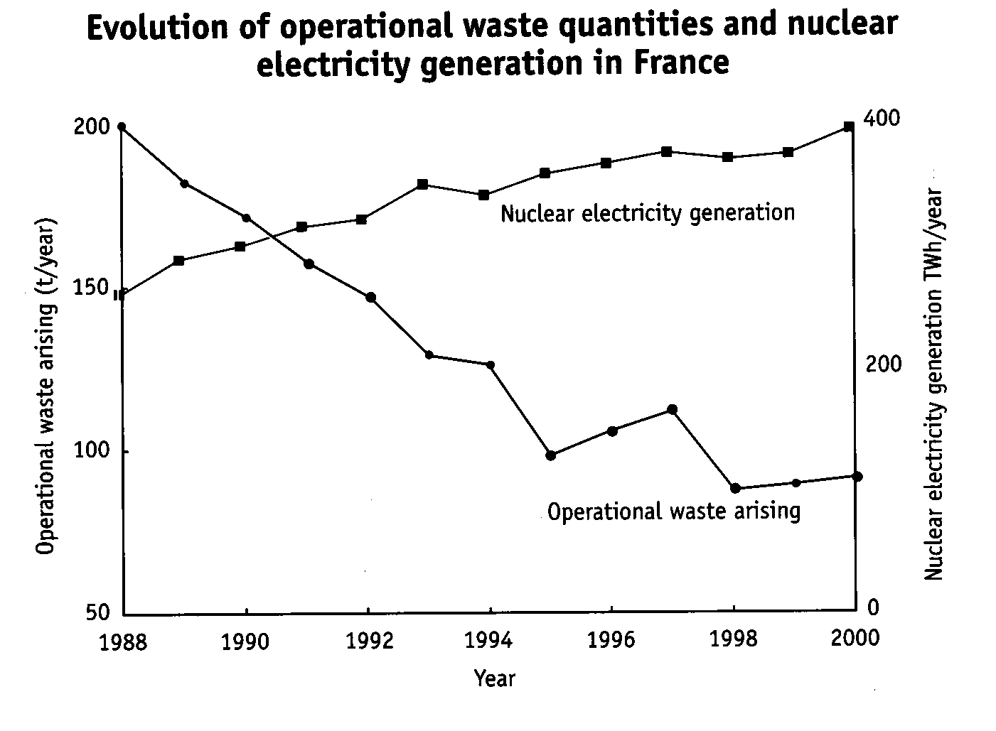

Figure 2 – waste per TWH/year

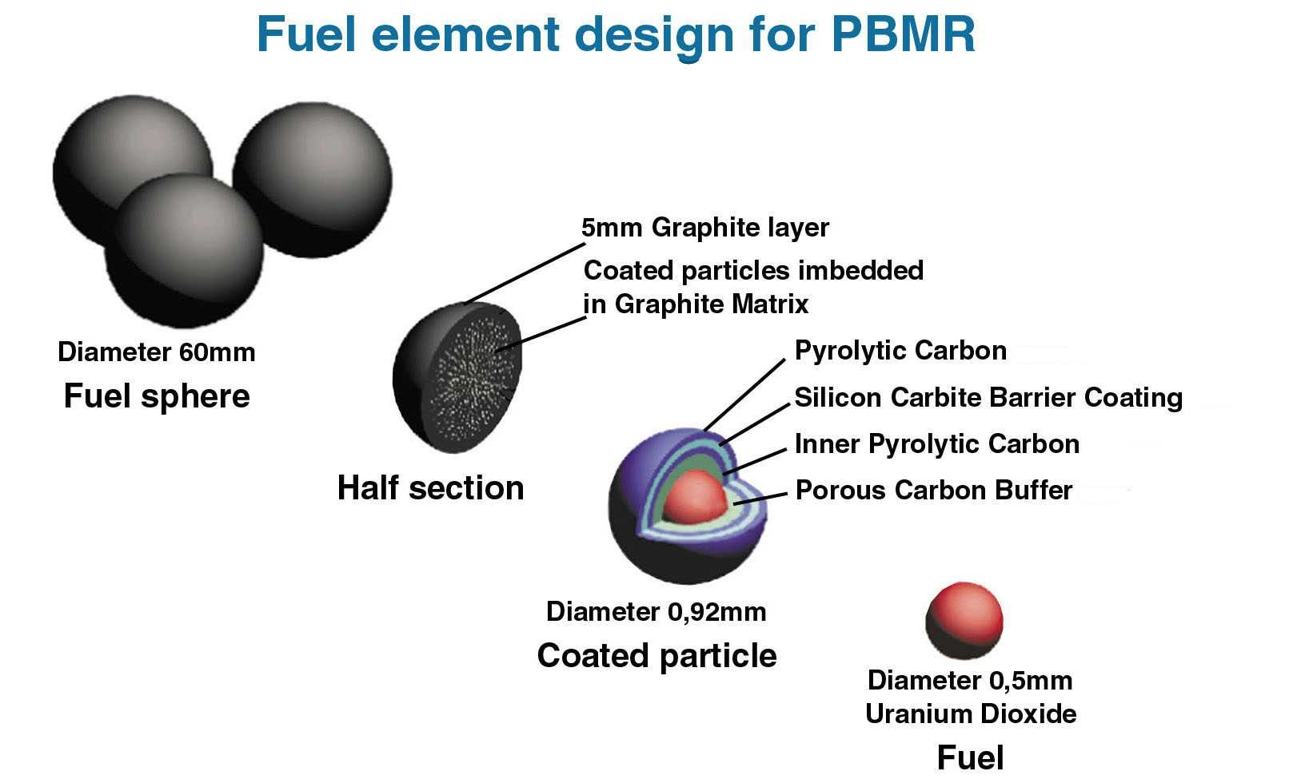
PEBBLES
TRISO
Figure 3 – the fuel
CONTROL BY THE LAWS OF PHYSICS
Ad page 1 - c.
Figure 4 – the nuclear fuel
With thanks to the South Africa Pebble-Bed Modular Reactor project
The way the inherently safe character is controlled by the laws of physics.
The nuclear part of the NEREUS installation is largely based upon the High Temperature Reactor test unit, as was tested for 20 years in Jülich, Germany. The fuel is shown in figure 3.
These fuel balls are cooled with helium, driven in a closed-cycle system by a blower (see figure 1). This construction of the nuclear fuel was tested under extreme circumstances and proved to be able to withstand temperatures up to 1600 °C [8].

Criticality is controlled by burnable poison (see figure 4), built into the fuel. It “eats” the surplus of neutrons [8].
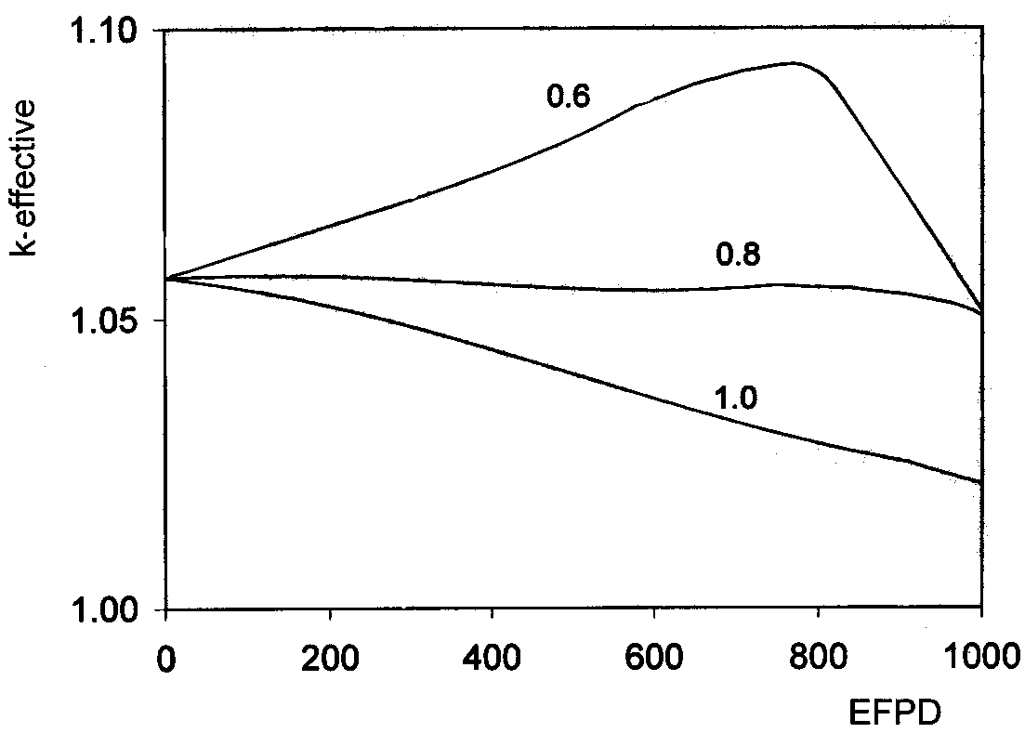
Figure 4 - Reactivity control by burnable neutron poisons(EFPD=effective full power days)

Power output is controlled by the negative temperature coefficient [8]. This implies that in case the coolant or fuel temperature increases the chance that a neutron causes another fission decreases and the change is counteracted. Thanks to this the reactor is stable and self-controlling.

This control feature was also tested to the extreme as figure 5 shows.
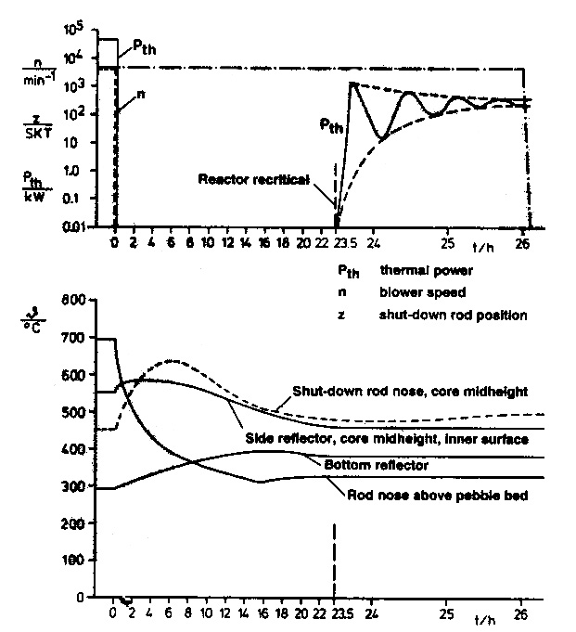
Figure 5 - Demonstration of the inherently safe shutdown of the AVR reactor in 1970.
The upper part shows the course of the reactor power after stopping the blowers with the control rods remaining withdrawn. The lower part shows the development of temperatures at several locations of measurement.
No dangerous situations ever occurred.

In September 2004 this self-controlling and unique safety and controlling feature was demonstrated again for a group of specialists from the Netherlands at the pebble-bed test facility in Beijing, China.
The reasons for the inherent safety of the reactor are the negative temperature coefficient and the low power density in the core (3 MW per M³) [8].

Most nuclear reactors have control rods which are moved by electro motors and in case of power failure they use gravity to fall into stop position. For a ship this is not acceptable.
So we choose torque activated rods. In case of power failure the torque will turn the rod in stop position.

There is a little decay heat, which is removed by natural draft (see figure 6, please note the difference scale used after 23 hours [8].
After shutdown of a nuclear reactor, the radioactivity of the fission products gives rise to production of some decay heat, which gradually decreases. The completely passive removal of this decay heat is an essential part of the inherently safe nuclear installation. For this purpose there is a space between the outside of the reactor drum and the inside of the biological shielding, through which air flows, driven by natural draft. This cooling will be there all the time and is established, without any ventilators etc. in a natural way. For this purpose a normal ship’s funnel construction (100 kW) can be used during normal operation. The cooling air must be supplied through air filter units at the open decks. This passive heat removal system is always in operation and removes at nominal power about 0.5% of the heat.
The funnel can also be used as a transport route for refuelling, maintenance and repair by replacement by the pool-management system.

MARKETS
Ad page 1 - d.
Markets we are aiming for, the market philosophies we have to meet.
We designed the NEREUS installation for the markets of: stand-alone heat production, Combined Heat & Power production, stand-alone electricity generation, and as prime mover on board ships. One philosophy we have to meet is the design criterion KISS – Keep It Simple and Sailors proof and in addition suitable for unmanned power plants and unmanned engine rooms.
The specifications of the NEREUS installation at the moment are: weight about 2000 tons (about the same weight as an 8 MWe diesel engine including fuel, supporting equipment and lubrication oil), thermal power 24 MWth, output power 8 – 10 MWe, fuel - 3 years at 80% time, power – 90% and with an efficiency - minimal 40%. Plant dimensions (figure 1) are 10 x 10 x 10 metres, (all additional equipment included). The installation is of a modular construction to make easy maintenance, refuelling, repair and overhaul possible under the control of a pool-management system, as is reasonably common in the gas turbine branch.
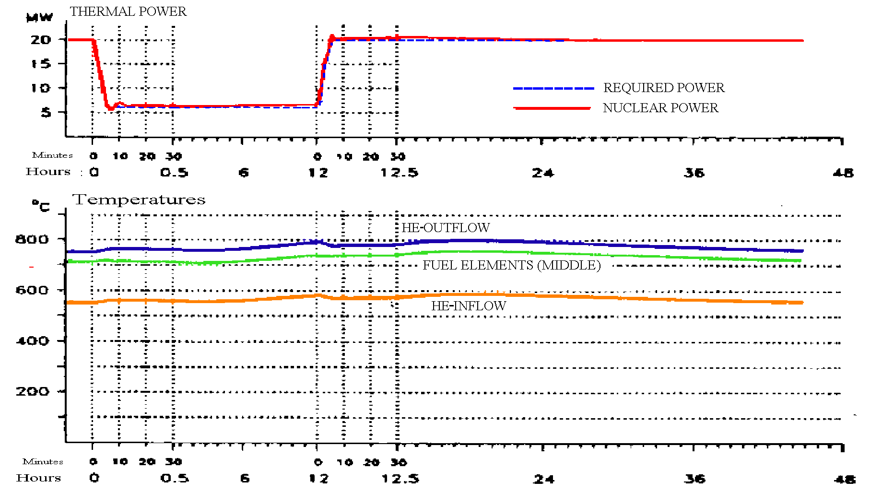
Figure 6 – reaction to a step change in power demand
The reaction to power changes is always very important, especially in the case of stand-alone operation. Figure 7 shows the reaction of the nuclear reactor, which as we explained, by the laws of physics, reacts to a step change from 100 – 40 – 100%. The temperatures in the reactor system do not change much, the negative temperature coefficient is the controller of the whole process.

This “self-regulating power control” makes this installation safe and very suitable for unmanned power plants, such as on board ships. Both markets prefer to work with “unmanned power plants” and “unmanned engine rooms”. The power control output of the installation is delivered by the generator and controlled by controlling the mass flow in the gas turbine cycle by controlling the revolutions per minute (rpm) of the compressor(s).

An important difference with existing gas turbine installations is, that the engine does not follow the amount of fuel injected into the combustion area, as we are all familiar with, but the fuel (the nuclear reactor) follows the gas turbine cycle in order to meet the power demand.

COMPONENTS
Ad page 1 - e. All installations are well-proven including the nuclear reactor, which is of the same design as the test reactor in Jülich, Germany. Most studies on nuclear gas turbines use the direct cycle using a helium gas turbine as energy conversion unit. But the design of such an engine is complicated and so costly. Too costly for the near future for the markets we aim for. So we left this road a few years ago. The NEREUS design uses turbo expanders for compressors and turbines [1].
There is a very small chance that radioactive dust is released from the pebbles and enters the primary helium flow. This will raise an alarm. But in the unlikely event that the heat exchanger leaks, the helium will enter the air flow of the gas turbine. The helium pressure must always be higher than the air pressure to prevent air coming into the reactor cooling system. So when the open-cycle gas turbine is, without precautions, connected to this helium flow, the gas turbine driven air flow could get contaminated. We discussed this matter with specialists in South-Africa and the USA and decided to put in a second helium loop with its own helium blower. So the helium flow through the reactor takes the heat to the primary helium loop, which takes it to the intermediate heat exchanger. Both helium circuits are monitored for any problems of a radioactive nature.
The advantage is a better protection against the very small chance of possible radioactive leaks. The disadvantage is a more complicated installation with an extra helium circuit and with its own blower and a lower efficiency, see figure 2. But keeping radioactive dust out of the biosphere prevails.

PROTECTION
Ad page 1 – f. The additional protection against attacks we are suggesting.
The nuclear safety features have been discussed in para c [8].
Safety aspects regarding the sea-going version apply to any other market as well and were discussed [9].
We are also recommending an extra protection of the nuclear part, using an armour of KEVLAR. This kind of armour is used in modern American aircraft carriers to protect their vital compartments [10].

COST Any price estimate should at least indicate
how much more it will be going to cost.
Murphy´s law
Ad page 1 - g.

The subject of costs per MWh is always a very difficult question. The nuclear branch talks about the production costs per MWh of utility size plants. These costs are based upon through life costing, so including waste management, scrapping, etc.
This financial system is much less known in the industrial world. A comparison between the two approaches is in fact impossible and a constant source of confusion. Energy production costs on a big scale or a small scale are different and that will never change. Part of the costs is the through life logistic support. For this a pool-management system is recommended. Well-known in the aero world, but not well-known in the markets as mentioned. The users of small-scale energy conversion units rarely think in terms of through life costing and through life support. They know the deal they made to install the plant, but this is always confidential information, and they know the cost related to operating the plant. Additional costs such as training, manning, insurance, etc. are rarely clear. The matter of through life costing and through life support forms one of greater areas of suspicion against the NEREUS installation by the potential users.

Estimated costs for a serial installation (of a population of 500 units) as is calculated in “new diesel” projects in the diesel branch.
The calculations are based upon through life costing combined with through life logistic support of a comparable diesel engine managed and operated under comparable circumstances. The design principles are: design to cost, design to maintain, design to refuel within two weeks (during a maintenance and inspection period), design to scrap, installation modules are transportable by train, air, ship or truck (with the exception of the biological shielding).

Costs are always an important aspect for any market and must therefore play a decisive role through the whole process of design, assembling, marketing, exploitation etc.. Markets are not so much interested in the costs of a proto-type, but only in the performance and the costs of a serial model.The installation we have in mind will not be customer built, but built as a serial model. As a result of the application of the price reducing tools as standardisation, the containerization, the modular building, a pool-management system and the usage of dedicated workshops etc., the price per kWh will become affordable.

Another important factor is the cost during the construction on-site. The aspects mentioned before will also reduce this cost dramatically. The cost and time for construction on-site can only be brought down if these aspects are taken into consideration during the whole designing phase. The target should be less than one year including groundwork, setting to work, testing, training etc..

The markets the NEREUS installation is aiming for are the markets where the diesel and/or the gas turbine are the energy conversion units. So the financial norms and ruling must be followed. Cost calculations will be done on Through Life Costing and will be compared with an on board diesel plant.

Any price estimate in this phase of the study is very difficult. Only the most important components are estimated. The estimates are based upon information which was obtained over many years and from many different and sometimes very reluctant sources. So a very big safety factor is used in the final step and applies only for the “first of a kind” engine.

It is estimated that with a series of 500 engines, the price per engine is 30% less. In addition there is a saying that there is a list price and/or an agreed price in a deal between the manufacturer and the customer.

Calculations are done on life cycle costs, incorporating design to cost, design to maintain, modular design, design to transport and design to scrap.

We analysed the costs at through life costing of a diesel engine in a ship as follows:

Life cycle costs of a diesel engine propulsion system
for a multipurpose cargo ship or industrial plant.

The calculations are based on a geared diesel propulsion machinery installation of 8000 kW. This means that the system includes the engine itself, the flexible coupling, the reduction box, the tail shaft, the fuel treatment systems, the lubrication and cooling water systems, the generator or the controllable pitch propeller.
The procurement costs of such an installation are estimated at € 800 per kW or 1000 USD per MWh. Total € 6,400,000 or 800,000 USD

The capital cost is estimated at 16% per annum, this includes depreciation and the loss of interest of the invested capital. The rest value, when the ship is eventually sold, is not taken into consideration, because it is very much depending on the market situation of that moment. It can considerable reduce the 16% as mentioned before.
Capital cost per annum is 16% of € 6,400,000 = € 1,000,000 = 1,200,000 USD

Average load of the diesel is 7200 kW. Average number of running hours 7000 hours per year.
Total output per year 50,000 MWh. € 20 per MWh = 25 USD per MWh

Cost of fuel
Average load of the diesel 7200 kW. Average number of running hours 7000 hours per year.
Total output per year 50,000 MWh. Specific fuel consumption 180 kilograms per MWh.
Which means a fuel consumption of 9000 tons per year at a price of € 150 per ton.
Fuel costs: € 1,350,000 per year or € 27 per MWh = 34 USD per MWh

Lubrication costs € 1,5 MWh = 2 USD per MWh

Additional costs
Costs of maintenance, manning, insurance, etc. € 3 per MWh = 4 USD per MWh

Total cost of a diesel plant of 8 MW on board a multi-purpose freighter (April 2005)
€ 50 per MWh or 65 USD per MWh.

Any new type of energy conversion system and
so the NEREUS installation as well has to meet this challenge.

To open up these markets, the price must be very attractive, because it is at the moment a very unattractive step. However as a few years ago was said by some leaders in the international shipping branch: “We had never heard of this (NEREUS installation ) possibility. We agree with the technical and non-technical arguments. For the near future we foresee problems with nuclear ships entering certain harbours or passengers taking a cruise on board a nuclear powered ship. However shipping is not going back to sailing or even rowing. Solar power is no option either. There is no alternative, we have to take nuclear on board”.

Cost price demo-engine – serial production engine

Another aspect which is often discussed and can be very confusing as well, is the difference between the first of a kind, the demonstration engine, and the price of a serial production engine.

For our thoughts and calculations we used the following example:
The costs of a demonstration diesel engine was 16 billion Euro or 21 billion USD for an engine of 4,200 MW. Which means 5 billion USD per MW.
The aim of the design was a procurement price for the buyer of 100,000 USD per MW, based upon a production volume of 500 engines.
Per engine of 4200 kW the costs of the demo-engine is 5,000,000/500 = 10,000 USD,
or in other words 10%.

For the project costs of the demo-NEREUS installation of 8 MWe the rules will be slightly modified. 500 installations and 8% return for development per NEREUS installation.

Life cycle costs NEREUS plant

As was calculated the costs of an 8 MWe diesel, based upon life cycle costs, are 65 USD per MWh.

To penetrate any market with a new product, the price of that product must be considerable lower. Because of its inherently safe character, based upon the laws of physics, the pool-management system, the manning, investment in safety aspects and know-how, etc. will be lower than for a gas turbine or diesel.
This means that the costs of the NEREUS (serial model) must meet a price of maximum 55 USD per MWh (15% less).

Estimated fuel price for a NEREUS plant, including waste treatment and storage -
5 USD per MWh
Costs of maintenance, manning, insurance, etc. - 3 USD per MWh
Costs demonstration engine 8% 4 USD per MWh
Investment target to be met is 55 – 5 – 3 - 4 = 43 USD per MWh or as calculated before, this allows an investment for an engine from a serial production of 43/20 x 6.4 x 1.3 =
18 million USD.
Fuel 5 USD per MWh
The price for the fuel is considered as operational costs and not, as is routine within the nuclear branch, as part of the investment.
The Pebble-Bed Modular Reactor project (ESKOM South Africa) estimates the price for the fuel 4 USD per MWh. So for three years operation at 90% time and 80% power (50,000 MWh per year), including waste treatment and handling, the costs for the fuel load
(per three years) is: 750,000 USD

Investments
Reflector
Total volume 35 m3. Density 2.1. Weight reflector is ± 75 ton.
Estimated price per kg, including machining, is 25 USD per kg
So the estimated costs
Reflector: 2 million USD

Starting and stopping rods, inside constructions
Reactor drum, inside components 1 million USD
Reactor drum
Material advice M.I.T. 1995 – SA-533 low alloy steel or 2¼ Cr Mo alloy steel.
Weight reactor drum is 32 tons.
Estimated price based upon some indications for the PBMR project is 45 USD per kg, including machining. Estimates from Japan state 37.6 USD per kg.
So the estimated costs
Reactor drum itself: 1.5 million USD

Biological Shielding
Weight biological shielding: 1300 tons . The price of cast iron is estimated (information for a manufacturer) 1000 USD per ton. The Price of KEVLAR is not available.
Estimated price is:
Biological shielding 2 million USD

Helium blower
Price unknown. Estimated: 1 million USD

Passive decay heat removal system
Estimated at: 0..5 million USD

Helium cleaning system is considered as a pool-investment because the helium will be changed during refuelling.

Total price for the nuclear part: 8 million USD

The non-nuclear part

Recuperator (NREC) 1 million USD
Gas turbines (Expanders – Ir. Laagland – KEMA ) 2 million USD
Intermediate Heat Exchanger (HEATRIC – UK) 2 million USD
Pipe work 0.5 million USD
Additional equipment 0.5 million USD

Total price non-nuclear part 6 million USD

Total price for the installation
(without civil work such as procurement of a site, fuel, investments in the pool, manning, infrastructure, licensing, etc.) 14 million USD
Investment target was calculated at 18 million USD,
which allows a financial safety factor of 30%.

DEMO unit.
The calculation costs for the demo-model are 5 USD per MWH. If calculated for 500 engines the available funds are: 500 x 4/20 x 6.4 x 1.3 = 800 million USD

Conclusion: For the 18 million USD in 6 years time 600,000 MWh can be generated. So the price per MWh for a NEREUS installation is 60 USD per MWh. Plus 4 USD per MWh for the fuel. Leads to an at least comparable price per MWh for a Small-scale, well-proven and inherently safe nuclear power plant and a diesel.

STARTING, STOPPING and MAINTENANCE
Ad page 1 - h.[11]
Maintenance
The air filtration unit of an open cycle gas turbine requires maintenance, as is well known. So we chose to go for two compressor/turbines. This means that the washing of the air filtration units, the change of oil filters and the washing of a compressor replacing components for repair, does not mean that the heat source has to be stopped. Engine Health Monitoring, vibration analyses, etc. are no different.
Refuelling takes place after an operational period of about three years, as is convenient to the owner. As has been pointed out this operation should be done by the pool-logistic management system en implemented by well-trained and specialised personnel.
In addition, and if necessary, during the refuelling period worn components should be replaced. The helium in both helium systems and the storage can be filled up.
All related costs should be shared by the members of the pool system on the basis of running hours.

Starting
Starting procedures are not much different from starting a fossil fuelled gas turbine installation. First of all the available fuel must be checked and if necessary brought to the required standards in quality and quantity. In this case the helium closed cycle systems must be checked. The nuclear branch is famous for its amount of legislation, ruling, procedures, etc. However specialists are indicating that for a HTR the amount can be reduced considerably.
For the starting and stopping phase an Assistant Power Unit (APU) is recommended, because it takes more time than the starting and stopping of existing gas turbine installations.
So the pressure, temperatures and availability of the helium blowers as well as the primary heat exchanger (PHX), the Intermediate heat exchanger (IHX) and monitoring equipment must be tested.
Secondly, after the well-known checks of lubrication oil systems, cooling water systems, etc. the compressor will be started and brought to starting speed. As a result the generators will start to rotate. So the air system is operating.
After a total check, as we are used to in the gas turbine branch, the helium systems are started as well.
Thirdly the stopping rods will be de-activated one by one and very slowly. At a certain moment the outlet temperature will reach 800° Celsius, the operational temperature of the reactor. Further increase in the energy production will take place when the revolutions of the compressor(s) increase, controlled by the power output control system, in order to take over the load required for the installation itself and, after a last check, of the grid, which has to be supported. In fact the output controls the mass flow through the open-cycle gas turbine and the nuclear reactor follows, controlled by the negative temperature coefficient.

Stopping
It is always good to have a final performance check at 80% power before starting this operation. Again an Assistance Power Unit (APU) must be available, because this procedure will take some time as well. Power (electricity and/or heat) output of the plant itself is brought to zero and disconnected from the grid or the local industrial grid. The generators are still driving the compressor(s). The negative temperature coefficient will bring the power output of the reactor down.
The stopping rods will be activated one by one and slowly. So the reactor energy production capacity will decrease in steps to zero. However the whole construction still holds a lot of heat. By keeping the compressors running and bypassing the turbines, the reactor core will be cooled as long as is necessary to achieve the temperature which allows maintenance and/or refuelling.

CONCLUSIONS
The High Temperature Reactor is suitable as a heat source for a gas turbine driven energy conversion unit for the markets of small-scale energy production because of its inherent safety characteristics, such as:
- Passive removal of the decay heat by natural draft
- Negative temperature coefficient
- Coated particle fuel (TRISO)
- Spherical fuel elements
- Low power density
- Fuel integrity is maintained under all conditions including depressurization and loss of cooling, so no "safety procedures" and no "defence in depth design" are needed.
- The gas turbine cycle (Brayton-cycle) has a higher efficiency, so produces less thermal pollution than the existing nuclear power plants, which use the steam cycle (Rankine- cycle).
- The inherently safe character of the nuclear heat source, the use of helium for the transport of energy between the heat source and the energy conversion unit, as well as the low pressures in the system allow for a simple construction, the use of cheaper materials and thus for the construction of an affordable energy production unit.
References:
1. ASME GT2004-53336 – Inherently safe nuclear power generation with electrically coupled compressor and turbo expanders, G.A.K. Crommelin and Ir. W.F. Crommelin
2. United Nations and Population Reference Bureau – Washington DC
3. ASME GT2004-53337 – Nuclear desalination, the small and peaceful way, G.A.K. Crommelin and Ir. W.F. Crommelin
4. Written down by former energy minister Brian Wilson, The Observer, Sunday August 22, 2004”
5. Nuclear Energy Agency, Paris, news nr. 22-1
6. Van Dam in a newsletter for the Dutch Association for Nuclear Power
7. Several publications, among others Modern Power Systems, August 2003 and Nuclear Engineering International, September 2003
8. ASME GT 2002-30510 – Nuclear Gas Turbines, small-scale inherently safe, well-proven nuclear power, H. van Dam and T.H.J.J. van der Hagen, Delft University of Technology
9. ASME GT2004-53795, A nuclear gas turbine as propulsion plant for a merchantman, G.A.K. Crommelin and Ir. W.F. Crommelin
10. A.D. Baker III, The Naval Institute Guide to Combat Fleets of the World, 2000 – 2001, page 904
11. Van Dam, G.A.K. Crommelin, W.F. Crommelin – so-called pre-business plan, chapter 17 – Operations (commercial in confidence)

Additional references are mentioned on the website www.romawa.nl
under the heading “down loads”.

A Natural safe, Efficient, nuclear Reactor, Easy to operate,
Ultimately simple and Small.
Suitable for unmanned power plants and unmanned engine rooms,
weight about 2000 tons,
fuel for 3 years – 80% power – 80% time, efficiency - 40%.

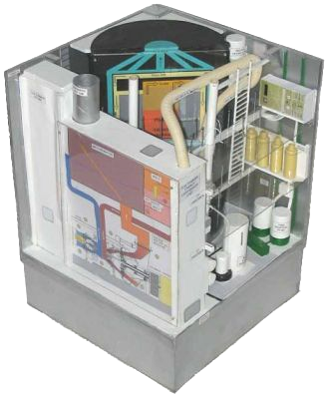

GAS TURBINE
INTAKE

FUNNEL

RECUPERATOR

DOUBLE IHX

ELECTRO MOTOR

COMPRESSOR

TURBINE

GEAR BOX

GENERATOR
DECAY HEAT
REMOVAL

HELIUM BLOWER(S)

DOUBLE HELIUM
CIRCUIT

SWITCH BOARD

PEBBLE-BED
REACTOR

HELIUM STORAGE

HIGH PRESSURE COMPRESSORS

FIRE FIGHTING
PUMPS

BILGE - BALLAST
PUMPS

Figure 7 - Model of a NEREUS, 8 MWe power plant,
scale 1 : 25, 10 x 10 x 10 meters,.

Is able to supply electricity, heat and fresh water for a community of 27,000 people

Inherently safe due to Safety and Power control by the Laws of Physics
(burnable poison, negative temperature coefficient, low power density and decay heat removal by natural draft)

Outlay for a ship, but without many modifications also suitable for energy conversion for Combined Heat & Power production, fresh water production,
stand-alone heat generation and stand-alone electricity generation, with an attractive price per kWh, based upon through life costing and a series of 500 units.

Claude Mandell is director of the International Energy Agency. From the briefing for the leaders of the G-8 in Gleneagles, Scotland, July 2005.
April 2005
March 2006 - Costs of IFO has about doubled, which is favourable for the NEREUS project
Prices are estimates and in round figures and for a production volume of 500 engines.

