Nuclear Power from the View Point of an Environmentalist

by Bruno Comby, President of EFN ⁽¹⁾

“I personally believe that mankind needs nuclear energy. It must be developed, but with absolute guarantees of safety.”

ANDREI SAKHAROV⁽²⁾

Today, many environmental organizations oppose nuclear energy. They propose many reasons to explain why, according to them, nuclear energy would be dangerously unsafe, unclean, anti-democratic, and should be considered as an energy with no future.

However, as an environmentalist dedicated since 20 years to promoting a better life-style and protection of the environment, and with some knowledge in the field of energy, I propose a new view point, based on solid scientific and environmental facts, rather than on irrational dogmas or political agendas, which shows that, for environmental reasons, well built and well-operated nuclear energy is in fact very ecological and can be considered as a central pillar for the satisfaction in a clean manner of the planet's energy needs, that is for creating or maintaining peace and an acceptable life-style for all inhabitants of the planet Earth, and especially to face the thirst for energy of industrial modern countries while saving as much as possible the use of fossile energies for other uses than just burning it and for the development of the poorer countries in Asia, South and Central America, and Africa, until they, themselves will access a level of industrial and financial wealth sufficient to access the use of clean nuclear energy.

While many environmental groups continue to criticize nuclear energy, and sometimes influence the political decisions of some countries, this new environmental view point leads to the conclusion that nuclear contrary is in fact the safest and cleanest energy available, and will be absolutely necessary to satisfy the planet's energy needs in the 21st century.

The world's population is growing and the planet's energy needs are increasing also
Today 25% of the world's population in the richest countries, consumes 75% of the energy. We can only hope that the on-going development of developing countries will continue. The world population is increasing constantly and can be expected to perhaps double by 2050. These two effects (development of developing countries, and increase in world population) are going to dramatically increase the global consumption of energy, the use of fossile fuels, and the production of carbon dioxyde rejected in the atmosphere. The world is thirsty for more energy and this is inevitable, even if developed countries were capable of reducing their energy consumption significantly.

The different types of energy available
Fossile energies (oil, ags, and coal) are the most consumed energy today. However they massively contribute to the greenhouse effect, especially coal, the only one of the three which has reserves extending out to face our needs throughout the coming century. Because they are mssively polluting the atmosphere, and/or will become scarce in a few decades, fossile energies will not, alone, be capable of facing the growing needs of humanity. The top priority should be to reduce our dependance on these energies.
Hydro-electricity is a renewable energy, but there are only a limited number of sites, the potential is therefore very limited in the future (the most interesting sites are already equipped in most countries). Hydro-electricity can help, and should be encouraged, to produce a certain amount (unfortunately limited) of energy in the future, but will not solve the problem alone. Due to the increase in global consumption, and even if we take in account the development of all new possible sites, the share of hydraulic energy is expected to decrease in the 21st century. Hydraulic dams also have a strong impact on the environment (flooding entire valleys) and are not without risks of major accidents. Although nuclear energy and hydraulic dams have produced similar amounts of electricity in the 20th century, dam bursts in the past have killed much more than nuclear energy. For example a single dam burst in Malpasset, France (December 2nd, 1959), created a giant 40 meter high wave that killed 429 persons in a few minutes (10 times more than the Tchernobyl accident did in 16 years) entirely destroying the village of Malpasset, and flooding the city of Frejus 30 km downstream.

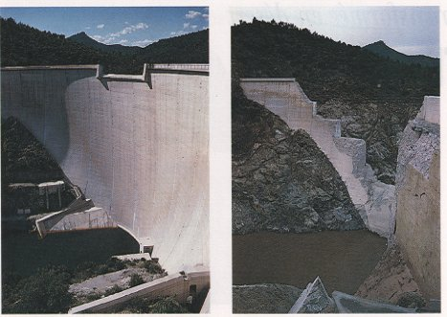

Other renewable energies (solar, wind, etc.) can contribute to some (rather small) extent, and they should be encouraged, but they are too "soft" and "diluted" and "not constant" over time, to contribute significantly. They produce watts or kilowatts, while the population is consuming gigawatts or Terawatts. When a global life cycle analysis of different types of energy production systems is made, solar and wind are largely disqualified due to the amount of energy and construction materials that would be needed to develop large surfaces of such installations (not to speak of the effect on the landscape). For domestic water heating, however, sun heaters by direct circulation of water in pipes exposed to the sun are quite OK. For tropical and some of the poorest countries such as Madagascar, some simple solar heaters could also help to slow down deforestation and the burning of wood just for cooking. Renewable energies can be well adapted for low temperature thermic energy needs (typically cooking or domestic hot water), but they are not very interesting (and would not be ecological) for the fabrication of electricity to be distributed on the grid.
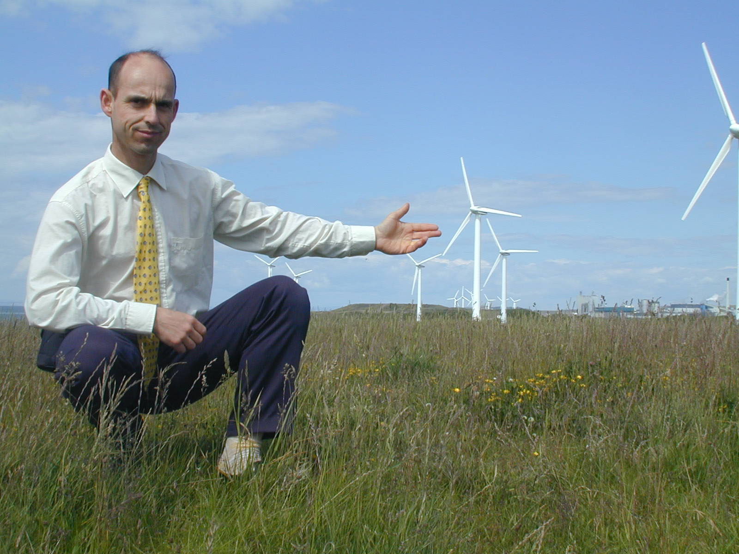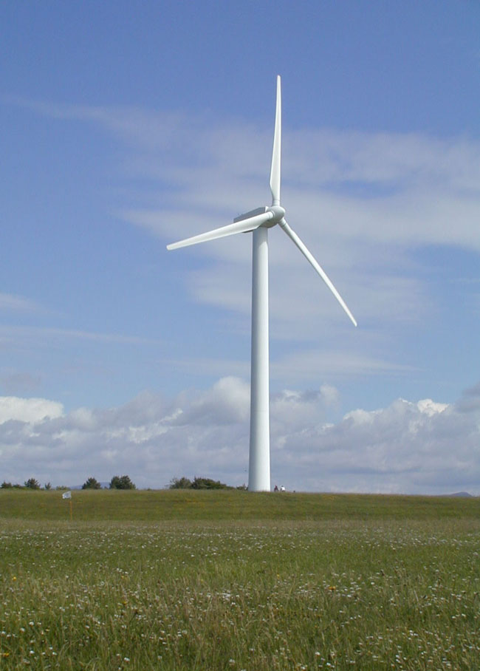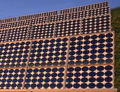
Renewable energies other than hydraulic produce only small amounts of non-constant energy. The only alternative to produce significant amounts of clean energy is nuclear energy.

Radioactivity in nature
Radioactivity exists everywhere in nature. We are exposed to intense and continuous natural radiation coming from the sun, cosmic radiation (from stars other than the sun), telluric radiation (from the ground), and even to the internal radiation of our own body (about 10 000 Becquerels for an average individual). The amount of natural radioactivity can vary very much from one region to another. The average background radiation on Earth is by the order of 0.2 microSv/h, or about 2 mSv/year. But in some areas such as Guarapari in Brazil, the radiation can be locally as high as 40 microSv/h (400 times more than the average background radiation). In Ramsar, Northern Iran, some people are exposed to natural radioactivity at the level of 260 mSv/year (compared to an average background radiation of 2 mSv elsewhere). No adverse effect whatsoever of such high natural background level of radioactivity has ever been demonstrated (if not some positive effects). Even plutonium exists in nature, where it appears by the effect of cosmic radiation on the U 238 contained in the Earth's crust. If the natural levels of radiation (even the highest ones) do not seem harmful in any way, however, we must be careful to protect the population and nuclear workers from the risk of exposure to very high levels of radioactivity.

The high density of nuclear power
One gram of uranium or plutonium or thorium yields as much energy as one ton of oil. Nuclear energy is therefore much more concentrated and powerful, by a factor of one million, than chemical energy. This is often seen as a danger, but this "factor one million" also implies considerable ecological benefits : to produce the same amount of energy, one million times less raw material (fuel) is required, and the volume of the waste produced is by order of one million times smaller, therefore much easier to handle, reprocess and deal with.

Nuclear waste
Nuclear waste is produced in very small amounts (compared to fossile energies), and they are, by definition, self-degradable over time, which is not the case of toxic stable chemical substances. Because of the small volumes of these wastes, they can be easily confined and stored, rather than being rejected into the biosphere or oceans. These waste can and should be reprocessed, and the ultimate waste (only about 3% of the used fuel for PWR's) can than be safely stored underground in a well chosen safe place. The natural reactors at OKLO (Gabon) which have been functioning two billion years ago, show us that, even when the waste is not confined, the heavy metals and waste elements of the nuclear reaction hardly migrate at all in the soil, even when no special protection or confinement system has been installed. Ethically, we must dispose these small volumes of initially highly radioactive waste in a safe way, and morally it is our duty that this be done by the same generation who built and operated the NPP's and benefited from it's electricity.
For ecological reasons, used nuclear fuel should not be considered as waste, and should be reprocessed, as is the case in France, Great Britain, Russia, and Japan.

This cylinder represents the volume of high-level vitrified long-lived radioactive waste resulting from the nuclear fuel that would produce enough electricity to meet the needs of a typical family in all-electric housing with modern conveniences (heating, cooking and other household appliances) for about 30 years. These wastes are not discharged into the environment, but are carefully confined. They are harmless to man and to the environment if they are buried deep under-ground. Nuclear waste represent only a very small volume and their radioactivity decreases very rapidly in the first years.

The example of France
I am very proud as an environmnentalist to be a citizen of the country with the highest share of nuclear electricity (80% of the French electricty production is nuclear), because, in great part thanks to our NPP's, we are one of the cleanest of all developed countries. A French citizen rejects into the atmosphere about half the amount of carbon dioxyde as a German or Danish citizen (their windmills don't produce enough energy to significantly reduce their emissions), and three times less as American citizens. Every year, France's 58 nuclear reactors avoid rejecting more than 200 million tons of CO2 into the planet's atmosphere. France shows to the world to what great extent developing nuclear energy can contribute to protecting the environment.

Informing the public
There are still many myths about nuclear energy. It is essential for the future, and for a cleaner planet, to better inform the public, and much remains to be done in this area. Environmental organizations can and should play a major role in this regard, because they are the most appropriate organizations when it comes to speaking about the environment. However this information should be done in a complete and honest manner, not by manipulating the public opinion with scary highly unrealistic scenarios as some anti-nuclear organizations often do. Now the time has come, and it is a vital issue for humankind, to, as Prof Akimoto nicely writes " dispel the many myths surrounding atomic energy that have been created by international intrigue and power struggles, individual ambition and sensationalism, and release … (citizens) … from the misunderstandings and confusion created by scientists and statesmen with narrow views."

Conclusion
Well built and well-operated nuclear reactors are a very safe and very clean source of energy for the future. We absolutely need to be very cautious about building safe nuclear reactors, and avoiding exposure to very high radioactivity or to prevent any military use of nuclear energy, but, this being said and done, we need not be afraid of relatively small (that is comparable to natural quantities) of radioactivity which have always been bathing the whole of the universe since it exists. As explains James Lovelock, author of the Gaia Theory, one of the main founders of environmentalism " Life began nearly four billion years ago under conditions of radioactivity far more intense than those that trouble the minds of certain present-day environmentalists. Moreover, there was neither oxygen nor ozone in the air so that the fierce unfiltered ultra-violet radiation of the sun irradiated the surface of the Earth. We need to keep in mind the thought that these fierce energies flooded the very womb of life. I hope that it is not too late for the world to emulate France and make nuclear power our principal source of energy. There is at present no other safe, practical and economic substitute for the dangerous practice of burning carbon fuels." (4)

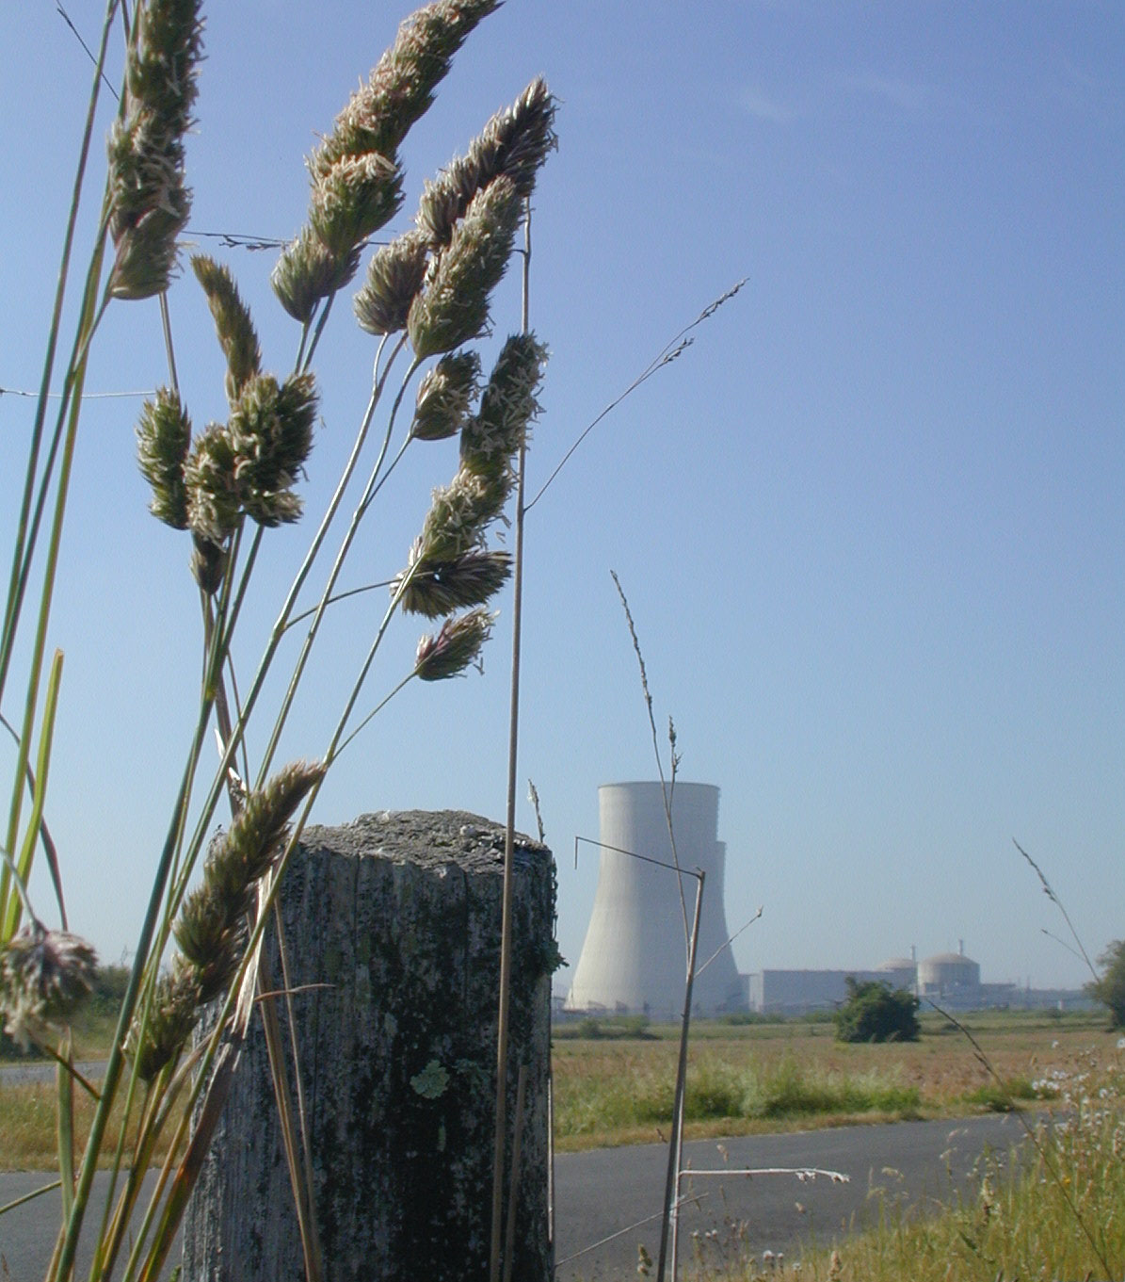 The Civaux nuclear power plant in France.

____________

NOTES :

(1) EFN : Association of Environmentalists For Nuclear Energy - www.ecolo.org - EFN is a non-governmental, non-political international organization gathering more than 5000 members and supporters in more than 40 countries.

(2) Andrei Sakharov, in his foreword to “The Truth about Chernobyl,” by Grigori Medvedev, translated from the Russian by Evelyn Rossiter, I. B. Tauris & Co Ltd, London - New York (May 1989).

(3) Pr. Yumi Akimoto, in his introduction to the Japanese edition of the book "Environmentalists For Nuclear Energy", by Bruno Comby, recently published in Japan by ERC SHUPPAN Publishing Co., April 2002.

(4) Pr. James Lovelock, in the book "Environmentalists For Nuclear Energy", TNR Editions, Paris, 2001 (recently published in Japan by ERC SHUPPAN Publishing Co., April 2002).



