Technology, Vol. 6. pp. 43-61. 1999

VALIDITY OF THE LINEAR-NO THRESHOLD

THEORY OF RADIATION CARCINOGENESIS IN

THE LOW DOSE REGION

Bernard L. Cohen
University of Pittsburgh, Pittsburgh, PA
The cancer risk from low level radiation is conventionally estimated from the well-known effects of high radiation doses by use of the linear-no threshold theory (LNT). Since this practice has great societal consequences, it is important to re-examine and evaluate it. It is shown that the original theoretical basis of LNT has completely disintegrated, and that the role of biological defense mechanisms is of paramount importance. Evidence on this is reviewed and essentially all of it suggests that low level radiation may be protective against cancer. The data on cancer risk to humans from low level radiation are reviewed; while they are weak statistically, they largely suggest failure of LNT in over-estimating the risk of low level radiation. This conclusion is supported by the fact that the latent period between exposure and tumor development increases with decreasing dose, so for low dose exposure, death from other causes would occur before tumor development.
The University of Pittsburgh study of lung cancer rates in U.S. Counties vs. radon exposures gives statistically indisputable evidence on the validity of LNT. This study is reviewed and updated, and criticisms of it are discussed. It concludes that LNT fails badly in the low dose region, grossly
exaggerating the cancer risk of low level radiation.
INTRODUCTION

There is a great deal known about the cancer risk of high radiation doses from studies of Japanese Atomic-bomb survivors, patients exposed for medical therapy, occupational exposures, and others. But the vast majority of important applications deal with much lower doses, usually accumulated at much lower dose rates referred to as "low level radiation" (LLR). Conventionally, the cancer risk from LLR has been estimated by use of a linear-no threshold theory (LNT). For example, it is assumed that the cancer risk from 0.001 Sv (100 mrem) of dose is 0.001 times the risk from I Sv (100 rem). In recent years, the former risk estimates have often been reduced by a "dose and dose rate reduction factor", which is taken to be a factor of two. But otherwise, LNT is frequently used for doses as low as 1/100,000 of those for which there is direct evidence of cancer induction by radiation. It is the origin of the commonly-used expression "no level of radiation is safe" and the consequent public fear of LLR.
The importance of this use of LNT is difficult to exaggerate. It is estimated that $85 billion will be spent in cleaning up the Hanford (WA) site to avoid LLR, and comparable sums will be spent on government operating sites at Savannah River (SC), Rocky Flats (CO), Fernald (OH), and others. If LNT is wrong and LLR is harmless, all of this money will be wasted. Some other areas where huge sums of money are devoted to avoiding LLR are:
- radioactive waste storage technology and siting;
- reactor accident safety; even in the worst accidents, well over 90% of the calculated deaths are from LLR;
3. reduction in routine emissions of radioactivity from nuclear plants; and
4. reduction of radon levels in homes.
Some other problems that would disappear if LNT calculations of the effects of LLR were proven wrong include:
1. The 10,000 to 20,000 deaths claimed to be anticipated from the Chernobyl accident;
2. fallout from nuclear bomb testing; and
3. patient fears of diagnostic x-rays which often compromise the effectiveness of medical treatment.
The LNT paradigm has been carried over to chemical carcinogens, leading to severe restrictions on use of cleaning fluids, organic chemicals, pesticides, and others. If LNT were abandoned for radiation, it would probably also be abandoned for chemical carcinogens.
This paper considers the validity of LNT.
BASIS FOR LNT

Theoretical basis and its shortcomings
The principal basis for LNT is theoretical, and simple. A single particle of radiation hitting a single deoxyribonucleic acid (DNA) molecule in a single cell nucleus of a human body can initiate a cancer. The probability of a cancer initiation is therefore proportional to the number of such hits, which is proportional to the number of particles of radiation, which in turn is proportional to the dose. Thus, the risk is linearly dependent on the dose, this is LNT.
The problem with this simple argument is that factors other than initiating events affect the cancer risk. Human bodies have biological defense mechanisms (BDM) which prevent the vast majority of initiating events from developing into a fatal cancer. Some specific examples follow: Human bodies produce DNA repair enzymes which repair effects of initiating events with high efficiency. Cancer development is a multi-stage process, and consideration must be given to how radiation may affect stages other than initiation. Radiation can alter cell-cycle timing, which can affect cancer development; damage repair is effective only until the next cell division (mitosis) process, so changing this available time can be important. There is good evidence that the immune system plays an important role in preventing cancer development, and its potency can be altered by radiation. All of these considerations and others, which are collectively referred as BDM, require consideration. The above-described basis for LNT is far too simple.
There is plenty of direct and obvious evidence on this. For example, the number of initiating events is roughly proportional to the mass of the animal, more DNA targets means more hits. Thus the simple theory predicts the cancer risk to be proportional to the mass of the animal. However, experience indicates that the cancer risk in a given radiation field is roughly the same for a 30 g mouse as for a 70 kg man, and there is no evidence that elephants are more susceptible than either. Our definition of dose in terms of radiation hits per unit targets mass would be misleading if only the number of hits (which is proportional to the number of initiating events) were relevant, regardless of the mass of the target. Another obvious example of the failure of the simple basis for LNT is in the spectacular increase in cancer incidence with age. Young people experience cancer initiating hits as frequently as old people, but the probability for a cancer to develop is much higher in old people.
There are also serious problems on the molecular level (Pollycove 1998). DNA damage events like those caused by radiation are occurring all the time in human bodies due to chemical and other spontaneous processes. . Single-strand breaks occur at a rate of 150,000 per day in each of the trillion cells in our bodies, whereas 0.1 Sv (10 rem) of radiation, which approaches the upper limit of LLR, causes only 200 per cell, an insignificant addition. As a counter-argument; it is sometimes suggested (despite strong contrary evidence) that double-strand breaks (DSB) are dominantly important for initiating a cancer. These are much more rare, but an average cell experiences about 200 spontaneous DSB per year, whereas 0.1 Sv (10 rem) gives it an average of only 4 DSB, still an insignificant contribution.
Thus, it seems clear that cancer-initiating events are of negligible importance in determining the dose-response relationship for radiation carcinogenesis in the LLR region. Apparently the principal effect of radiation in causing cancer is from modifying BDM rather than from providing initiating events. Thus, the simple basis for LNT has collapsed. LNT can only be justified if the effectiveness of BDM is reduced linearly with increasing dose. This possibility is explored as part of the larger question of how LLR affects the molecular processes involved in cancer development.

Effects of LLR on cancer development
Cancers are initiated by genetic damage in a cell nucleus. One type of genetic damage that has been widely studied is chromosome aberrations, and it was long ago recognized that a high dose of radiation increases the number of these. However, Table I (Shadley and Dai 1992) shows an in vitro example of how that process is affected if the high dose is preceded a few hours before by a low dose (LLR). It can be seen that the number of chromosome aberrations caused by the high dose is substantially reduced. As an example of an in vivo experiment, Cai and Liu (1990) reported that exposure of mouse cells to 65 rad caused chromosome aberrations in 38% of bone marrow cells and in 12.6% of spermatocytes, but if these exposures were preceded 3 h earlier by an exposure to 0.2 rad, these percentages were reduced to 19.5% and 8.4%. respectively. There are many other examples of such experiments, both in vitro and in vivo, and the results are usually explained as stimulated production of repair enzymes by LLR. These are examples of what is called "adaptive response", whereby the body adapts to effects of radiation by developing protective responses.

Table 1. Effects of pre-exposure to 5 cGy on chromosome aberration in human Iymphocyte cells induced by 400 cGy of x-rays 6 h later
Donor Dicentrics& Rings Deletions
400 cGy (5 + 4(00) cGy 400 cGy (5 + 400) cGy
#1 136 92 52 51
#2 178 120 62 46
#3 79 50 39 15
#4 172 42 46 34
#5 134 106 58 41
(Shadley and Dai 1992)

Another type of experiment that reveals effects of "adaptive response" involves detection of genetic mutations. In an example of an in vitro experiment, Kelsey et al. (1991) found that an x-ray exposure of 300 rad induced a frequency of mutations at the hprt locus of 15.5 x I0⁻⁶, but if this large exposure was preceded 16 h earlier by an exposure of I rad, this frequency was reduced to 5.2 x I0⁻⁶. In an in vivo example, Fritz-Niggli and Shaeppi-Buechi (1991) found that the percentage of dominant lethal mutations in offspring resulting from exposures of female drosophila to 200 rad of x-rays before mating was substantially reduced by preceding this high dose with an exposure to 2 rad; for different strains of drosophila and different oocyte maturities, these percentages were reduced from 42% to 27%, from 11% to 4.5%, from 40% to 36%, from 32% to 12.5%, from 42% to 30%, and from 51% to 22%.
A technique has recently been developed for directly observing repair of DNA base damage, and it was applied to studying adaptive response (Le et al. 1998). It was found that preceding an exposure to 2 Gray of gamma radiation with 0.25 Gray 4 h before reduced the time for 50% lesion removal from 100 min to 50 min.
It has been argued that adaptive response may only be effective against large doses of radiation, but it has recently been shown (Azzam et al. 1996) that exposures to low doses of radiation can reduce the rate of spontaneous neoplastic transformation in cells by 3-fold or more.
Since the immune system is important in resisting the development of cancer, the effects of LLR on it are relevant. The effects of LLR on several different measures of the immune response are listed in Table 2 (Liu 1992). By each of these measures, the immune response is increased by LLR. There is at least one study of this effect over a wide range of radiation doses (Makinodan and James 1990); it reports increases in immune response by 80% in vitro and by 40% in vivo at about 20 rad followed by a rapid decrease to well below the unirradiated level at doses of about 50 rad.

Table2. Effects of radiation on immune response. Different columns are percent of response to various tests in unexposed mice to response in mice exposed as indicated
Test 2.5 cGy 5 cGy 7.5 cGy
PFC Reaction 110 143 174
MLC Reaction 109 133 122
Reaction to Con A 191 155 530
NK activity 112 109 119
ADCC Activity 109 128 132 (Liu 1992)

All of the work reported in this section suggests that LLR is protective against cancer. quite the opposite of what is expected from LNT. Not only has the simple basis for LNT collapsed, but there is a large body of evidence indicating that a more complete treatment of the problem would show a decrease in risk with increasing dose in the low dose region. However, final decisions on dose-response are always most heavily weighted on experiences with exposures to humans.
Risk vs. dose data from human exposures
The principal data that have been cited by those in influential positions (Clarke 1997; Sinclair 1996) to support LNT are solid tumors (all cancers except leukemia) among the Japanese A-bomb survivors, and a study of occupational doses to radiation workers by the International Agency for Research on Cancer (IARC). The former data (Pierce et al. 1996) are shown in Fig. 1, where the error bars represent 95% confidence limits (two standard deviations). If error bars are ignored, the points do indeed suggest a linear relationship with intercept near zero dose. But the data themselves give no statistically significant indication of excess cancers for doses below 25 cSv. In fact, it has been shown (Cohen 1998) that considering the three lowest dose points alone, the slope of the dose-response curve has a 20% probability of being negative (risk decreasing with increasing dose). The analysis utilized by Pierce et al, is elaborate, involving fitting models with many variables, city (Hiroshima, Nagasaki), sex, age at risk, year, age at exposure, time since exposure, and dose, to determine both background expected deaths and excess deaths for each of the thousands of combinations of these variables. It is difficult to understand the uncertainties in their analysis. but intuitively it is difficult to understand how strong conclusions can be drawn from their data below 20 cSv, involving a total of 6,312 observed deaths vs. 6,251 expected background deaths derived from their model.

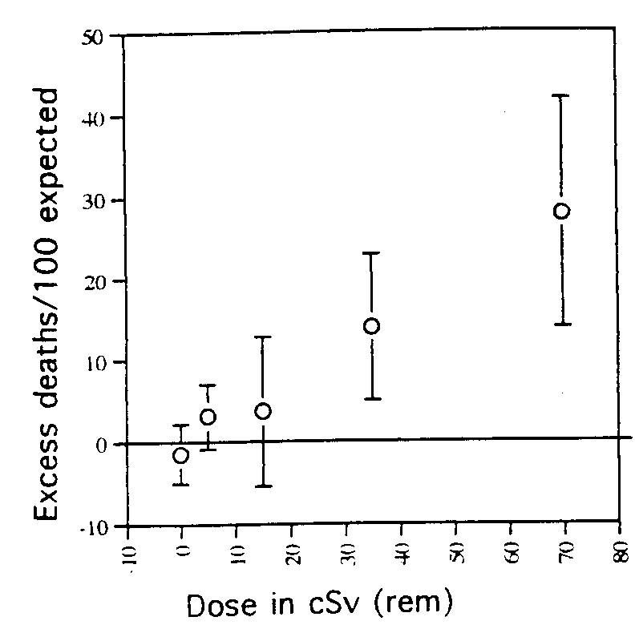

Fig. I Excess deaths from solid tumors per 100 "expected" among Japanese A-bomb survivors (1950-1990) vs.dose (Pierce et al. 1996). Errors bars are 95% confidence limits.

In considering Fig. 1, it may seem implausible for the curve over most of its range to be a straight line directed to zero intercept at zero dose, and then suddenly "dive-down" in the low dose region. But one simple explanation of how this can occur is shown in Fig. 2, which assumes a linear-no threshold dose-response relationship (labeled LNT) plus a stimulation of biological defense mechanisms at low dose (small dot line). Adding these gives the resultant large dot line at low dose merging into the LNT line. Note that the zero ordinate is
easily adjustable because of uncertainties in the "expected'' number of tumors, and the LNT line goes to zero ordinate at a dose of about -5 cSv rather than zero because assigned doses do not include natural background. The resultant curve is an excellent fit to the A-bomb survivor data. With this explanation, one would not necessarily expect the dependence on sex, age, time since exposure, etc. to be the same for LNT as for stimulation of biological defense mechanisms, which would invalidate the elaborate modeling process of Pierce et al. for determining expected background deaths in the low dose region. The other evidence that has been cited as supporting LNT is the IARC study (Cardis et al. 1995) of 95,673 monitored radiation workers in the U.S., U.K., and Canada. For all cancers except leukemia, there were 3.830 deaths but no excess over the number expected. The risk is reported as -0.07/Sv with 90% confidence limits (-04, +0.3).
There is no support for LNT here.

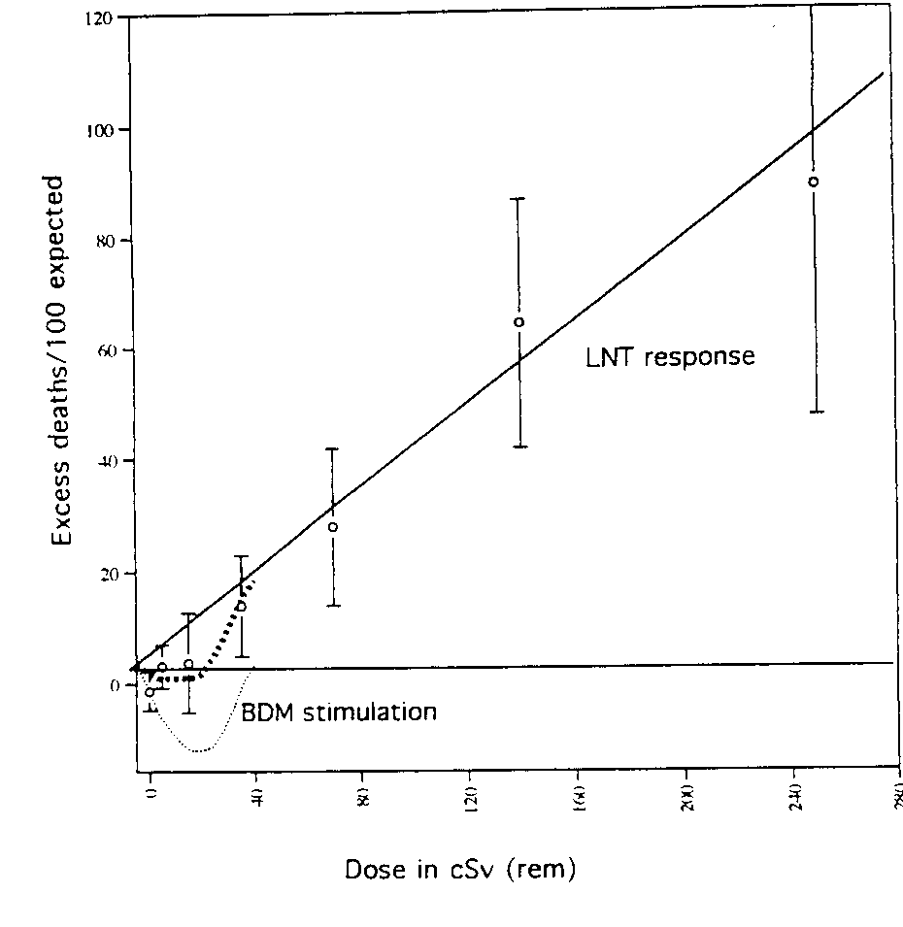

Fig 2. Data from Fig 1 extended to high dose and with proposed analysis into an LNT component (solid line) plus a contribution at low dose from BDM (small dot line) to give a resultant behavior at low dose (large dot line) merging into the LNT line above 50 cSv.

However, for the 146 leukemia deaths, they do report a positive risk vs. dose relationship and claim that this supports LNT. Their data are listed in Table 3. There is no indication of an excess risk below 40 cSv (even the excess for >40 cSv is by only 1.4 standard deviations).

Table 3. Leukemia deaths from IARC study
Dose (cSv) Observed Expected 0/E
0-1 72 75.7 0.95
1-2 23 21.2 1.08
2-5 20 21.8 0.92
5-10 12 11.3 1.06
10-20 9 7.8 1.15
20-40 4 5.5 0.73
>40 6 2.6 2.30
(Cardis et al. 1995)

While the solid tumor data on A-bomb survivors and the leukemia data on monitored radiation workers are said to support LNT (although the leukemia data on the former group and the solid tumor data on the latter group do not). there are several studies that seem to contradict LNT. The data on leukemia among A-bomb survivors (Pierce et al. 1996) are shown in Fig. 3. with error bars indicating 95% confidence limits. These data strongly suggest a threshold above 20 cSv.

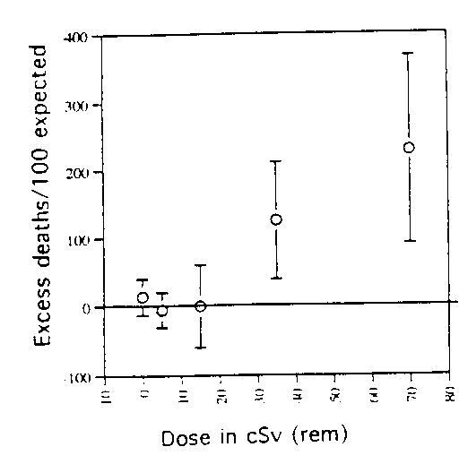

Fig. 3. Excess deaths from leukemia per 100 "expected'' among Japanese A-bomb survivors (1950-1990) vs. dose (Pierce et al 1996). Error bars are 95% confidence limits

A similar behavior is found for breast cancer among Canadian women exposed to x-ray fluoroscopic examinations for tuberculosis (Miller et al. 1989), the data for which are shown in Fig. 4. Here again, there seems to be a decrease in risk with increasing dose at least up to 20 cSv.

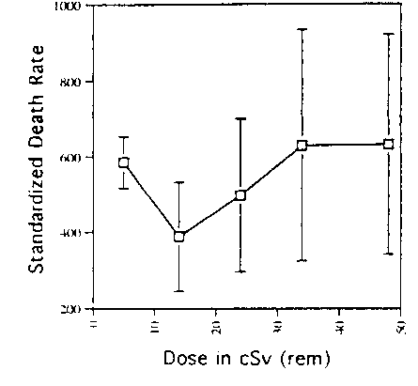

Fig 4. Standardized death rates per million person-years from breast cancer among Canadian women after irradiation in fluoroscopic examinations vs radiation dose (Miller et al 1989). Error bars are 95% confidence limits.

The data on lung cancer among these Canadian women (Howe 1995), and also a one-point study of 10.000 individuals in Massachusetts (Davis et al. 1989) are shown in Fig 5. Here again, there is a decrease in the low dose region, in this case extending at least up to 100 cSv. In Fig. 5 these data are compared with lung cancer data for the Japanese A-bomb survivors, and there is a difference between the
two data sets that is statistically significant, the A-bomb survivor data gives a much higher risk at all doses. This may be explained by the difference between very high dose rate in the A-bomb survivors and the lower dose rate from protracted fluoroscopic exams extending over many weeks. Figure 5 must give one pause before using A-bomb survivor data the method normally used to predict risks from LLR.

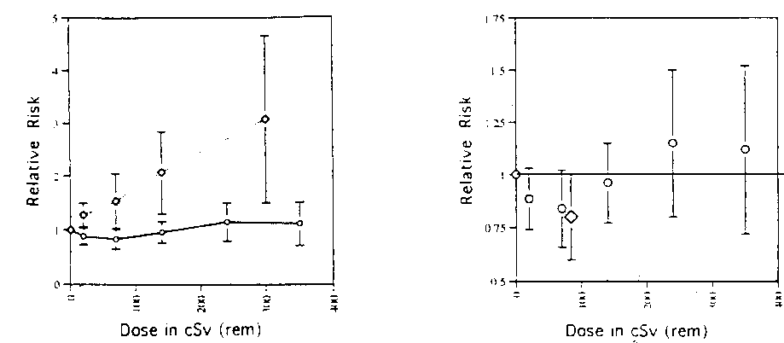
Fig 5. Relative risk or mortality from lung cancer vs. dose to lung, with 95% confidence limits. In lower figure with expanded vertical scale, circles are from Howe (1995) and diamond is from Davis et al (1989). In upper figure (Howe 1995), solid line connects data from Canadian fluoroscopy patients,
and dashed line connects data from A-bomb survivors.

Perhaps the most frequently cited evidence against LNT is based on bone and head cancers among dial painters. chemists. and others occupationally exposed to ingested radium (Evans 1974) The data are shown in Fig. 6. The error bars on the high dose data are one standard deviation. but there were no tumors among those with exposures below 1,000 cGy, making it difficult to estimate error bars.
The asterisks show the ordinate if there had been one rather than zero tumors in each category. The data in Fig. 6 give no support for LNT, and are strongly suggestive of a threshold behavior. Moreover, this threshold behavior is strongly supported with much better statistics by data from injection of radioactivity into animals (References listed in Cohen 1980).

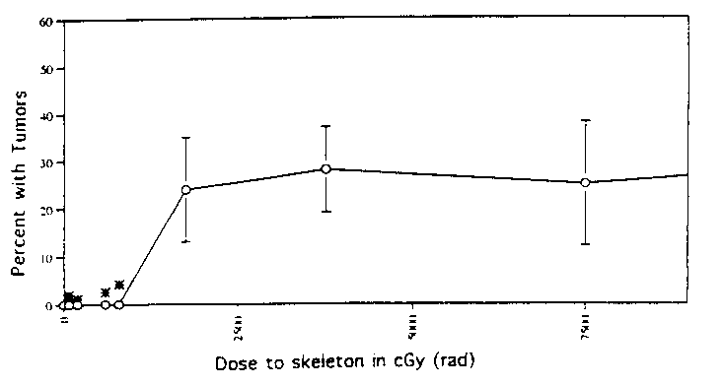

Fig. 6. Data on dial painters, chemists, and others exposed to ingested radium. Ordinate is percent in each dose category that had tumors in the bone or head, and abscissa is the dose in cGy (rad) to the skeleton. For doses above 1.000 cGy, error bars are one standard deviation. There were no tumors for doses below 1.000 cGy; asterisks show the ordinate if there had been one tumor in the dose category. A higher dose data point at 20.000 cGy with ordinate 38% (+/- 13%) is oft the plot (Evans 1971).

In summary of the data on human exposures, there are no statistically-indisputable data sets. If one is guided by indications of marginal to moderately high statistical significance, there is more evidence suggesting a threshold than suggesting validity of LNT in the low dose region
Dependence of latent period on dose
There is a substantial body of data, both on animals and humans, indicating that the latent period between radiation exposure and cancer death increases with decreasing exposure. Earlier references on this work are listed in Cohen (1980). Other elaborate more recent studies by Raabe and others on dogs, people, and rats are reviewed by Raabe (1994). This means that for low exposures, the latent period exceeds the normal life span, so no actual cancers develop. Thus, there is an effective threshold.
This effect alone, even in the absence of all considerations discussed previously, would invalidate LNT for LLR.
How can statistically-indisputable evidence be obtained?
A definitive answer to the validity of LNT in the low dose region must be based on human data, but to obtain statistically-indisputable data requires much larger numbers of subjects than can be obtained from occupational, accidental, or medical exposures. The obvious source is natural radiation. If one attempts to use natural gamma radiation, which varies somewhat with geography, one is faced with the problem that LNT predicts that only a few percent of cancers are due to natural radiation; whereas there are unexplained differences of tens of percent for different geographic areas. For example, the percentage of all deaths that are from cancer varies in the U.S. from 22% in New England to 17% in the Rocky Mountain States (where radiation levels are highest). Another problem is that gamma ray backgrounds vary principally with geographic regions, and there are also many potential confounding factors that may vary with geography. Nevertheless, there have been from occupational, accidental, or medical exposures. The obvious source is natural radiation. If one attempts to use natural gamma radiation, which varies somewhat with geography, one is faced with the problem that LNT predicts that only a few percent of cancers are due to natural radiation; whereas there are unexplained differences of tens of percent for different geographic areas. For example, the percentage of all deaths that are from cancer varies in the U.S. from 22% in New England to 17% in the Rocky Mountain States (where radiation levels are highest). Another problem is that gamma ray backgrounds vary principally with geographic regions, and there are also many potential confounding factors that may vary with geography. Nevertheless, there have been attempts to study effects of gamma ray background on cancer rates and, in general, either no effect or an inverse relationship has been found. For example, no excess cancer has been found in the high radiation areas of India or Brazil. However, all such effects can easily be explained by potential confounding factors.
A more favorable situation is available for radon in homes. According to LNT, it is responsible for at least 10% of all lung cancers, and a known confounded, cigarette smoking, is responsible for nearly all of the rest. Another advantage is that levels of radon in homes vary much more widely than natural gamma radiation.
There have been numerous case-control studies of the relationship between radon in homes and lung cancer. The results of the most credible of these are shown in Fig. 7, and a meta-analysis of them (Lubin and Boice 1997) is shown in Fig. 8. Figure 8 shows that the results from different studies have been inconsistent and this work has given no statistically significant information on the validity of LNT in the low dose region which, in this paper, is defined as below 5 pCi/L, which corresponds to 20-50 cSv (whole body equivalent dose) over a lifetime. A different approach, specifically designed for testing LNT, was carried out by Cohen and is described in the following section.

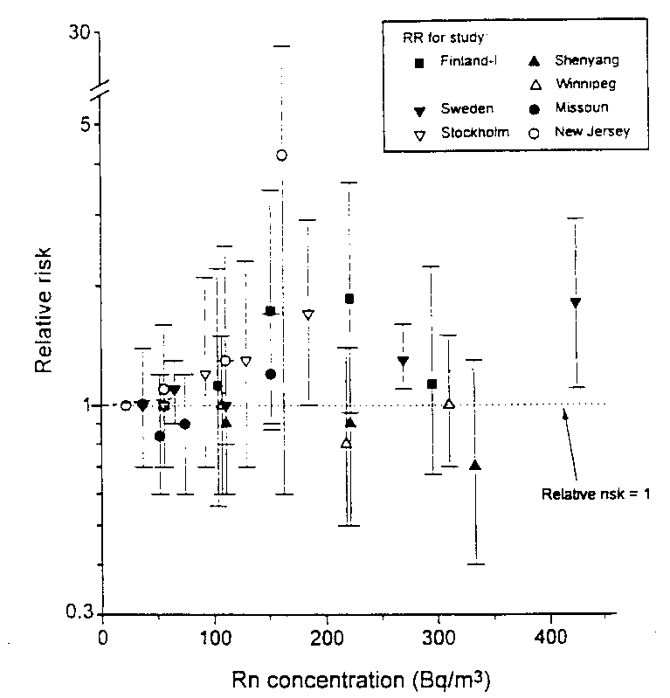

Fig 7. Lung cancer risk vs. radon levels in homes from case-control studies (Lubin and Boice 1997) For converting the horizontal axis, 37 Bq/m³ = 1 pCi/L.
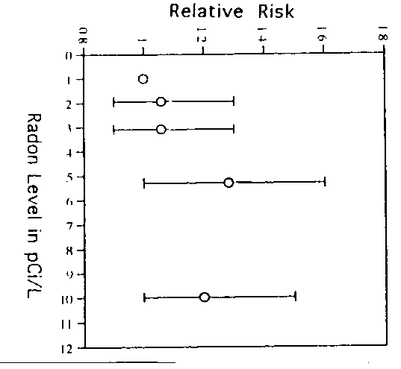

Fig. 8 lung cancer risk vs. radon level in homes from meta-analysis of eight case-control studies by Lubin and Boice (1997)
UNIVERSITY OF PITTSBURGH STUDY
Original 1995 paper

The radon group at the University of Pittsburgh developed an elaborate study designed specifically to test LNT (Cohen 1995). Hundreds of thousands of radon measurements from several sources were compiled to give the average radon level. r, in homes for 1.729 U.S. counties, well over half of all U.S. counties and comprising about 90% of the total U.S. population. Plots of age-adjusted lung cancer mortality rates, m, vs. r are shown in Figs. 9a and c where. rather than showing individual points for each county, they have been grouped into intervals of r (shown on the base-line along with the number of counties in each group). Subsequently. the mean value of m for each group is plotted, its standard deviation indicated by the error bars, and the first and third quartiles of the distribution are shown. Note that when there is a large number of counties in an interval, the standard deviation of the mean is quite small. Figures 9a and c show a clear tendency for m to decrease with increasing r, in sharp contrast to the increase expected from the supposition that radon can cause lung cancer, shown by the line labeled "Theory".
One problem is migration: people do not spend their whole lives and receive all of their radon exposure in their county of residence at time of death where their cause of death is recorded. However. it is easy to correct the theoretical prediction for this, and the "Theory" lines in Fig. 9 have been so corrected. As part of this correction, data for Florida, California, and Arizona, where many people move after retirement, have been deleted, reducing the number of counties to 1.601. This deletion does not affect the results.
A more serious problem is that this is an "ecological study", relating the average risk of groups of people (county populations) to their average exposure dose. Since most dose-response relationships have a "threshold" below which there is little or no risk, the disease rate depends largely on the fraction of the population that is exposed above this threshold, which is not necessarily closely related to the average dose which may be far below the threshold. Thus, in general, the average dose does not determine the average risk, and to assume otherwise is what epidemiologists call "the ecological fallacy". However, it is easily shown that the ecological fallacy does not apply in testing a LNT. This is familiar from the fact that, according to LNT, population dose in person-rem determines the number of deaths; person-rem divided by the population gives the average dose: and number of deaths divided by the population gives the mortality rate which is the average risk. These are the quantities plotted in Fig. 9. Other problems with ecological studies have been discussed in the epidemiology literature, but these have also been investigated and found not to be applicable to Cohen's study.

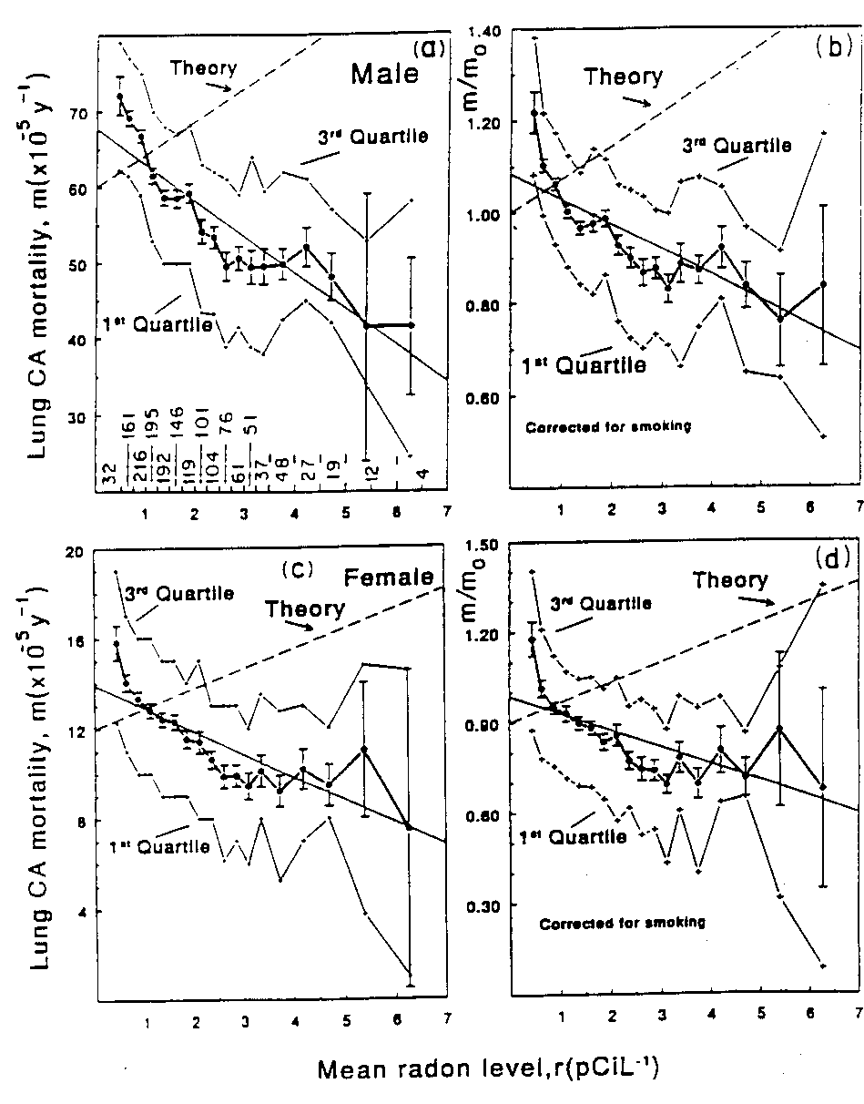

Fig. 9. Lung cancer mortality rates (age-adjusted) vs. average radon level in homes for U.S. Counties (Cohen 1995). Figures b and d are lung cancer rates corrected for smoking prevalence. See
explanations in text.

Epidemiologists normally study the mortality risk to individuals, m', from their exposure dose, r', so one can start from that premise (Eq. 1) using the BEIR-IV (NRC 1988) version of LNT (simplified form: full treatment in Cohen 1995).
m' = a_{n}(l + b r') nonsmokers
m' = a_{s}(1 + b r') smokers
where a_{n} and a_{s} are constants determined from
national lung cancer rates, and b is a constant determined from studies of miners exposed to high radon levels.
Summing these over all people in the county and dividing by the population gives:
m = [Sa_{s}+(1 -S)a_{n}](1 +br) (1)
where m and r have the county average definitions given in the presentation of Fig. 9, and S is the smoking prevalence, the fraction of the adult population that is smokers. Equation l is the prediction of the LNT theory that is being tested here. Furthermore. it can be shown that this test applies not only to the BEIR-IV version but to all other LNT theories. This theory is derived by rigorous mathematics from the risk to individuals, with no problem from the ecological fallacy.
The bracketed term in Eq. 1, referred to here as m₀ contains the information on smoking prevalence, so m/m₀ may be thought of as the lung cancer rate corrected for smoking,. Figures 9b and d show m/m₀ vs. r. The data (i.e.. all 1,601 points) are fit to
m/m₀ = A + B r (2)
deriving values of B. The theory lines are from Eq. I with slight re-normalization. Figures 9b and d show that there is a huge discrepancy between measurements and theory. The theory predicts B = +7.3% per pCi/L, whereas the data are fit by B = -7.3 (+/- 0.6) and -8.3 (+/- 0.8) % per pCi/L for males and females, respectively. A discrepancy between theory and observation of about 30 standard deviations was detected and henceforth referred to as "our discrepancy".
All explanations for this discrepancy that could be developed or have been suggested by others have been tested and found to be grossly inadequate. The review of some of the details of this process follows.
There may be some question about the radon measurements, but three independent sources of radon data, our own measurements, measurements by the U.S. Environmental Protection Agency (EPA), and measurements sponsored by various state governments, have been used and each gives essentially the same results. These data correlate well with one another, and by comparing them, one can estimate the uncertainties in each and in the combined data set; these indicate that uncertainties in the radon data are not a problem
Another potential problem is in values for smoking prevalence (S). Three different and independent sources of data on smoking prevalence were used, and all result in essentially the same discrepancy with LNT seen in Figs 9b and d. Nevertheless, since cigarette smoking is such an important cause of lung cancer, one might think that uncertainties in S-values can frustrate efforts. Analysis shows that the situation is not so unfavorable. The relative importance of smoking and radon for affecting the variation of lung cancer rates among U.S. counties may be estimated by use of the BEIR-IV (NRC 1988) theory. For males, the width of the distribution of S-values, as measured by the standard deviation (SD) for that distribution, is 13,3% of the mean, and according to BEIR-IV a difference of 13,3% in S would cause a difference in lung cancer rates of 11,3%. Whereas the SD in the width of the distribution of radon levels for U S counties is 58% of the mean which, according to BEIR-IV, would cause a difference in lung cancer rates of 6.6%. Thus, the importance of smoking for determining variations in lung cancer rates among counties is less than twice ( 11.3/6.6) that of radon. Smoking is not as dominant a factor as one might think it is.
More important is that S can only influence the results to the extent that it is correlated with the average radon levels in counties. Thus, one is faced with a straightforward quantitative question: How strong a correlation between S and (CORR-r) would be necessary to explain the discrepancy? If one uses the best estimate of the width of the distribution of S-values for U.S. counties, even a perfect negative correlation, CORR-r = -1.0. eliminates only half of the discrepancy. If the width of the S-value distribution is doubled, making it as wide as the distribution of lung cancer rates, which is the largest credible width since other factors contribute to lung cancer rates, an essentially perfect negative correlation, C0RR-r = -0.90, would be required to explain the discrepancy: and to cut the discrepancy in half requires C0RR-r = - 0.62.
How plausible is such a large CORR-r? There is no obvious direct relationship between S and r, so the most reasonable source of a correlation is through confounding by socioeconomic variables (SEV). Fifty-four different SEV were studied to find their correlation with r, including population characteristics, vital statistics, medical care, social characteristics, education, housing, economics, government involvement's, etc. The largest CORR-r was 0.37; the next largest was 0.30; and for 49 of the 54 SEV, CORR-r was less than 0.20. Thus, a CORR-r for S approaching 0.90, or even 0.62, seems completely incredible. Therefore, one must conclude that errors in the S-values can do little to explain "our discrepancy".
In another, largely unrelated study, Cohen (1993) found that the strong correlation between radon exposure and lung cancer mortality (with or without S as a covariate), albeit negative rather than positive, is unique to lung cancer; no remotely comparable correlation was found for any of the other 32 cancer sites. Therefore, the observed behavior is not something that can easily occur by chance.
To investigate effects of a potential confounding variable, data are stratified into quintiles on the values of that variable, and a regression analysis is done separately for each stratum. Since the potential confounder has nearly the same value for all counties in a given stratum, its confounding effect is greatly reduced in these analyses. An average of the slopes B of the regression lines for the five quintiles then gives a value for B which is largely free of the confounding variables under investigation.
This test was carried out for the 54 SEV mentioned above, and none was found to be a significant confounder. In all 540 regression analyses (54 variables x 5 quintiles x 2 sexes), the slopes, B, were negative and the average B value for the five quintiles was always close to the value for the entire data set. This means that the negative correlation between lung cancer rates and radon exposure is found if one considers: only the very urban counties or only the very rural counties; only the richest counties or only the poorest: only the counties with the best medical care or only those with the poorest; and so forth for all 54 SEV. It is also found for all strata in between, as, for example, considering: only counties of average urban-rural balance. or only counties of average wealth, or only counties of average medical care.
The possibility of confounding by combinations of SEV was studied by multiple regression analyses and found not to be an important potential explanation for the discrepancy.
The stratification method was used to investigate the possibility of confounding by geography, by considering only counties in each separate geographical region, but the results were similar for each region. The stratification method was also used to investigate the possibility of confounding by physical features, altitude, temperature, precipitation, wind, and cloudiness, but these factors were of no help in explaining the discrepancy. The negative slope and gross discrepancy with LNT theory is found if one considers: only the wettest areas or only the driest; only the warmest areas or only the coolest; only the sunniest or only the cloudiest.
The effects of the two principal recognized factors that correlate with both radon and smoking were calculated in detail: 1) urban people smoke 20% more but average 25% lower radon exposures than rural people; 2) houses of smokers have 10% lower average radon levels than houses of non-smokers. These were found to explain only 3% of the discrepancy. Since they are typical of the largest confounding effects one can plausibly expect, it is difficult to imagine a confounding effect that can explain the discrepancy. Requirements on such an unrecognized confounder were listed, and they make its existence seem implausible.
Updates on original paper
The 1995 paper (Cohen 1995) was based on lung cancer rates for 1970-1979, the latest age-adjusted data available at that time. Recently, age-adjusted lung cancer rates for 1979-1994 have become available. When these are used, the slopes, B, are changed from -7.3 to -7.7% per pCi/L for males, and from -8.3 to -8.2 for females. Since there are more lung cancer cases included, the standard deviations of these B-values are reduced. increasing the discrepancy with the predictions of LNT to about 30 standard deviations.
The 54 SEV used in the original paper were from the 1980 Census. About 450 new SEV from the 1990 Census have now been introduced and investigated. These include the percentage of the population: I) in 31 different age intervals; 2) with annual income in 10 intervals per capita, per family, and per household; 3) persons, families, and households below the poverty level, with householder age >65, with children age <5, and with children age 5-17; 4) educational attainment of head of household in seven categories; 5) percentage of housing units in 20 different ranges of dollar value; 6) age of house in eight intervals; 7) years family lived in present house in six ranges; 8) number of housing units in the structure in nine intervals; 9) number of persons in the household; 10) age of head of household in seven ranges: 11) number of bedrooms; 12) thirteen different plumbing and heating characteristics; 13) availability of motor vehicles and telephones; 14) rent in six intervals; 15) rent and owner-occupied costs as percentage of income in six intervals: 16) percent of population of five different races, 33 different ancestries, with 17 different languages spoken in the home; 17) year of entry for foreign born in 10 intervals; and 18) percentage of population foreign born, born in different section of U.S.. and born in a different state. Other categories of the newly-added SEV are: family type and presence and age of children: school enrollment: labor force characteristics: methods and times for commuting to work: marital status by sex and age: children ever born to women by age and marital status: and percent of workers in 12 different occupational categories, and in 17 categories of industry. None of these SEV had CORR-r >0.5, and stratification studies for all variables with CORR-r >0.3 gave no indication that any of them would help explain the observed discrepancy.
The ecological study issue
Most criticisms of the Cohen (1995) study have been based on generalized criticisms of ecological studies that have appeared in the literature and are widely recognized. But there are many important differences between our work and other ecological studies. One such difference is in the quantity of data involved. Most ecological studies involve 10-20 (or less) groups of people, whereas ours involves 100 times that number (1,729 counties). Not only does that give a tremendous improvement in statistical accuracy, but it allows more elaborate and sophisticated analyses to be done, including consideration of large numbers of potential confounding factors and use of stratification techniques.
An important difference is that our work avoids the "ecological fallacy". There appears to be no other ecological study that contains that feature. That alone makes our study different from the others, and should earn it the right to be considered free from the prejudice attached to consideration of other ecological studies.
Ecological studies are normally viewed as being fast, simple to carry out, and inexpensive, but none of these adjectives applies to our study. It was the focus of a significant research effort for many years. The radon measurements extended over six years and involved hundreds of assistants with millions of dollars in salaries. The completely separate EPA and State-sponsored measurements used in our study were comparably elaborate. Our data analysis efforts involved dozens of assistants and several years of efforts. Without the power of modern computers and software packages, which have not been available until quite recently, such analyses would have been completely impractical. No other ecological study is known to which any of the considerations would apply.
Since any deep understanding of how radon causes lung cancer must be based on its effects on individuals, it is essential to study the problem in terms of risks to individuals, which seems contrary to the ecological approach. However, our treatment is based on risks to individuals as described in the derivation of Eq. 1. That theory is developed by rigorous mathematics to obtain the prediction of Eq. 1, used to compare with observations. This is a time-honored procedure in science; for example, Newton's famous formula,
F = m a
is rarely tested by direct measurements of acceleration (a) but rather, the formula is developed mathematically to determine distance traveled vs. time, which is much easier to measure. as a test of the theory.
This process is described by the illustrious Nobelist Richard Feynman as follows: "... we look for a new law by the following process: first we guess at it. Then we compute the consequences of the guess to see what would be implied if this law we guessed is right. Then we compare the result of the computation with ... observation, to see if it works. If it disagrees with experiment, the law is wrong. In that simple statement is the key to science. It does not make any difference how beautiful your guess is. It does not make any difference how smart you are, who made the guess, or what his name is, if it disagrees with experiment it is wrong. That is all there is to it."
In our case, the law that "was guessed at" is LNT for individuals, and the consequences that were computed was the relationship between lung cancer rates in counties and average radon exposures in those counties, with suitable corrections for confounding factors. "Our discrepancy" is that the computed relationship is different from the observed relationship.
Negative slopes and conflict with data from case-control studies
It is frequently suggested that the negative slopes in our data for m vs. r (i.e., m decreases with increasing r) are incredible and are in conflict with the results of the case-control studies. It should be recognized at the outset that case-control studies investigate the causal relationship between radon exposure and lung cancer, whereas our work has the much more limited objective of testing the LNT; if that theory fails as we have concluded, "the ecological fallacy" becomes relevant and our results cannot be directly interpreted as representing the risks to individuals. We have therefore never claimed that Fig. 9 gives risks to individuals, or that low level exposure to radon is protective against lung cancer. Our only conclusion is that LNT fails badly, grossly over-estimating the cancer risk of low level radiation.
However, if one insists on interpreting our data as representing the dose-response relationship to individuals, it should be recognized that the negative slopes in our data are entirely based on radon exposures in the range r = 0-3.5 pCi/L (0-130 Bq/m3), whereas the case-control studies give essentially no information on the slope in this region as is evident from Figs. 7 and 8.
Cross-level bias
Recently, Lubin dismissed Cohen's work as useless by a mathematical demonstration of the "cross level bias problem" (Greenland and Robins 1994), showing that an ecological study does not do an adequate job in handling a confounding factor. This problem was addressed in some detail in Cohen (1995, 1997) where it is described as "the ecological fallacy for confounding factors (CF)". The classical "ecological fallacy" arises from the fact that the average dose does not, in general, determine the average risk, but this problem is avoided by designing the study as a test of LNT. Thus, in LNT, the average dose determines the average risk. Use of separate and independent risks for smokers and nonsmokers avoids this problem for smoking prevalence. However, this problem arises for other CF, the average value of a CF does not adequately determine its confounding effects, as demonstrated mathematically by Lubin.
For example, consider annual income as a CF that might confound the radon vs. lung cancer relationship, maybe very poor people have lower radon levels and, for unrelated reasons, have higher lung cancer rates than others. As Lubin's demonstration shows, average income is not necessarily a measure of what fraction of the population is very poor. A case-control study, in principle, selects cases and controls of matched incomes (although this is not always done, and is less frequently done well).
The approach used to address this problem was to use a large number of CFs. For the example under discussion, one may use as CF the fraction of the population in various income brackets, <$5,000/y, $5,000-$1 0,000/y, ..., >$ 150,000/y ( 10 intervals in all). In addition, one may consider combinations of adjacent brackets, and other related characteristics such as the fraction of the population that is below the poverty line, the percent of unemployment, etc.
We have found that smoking prevalence, which is very strongly correlated with lung cancer, must have at least a 25% correlation (CORR-r = -0.5) with radon to have a significant effect, but none of the above CF have a correlation larger than 7%. This provides convincing evidence that income is not an important confounder of the lung cancer vs. radon relationship. If someone can come up with a not implausible model in which income can have an impact, one will be happy to concede.
It is not difficult to devise a model in which cross level bias could nullify the results. For example, one might suppose that those with an income that is an integral multiple of $700 have 50 times lower radon and 50 times higher lung cancer rates than average. Although we have no data to show that this is not the case, such a model is not acceptable for two reasons:
1. It is not plausible.
2. It would also not be taken care of in case-control studies (they do not match incomes with that precision).
What is needed is a model that avoids these two limitations, which are effectively corollaries to Lubin's mathematical proof.
Of course. annual income is not the only CF that must be considered. Another example is age distribution. Case-control studies match cases and controls by age, and as Lubin's mathematical demonstration shows, average age in a county does not handle this problem in our study. Age-adjusted mortality rates were used, which take care of the gross aspects of that problem, but there are limitations in the age-adjustment process. Thus. the solution was to use as CF the percent of the population in each age bracket, < 1 y, 1-2y, ……80-84y. >85y (31 age brackets in all), and to also use combinations of adjacent age brackets. None of these age brackets had correlation's with radon above 4% with the exception of the >85y bracket where the correlation was 7.7%. This was further investigated by stratification, using five strata of 320 counties each and determining B (cf., Eq. 2) of the lung cancer vs. radon relationship for each stratum. As one goes from the stratum with the lowest to the stratum with the highest percent of population with age >85y, B-values for males were -10.1, -6.4, -6.1, -4.7, and -7.2% per pCi/L: for females they were -6.3, -2.0, -9.1, -3.5. -10.7% per pCi/L, whereas LNT predicts B = +7.3% per pCi/L. Since the value of B is negative and grossly discrepant with the LNT prediction for all cases, and there is no consistent trend in its variations. the correlation between radon and elderly people cannot explain the observed discrepancy. One cannot prove this mathematically, but one cannot concoct a not-implausible model in which variations of radon and lung cancer with age helps substantially to explain "our discrepancy". As Lubin's proof shows, it is possible to concoct a model to explain the observed discrepancy, e.g., one might assume that those born on the first day of a month have 50 times higher radon levels and 50 times lower lung cancer rates than others, but that does not satisfy the two corollaries to Lubin's proof.
There are few, if any, other bases on which case-control studies match cases and controls, but our study gave similar treatments to a host of other potential confounding factors, educational attainment, urban vs. rural differences, ethnicity, occupation, housing, medical care, family structures, etc. None of these can explain the observed discrepancy.
The smoking-radon interaction
Equation 1. derived to relate lung cancer rate m to r and S is
m = [ S a_{s}+ (1 - S) a_{n}] (1 + B r )
where a and B are constants. This has given many the impression that we have assumed some special and simple (linear) relationship between smoking and radon exposure in causing lung cancer. Despite the appearance of the above equation, that is not the case.
BEIR-IV considers smokers and non-smokers as separate "species", each with its own lung cancer risks. The relationship between radon and smoking in causing lung cancer in an individual can be infinitely complex In utilizing the BEIR-IV model to mathematically derive the mortality rate for a county, the fraction of the county population that smokes, S, logically arises and the result is the above formula. Note that S is not the intensity of smoking by an individual, but it is simply the fraction of the population that smokes cigarettes, the fraction of the population that is in that "species".
If counties kept separate statistics on cause of death for smokers and non-smokers, S would not be involved. In this case, two completely separate and independent studies could be performed for smokers and non-smokers. It is only because counties do not keep separate statistics that one must combine these two studies, and this introduces the relative size of the two groups which is represented by S.
CONCLUSION
Because no other plausible explanation has been found, the most plausible explanation for the observed discrepancy is that LNT fails, thereby grossly over-estimating the cancer risk in the low dose, low dose rate region. There are no other data capable of testing the theory in that region.
An easy answer to the credibility of this conclusion would be for one to suggest a potential not-implausible explanation based on some selected variables. Subsequently, one would then calculate what values of those variables are required to explain the discrepancy. One could then make a judgment on the plausibility of that explanation. To show that this procedure is not unreasonable, Cohen offers to provide a not-implausible explanation for any finding of any other published ecological study. This alone demonstrates that this work is different from any other ecological study, and therefore deserves separate consideration

Acknowledgment. The author is greatly indebted to Dr. Myron Pollycove (U.S. Nuclear Regulatory Commission) for very helpful discussions and references to relevant publications.
REFERENCES
Azzam, E.l.: de Toledo, S.M.: Raaphorst, G.P.: Mitchel, R.E.J. Low dose ionizing radiation decreases the frequency of neoplastic transformation to a level below spontaneous rate in C3H I0TI/2 cells. Radiat. Res. 146 :369-373:1996.
Cai. L.: Liu. S.Z. Induction of cytogenic adaptive response of somatic and germ cells in vivo and in vitro by low dose x-irradiation. Int. J. Radiat. Biol. 58: 187-194: 1990.
Cardis, E. et al. Effects of low dose and low dose rates of external ionizing radiation: Cancer mortality among nuclear industry workers in three countries. Radiat. Res. 142: 117-132; 1995.
Clarke. R. (President of ICRP) Address at Massachusetts Institute of Technology. December 8. 1997. unpublished.
Cohen. B.L. The cancer risk from low level radiation. Health Phys. 39: 659-678: 1980.
Cohen. B.L. Relationship between exposure to radon and various types of cancer. Health Phys. 65: 529-531: 1993.
Cohen. B.L. Test of the linear-no threshold theory of radiation carcinogenesis for inhaled radon decay products. Health Phys. 68: 157-174: 1995.
Cohen. B.L. Problems in the radon vs. lung cancer test of the linear-no threshold theory and a procedure for resolving them. Health Phys. 72: 623-628:1997.
Cohen. B.L. The cancer risk from low level radiation. Radiat. Res. 149: 525-526: 1998.
Davis. H.G.; Boice. J.D.: Hrubec, Z.: Monson. R.R. Cancer mortality in a radiation-exposed cohort of Massachusetts tuberculosis patients. Cancer Res. 49: 6130-6136: 1989.
Evans. R.D. Radium in man. Health Phys. 27: 497-510: 1974.
Fritz-Niggli, H.; Schaeppi-Buechi. C. Adaptive response to dominant lethality of mature and immature oocytes of D. Melanogaster to low doses of ionizing radiation: Effects in repair-proficient and repair deficient strains. Int. J. Radiat. Biol. 59: 175-lg4: 1991.
Greenland. S.: Robins. J. Ecologic studies: Biases, misconceptions. and counter examples. Am. J. Epidemiol. 139 747-760: 1994.
Howe. G. R. Lung cancer mortality between 1950 and 1987 after exposure to fractionated moderate dose rate ionizing radiation in the Canadian fluoroscopy cohort study and a comparison with lung cancer mortality in the atomic bomb survivors study. Radiat. Res. 142: 295-304;1995.
Kelsey. K.'f.: Memisog1u. A.: Frenkel. A.: Liber. H.L. Human lymphocytes exposed to low doses of x-rays are less susceptible to radiation induced mutagenesis. Mutat. Res. 263: 197-201: 1991.
Le, X.C.: Xing. J.Z.: Lee. J.. Leadon. S.A.: Weinfeld. M. Inducible repair of thymine glycol detected bv an ultrasensitive assay for DNA damage. Science 280: 1066-1069; 1998.
Liu. S.J. Multilevel mechanisms of stimulatory effect of low dose radiation on immunity. In: Low Doser Irradiation and Biological Defense Mechanisms. Amsterdam: Excerpta Medica: 1992.
Lubin. J.ll.; Boice. J.D. Lung cancer risk from residential radon: meta-analysis if eight epidemiologic studies. J. Nat. Cancer Inst. 89: 49-57: 1997.
Makinodan. T.: James. S.J. T cell potentiation by low dose ionizing radiation: Possible mechanisms. Health Phys. 59: 2934:1990.
Miller. A.B.: Howe. G.R.: Sherman, G.J.. Lindsay. J.P.: Yaffe. M.J.: Oinner. P.J.: Risch. H.A.: Preston. D.L. Mortality from breast cancer after irradiation during fluoroscopic examinations in patients being treated for tuberculosis. N. Engl. J. Med.321: 1285-1289: 1989.
NRC (National Research Council). Health risks of radon and other internally deposited alpha emitters (BEIR-IV). Washington. DC: Natl. Acad. Press: 1988.
Pollycove M. Human biology, epidemiology, and low dose ionizing radiation. Presentation to NCRP. Bethesda. MD: Feb. 17, 1998
Pierce. D.A.. Shimizu. Y.: I'reston. D.l..: Vacth. M.: Mabuchi. K. Studies of the mortality of atomic bomb survivors. Report 12. Pan 1. Cancer: 1950-1990. Radiat. Res. 146: 1-27: 1996.
Raabe. O.G. Three dimensional models of risk; from internally deposited radionuclides. Chap. 30. In: Raabe. O.G.. ed. internal Radiation Dosi-metry. Madison. Wl: Med. Phys. Publ.: 1994.
Shadley. J.D.: Dai. G.Q. Cytogenic and survival adaptive responses in G-1 phase human lymphocytes. Mutat. Res. 265: 273-28: 1992.
Sinclair. W. (President-Emeritus of NCRP). Nucleon. Week 36 (46) November 14. 1996.

