What Becomes of Nuclear Risk Assessment in Light of Radiation Hormesis?

Jerry M. Cuttler

Cuttler & Associates Inc.
1781 Medallion Court, Mississauga, ON L5J2L6
jerrycuttler@rogers.com

Abstract – A nuclear probabilistic risk or safety assessment (PRA or PSA) is a scientific calculation that uses assumptions and models to determine the likelihood of plant or fuel repository failures and the corresponding releases of radioactivity. Estimated radiation doses to the surrounding population are linked inappropriately to risks of cancer death and congenital malformations. Even though PRAs use very pessimistic assumptions, they demonstrate that nuclear power plants and fuel repositories are very safe compared with the health risks of other generating options or other risks that people readily accept. Because of the frightening negative images and the exaggerated safety and health concerns that are communicated, many people judge nuclear risks to be unacceptable and do not favour nuclear plants.

Large-scale tests and experience with nuclear accidents demonstrate that even severe accidents expose the public to only low doses of radiation, and a century of research has demonstrated that such exposures are beneficial to health. A scientific basis for this phenomenon now exists. PRAs are valuable tools for improving plant designs, but if nuclear power is to play a significant role in meeting future energy needs, we must communicate its many real benefits and dispel the negative images formed by unscientific extrapolations of harmful effects at high doses.

- NUCLEAR RISK ASSESSMENT

Nuclear engineers calculate the likelihood of all possible accidents at a nuclear power plant and the resulting probability that people nearby might be harmed by such accidents. The discipline is called probabilistic risk or safety assessment (PRA or PSA). The best known study, completed thirty years ago, was sponsored by the NRC and directed by N. Rasmussen at MIT.^{[1]} It was based on the method known as fault tree analysis.

The PRA starts with the initiating event and is followed by an “event tree”. The first probability is the probability that event will be initiated. Then the first branch in the event tree is examined and the probability that each option will occur is entered. Then the next branch in each option is examined and the probabilities that each possibility will occur are entered, and so forth. Finally, the probabilities of the paths that lead to the accident are summed to obtain the probability of the accident.
The NRC has set the following two safety goals in terms of the probability of a human fatality:
- The probability that a person living near a nuclear power plant will die soon after a nuclear accident from the radiation released in the accident must be less than 0.1% of the total probability that a person will be killed in any accident.
- The probability of death from cancer for any member of the public following an accident must be less than 0.1% of the total probability that a person will die of cancer from all causes.

Since the average probability per year that a person will die from all accidents is about 5 x 10⁻⁴ or one chance in 2000, the first safety goal means that the probability per year that the person living next to a nuclear plant will die soon after a nuclear accident from the radiation released in the accident must be 1000 times less, that is less than one chance in two million.

The most extensive study of reactor safety ever conducted, NUREG-1150, was completed by the NRC in 1990.^{[2]} Five specific PWR and BWR nuclear plants were studied. The analysis was broken down into four fundamental parts:
- The frequency of core damage
- Radioactive source term inside containment
- The probability of containment failure
- Calculated off-site consequences.

For one of the plants, the average probability of core damage per year from all potential internal accident scenarios is 4 x 10⁻⁵ per year or one chance in 25,000 per year. The range of calculated probabilities (5-95% certainty) is not greater than one chance in 8000 and not less than one chance in 140,000 per year. Next the amount of radioactive material that can get out of the fuel and into containment is considered, with particular focus on iodine-131, cesium-137 and strontium-90. The next steps address the ways that radioactivity can escape or be released from containment and the off-site consequences, which depend on weather conditions, surrounding population density, the extent and timing of evacuation, and the damage to health due to exposure to the various radionuclides that reach the people. The final step links cancer risk to radiation exposure. It uses the linear, no-threshold (LNT) model of radiation carcinogenesis.

The significant results of the NUREG-1150 are:

 | Surry (PWR) | Peach Bottom (BWR) | NRC Safety Goal
Average probability of an individual early fatality per year | 2 x 10⁻⁸ | 5 x 10⁻¹¹ | 5 x 10⁻⁷
Average probability of an individual latent cancer death per year | 2 x 10⁻⁹ | 4 x 10⁻¹⁰ | 2 x 10⁻⁶

For both the PWR and the BWR, the calculated probabilities for damage to the public are far below the safety goals. These results hold for all the reactors analyzed and for the range of probabilities calculated in addition to the average results. In addition, it was determined that the likelihood per year of an accident large enough to cause at least one early fatality to the public is in the range of one in one million to one in one billion per year.

- WHY ARE PEOPLE SO CONCERNED ABOUT NUCLEAR SAFETY?

These scientific PRA calculations show that nuclear plants are very safe and, if the “unsolved problem” of managing used nuclear fuel (above or below ground) is also considered,^{[3]} nuclear power generation is much safer than fossil-fired generation. So why are people so concerned about the safety of nuclear power generation?

Firstly, as discussed later, the radiation protection authorities have grossly exaggerated the hazards due to low doses of radiation, in terms of congenital malformations and death from cancer, which are very negative images for public perception of nuclear technology. There is no scientific evidence to support these postulated adverse health effects in nearby populations following even worst-case accident scenarios. There is no evidence of an increase in the incidence of adverse genetic effects, even among the Japanese atom bomb survivors.^{[4]} On the contrary, as discussed in Section V, there is recent evidence suggesting that the incidence of congenital malformations after exposure to low dose rate radiation is lower than the spontaneous incidence. As for cancer, the evidence suggests that a lower incidence of cancer mortality can be expected instead of a higher incidence. So, there is no scientific justification for the “as low as reasonably achievable” (ALARA) requirement; the radiation scare that has been created is not warranted.

Secondly, the probabilities for events and the associated radiation doses, calculated in PRAs, are much greater than are really likely to occur. Safety analysts make very conservative assumptions in creating accident scenarios, “just to be on the safe side”. They do not take adequate credit for the high degree of quality and safety assurance provided by the use of nuclear standards in the design, manufacture (with nuclear-grade materials) and construction of nuclear facilities. Adequate credit is not allowed for the high standards employed in the operation, inspection and maintenance of nuclear facilities, which include upgrades due to feedback of operational experience from other facilities. Calculations of the movement of radioactivity to nearby people are pessimistic. The analysis methodologies employed are very conservative. Yet concerns are often expressed about the need to “improve” nuclear safety, which have created increased anxiety in a public that has been taught to fear any exposure to radiation. This has been recognized. Recently, an evolution-revolution has begun in safety analysis technology to examine assumptions and conservatisms in order to model reality more accurately.^{[5]}

Comparisons by the nuclear industry between calculated nuclear risks and other risks that people accept will not persuade the public to accept nuclear technologies because the industry continues to inform people that any amount of radiation is dangerous and that the safety of nuclear facilities has to be improved. Consequently, people make adverse judgments about the acceptability of nuclear risks, which translates into considerable public reluctance to accept nuclear generation.
- WHAT ARE THE OBSERVED HEALTH CONSEQUENCES OF NUCLEAR ACCIDENTS?

So-called “nuclear accidents” generally do not harm people, as do automobile or airplane accidents, so better terminology is required. Consider the consequences of the 1986 Chernobyl disaster,^{[6, 7]} which is about the worst imaginable nuclear accident – well beyond the design basis of modern reactor designs. Approximately 40% of the reactor core and most of its radioactivity were released to the surroundings. The nearby population was evacuated soon after the event. These people received an average whole body radiation dose of 0.015 Gy (1.5 rad)∗. About 1800 cases of operable thyroid cancer, possibly spontaneous occult thyroid cancers,^{[8]} were detected in the screening process. No excess leukemia or other cancers were observed during the following 14 years. These data are being reviewed continually, and the new evidence continues to confirm these observations.

Psychological stress was the major adverse health effect due to fear of the potential consequences that the radiation protection authorities have been predicting. The permanent relocations have been very stressful. Throughout the world, there was widespread fear of the radioactive contamination and there were very strong social and political reactions. The economic consequences were severe in the Ukraine and somewhat less so in the neighbouring countries.

- EVOLUTION OF RADIATION PROTECTION RECOMMENDATIONS

For more than a century, beneficial health effects have been observed following acute exposures to small doses or chronic exposures to low dose rates of ionizing radiation.^{[9]} Why have attitudes toward all nuclear technologies been clouded by the negative images of the risk of cancer and congenital malfunctions for the past 50 years? Even diagnostic X-ray exposures are resisted.

The early radiation protection recommendations were tailored to avoid burns and late effects from acute doses of radiation. This involved defining a safe limit for exposures (e.g., 0.2 R/d in 1934 and 0.3 R/wk in 1951). By 1955, this threshold concept was rejected by the International Commission on Radiological Protection (ICRP) in favour of the concept of cancer and genetic risks, kept small compared with other hazards in life. “Since no radiation level higher than natural background can be regarded as absolutely ‘safe’, the problem is to choose a practical level that, in the light of present knowledge, involves negligible risk.”^{[10]} This change in philosophy was brought about by new biological information – epidemiological evidence of excess cancer malignancies among radiologists and indications of excess leukemia cases in the survivors of the atomic bombings at Hiroshima and Nagasaki – “stochastic effects”, whose probability of occurrence, not the severity, was assumed to be proportional to the size of the dose.^{[10]}

This is the origin of the linear, no threshold (LNT) model of radiation carcinogenesis. It derives from the hypothesis that a single impact of ionizing radiation on a cell causes an alteration, which could develop into a mutation, which could eventually become the first cancer cell in a tumor, which could cause death. The likelihood of this transformation, from a normal cell to organism death, is assumed to be proportional to dose. Following exposure to a range of high doses, statistically significant data on the number of cancer deaths in a population (the Hiroshima-Nagasaki survivors) in excess of the naturally-occurring (spontaneous) number expected were fitted by a straight line. It was then extended to zero dose through the low dose region, < 0.5 Gy, where there was no statistically significant evidence of adverse effects.

The LNT model for an acute exposure to low LET radiation is shown in Figure 1.^{[11, 12]} It is still employed to calculate the excess number of cancer fatalities in a population following its exposure to a low dose from a (human-made) source of radiation. (A risk reduction factor, in the range from 2 to 10, may be applied to the integrated dose of a chronic exposure at a low dose rate.) The increase in the average dose (above background) received by this population due to the source is evaluated. This “collective dose” is multiplied by the slope of the LNT line to predict the number of people, in excess of the number of spontaneous cancer deaths (about a quarter of the population), who will die from cancer. And for a person, the incremental exposure he/she received is multiplied by this factor to determine his/her increased risk of dying from cancer.

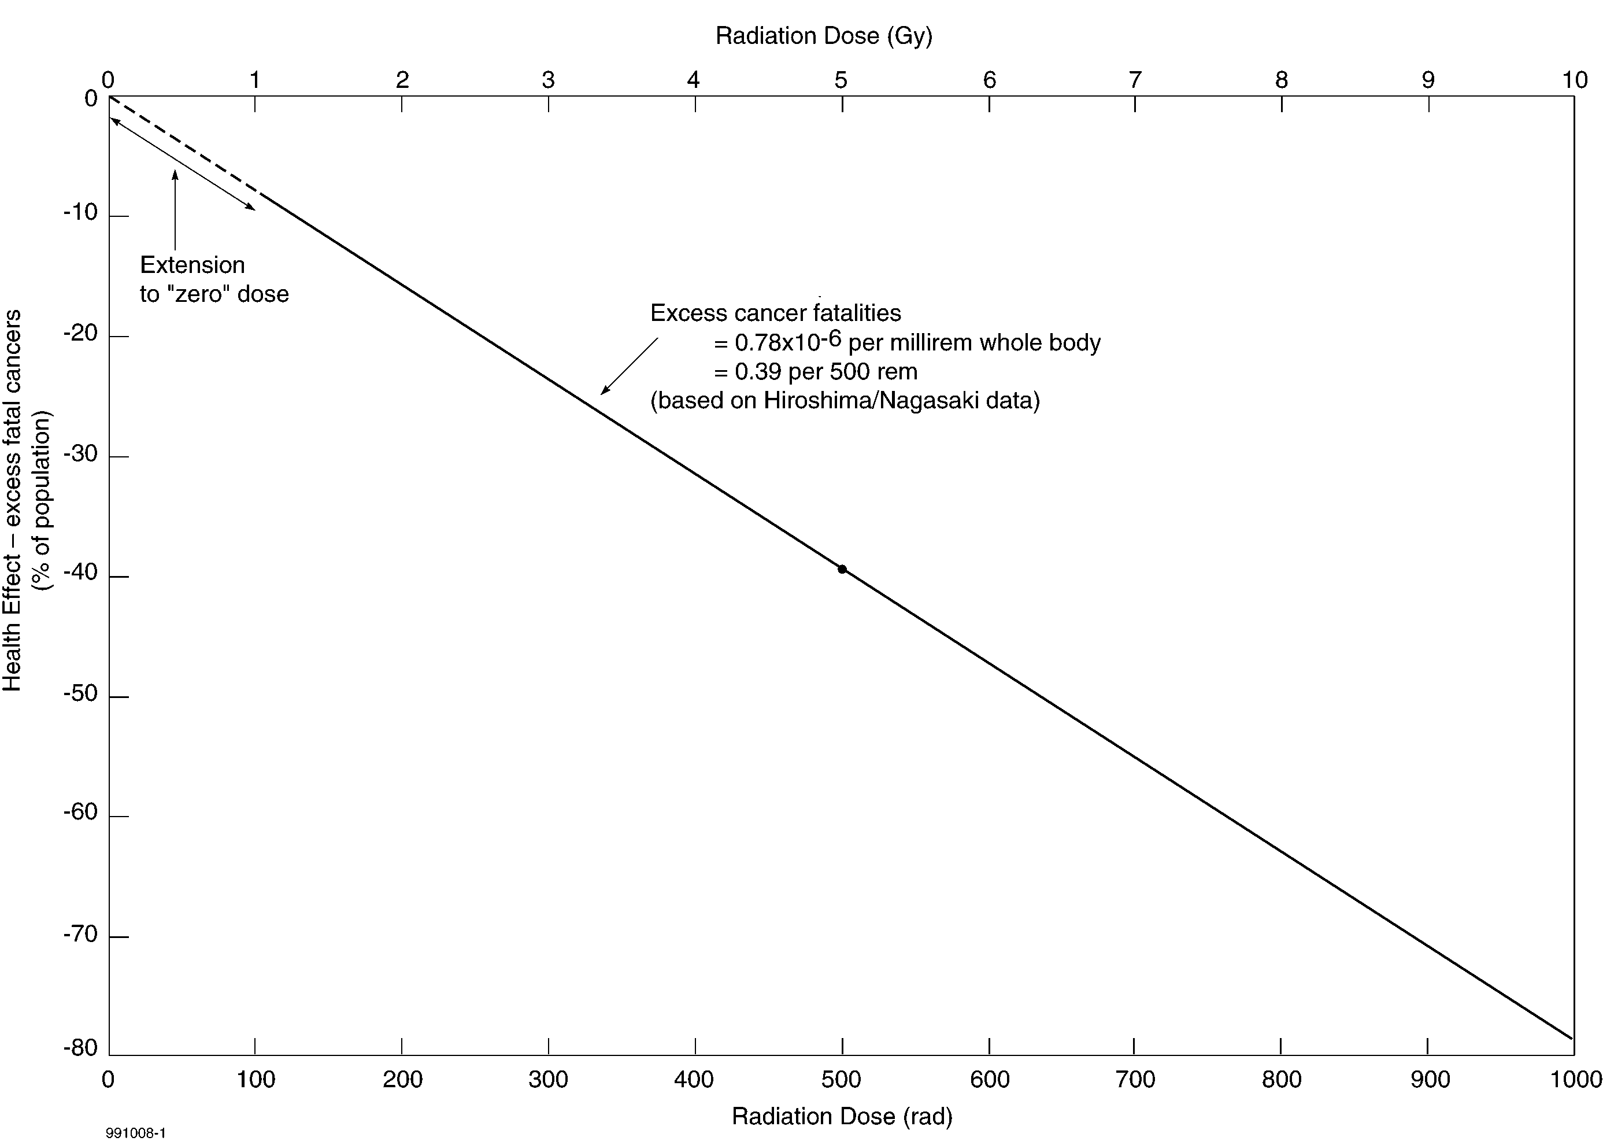

Figure 1. The linear, no threshold dose-response model for radiation-induced cancer^{[11, 12]}

But why were the beneficial health effects, observed in prior years,^{[9]} ignored during the 1930-50s when recommendations evolved to protect radiation workers? To understand the answer, we have to consider the social and political environment at that time. Scientists were agonizing over their roles in the development and actual use of A-bombs in war. The creation of large stockpiles of more powerful nuclear weapons in several countries raised enormous moral issues and fears about their potential use. People realized they could not “put the genie back in the bottle”, and many campaigned against A-bomb development, testing and production, and for nuclear disarmament. Figure 2 is an example of the concerns that were expressed by some scientists and others about potential, long-term adverse health effects following exposures to very small amounts of radioactive fallout.^{[13]}

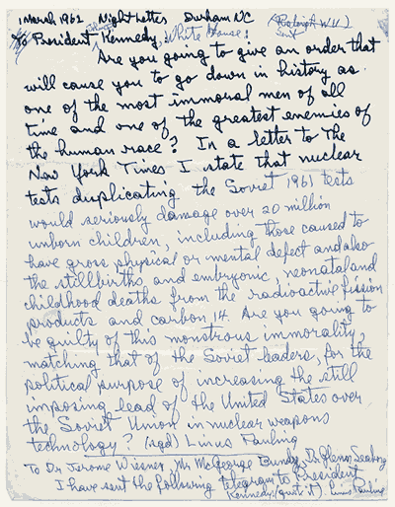

Figure 2. Professor Linus Pauling’s telegram to President J.F. Kennedy, March 1, 1962^{[13]}
After winning the Nobel Prize in Chemistry in 1953, Pauling became science’s most prominent activist against nuclear weapons testing, a movement which led to the 1963 ban on above-ground testing and Pauling’s Nobel Peace prize.

These concerns were based on political agendas; there was (and is) no scientific basis for such statements. Once such concerns are created about small amounts of radiation, it is very difficult to change attitudes back to a scientific approach. Over the past 60 years, many research programs were carried out to study adverse biological effects, measured at high doses and extrapolated linearly to zero dose. Observations of beneficial health effects were either ignored or suppressed. The experiments were generally not designed to observe beneficial effects.^{[14]}

- IS THE LNT MODEL VALID?

Intensive, wide-ranging research has been carried out on the effects of radiation on living organisms, including humans.^{[15, 16, 17]} Generally, cellular stimulatory effects are observed following low doses – short-term exposures in the range 0.01-0.50 Gy (1-50 rad) – while damaging or lethal cellular effects are observed following high doses. This biphasic radiation dose response is known as radiation hormesis, an adaptive response of biological organisms to low levels of stress or damage – a modest overcompensation to a disruption–resulting in improved fitness.^{[18, 19]} “The hormetic model is not an exception to the rule – it is the rule.”^{[20]}

Recent discoveries indicate that oxidative DNA damage occurs naturally to living cells at an enormous rate. Survival to old age depends on the performance of a very capable damage-control biosystem, which prevents, repairs, or removes almost all the DNA alterations.^{[21, 22]} Figure 3 illustrates the very powerful antimutagenic performance of this biosystem.^{[23]} Those DNA alterations not eliminated by this protective system are residual mutations, a very small fraction of which eventually develops into cancer.

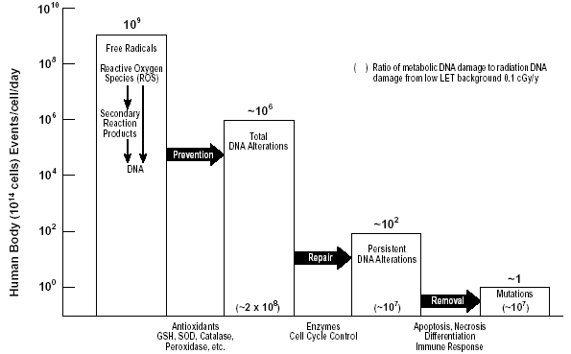

Figure 3. Antimutagenic DNA damage-control biosystem^{[23]}

The rate of DNA mutations caused directly by background radiation compared with the rate produced by endogenous oxygen metabolism is extremely small. Nevertheless, radiation has a very important effect on the damage-control biosystem. While high doses decrease biosystem activity, causing increased cancer mortality, low doses stimulate biosystem activity causing lower-than-normal cancer mortality. Stimulation of the immune system increases the attack and killing of cancer cells (including metastases) globally.^{[24]} These stimulatory effects reduce or delay significantly the incidence of cancers due to oxidative DNA damage or other causes.

The evidence of hormetic effects of radiation exposure on cancer has lead to recent applications of whole-body, low-dose irradiation therapy for cancer, with no symptomatic side effects.^{[25]}

As mentioned earlier, iodine-131 is a prime concern in reactor safety. It is easily released (as seen in the 1957 Windscale incident) and is readily absorbed (in the thyroid). Safety analysts assume that it causes cancer deaths according to the LNT hypothesis, but does it really? Medical studies of cancer incidence and mortality after radioiodine treatment for hyperthyroidism indicate otherwise. The Birmingham Study^{[26]} of 7417 patients revealed an incidence of 634 cancer cases, compared with an expected number of 761 (standard incidence ratio [SIR] 0.83 [95% CI 0.77 to 0.90]). The relative risk of cancer mortality is also decreased (observed cancer deaths 448, expected 499; standard mortality ratio [SMR] 0.90 [0.82 to 0.98]). The mean cumulative dose of iodine-131 is 308 MBq; the standard deviation is 232 MBq. The whole body dose corresponding to 300 MBq is 0.28 Sv (28 rem), but the thyroid dose is 500 Sv (50,000 rem)!^{[27]} Surely there is a significant increase in thyroid cancer. Not so. The number of observed diagnoses is 9 (expected 2 to 8), and the number of deaths is 5 (expected 1 to 8).

What about individuals who, because of their genetic makeup, are radiation sensitive and cancer prone? Research has been carried out on genetically modified mice that model such people.^{[28]} It demonstrated that a low dose of cobalt-60 radiation affected cancer latency, reducing the rate at which spontaneously initiated cells progressed to malignancy. The effect of this adaptive response persisted for the lifespan of all the animals that developed tumors.

Even chronic exposures appear to be a very effective prophylaxis against cancer and congenital malfunctions, based on a study of about 8,000 residents who lived 9-20 years in 1700 apartments contaminated with cobalt-60 in Taiwan.^{[29]} They unknowingly received doses, which averaged 0.4 Sv.

About 186 spontaneous cancer deaths were expected in this population, plus 56 radiation-induced deaths according to the ICRP’s LNT model. But only five cancer deaths were observed (2.7% of the cancer mortality of the general population). Forty-six cases of spontaneous congenital malfunctions were expected, plus 21 radiation-induced cases according ICRP models. Only three cases (heart disease) were observed. In 1983, the average cobalt-60 dose was about 74 mGy, and the maximum was about 910 mGy. This is well inside the range of biopositive effects for chronic radiation exposure shown in Figure 4 (Figure 9.1 in Reference 16).

The conclusions regarding the health of these apartment residents, presented by the fourteen authors of this study, are preliminary because the age distribution of this population has not yet been determined. The authors assumed that it is the same as that of the general Taiwan population because these 8,000 people appear to be representative of the general population. Another important consideration is standard of living, because this affects diet and quality of medical care. This factor was reviewed, and it was determined that the residents have approximately the same distribution of income as the general public.

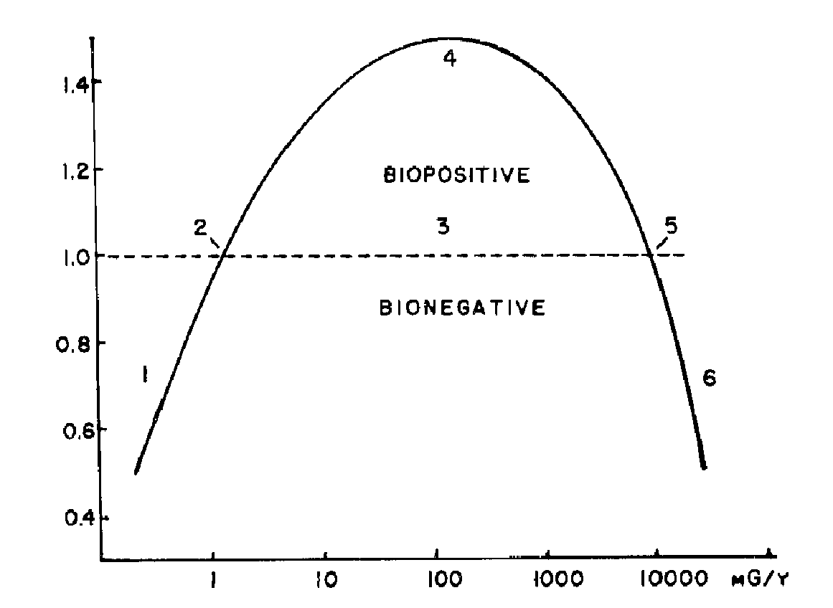
Figure 4. Idealized, complete dose-response curve.^{[16]} The ordinate indicates approximate responses compared with the controls. The abscissa suggests mammalian whole-body exposures as mGy/year. The numbered areas are: (1) deficient, (2) ambient, (3) hormetic, (4) optimum, (5) zero equivalent point, and (6) harmful.

The findings of this study are such a departure from those expected by ICRP criteria that it is important that they are reviewed by other independent organizations, and that population data not available to these authors be provided, so that a fully qualified, epidemiologically valid analysis can be made. Many of the confounding factors that limit other studies used to date, such as the A-bomb survivors, the Mayak workers and the Chernobyl evacuees, are not present in this population exposure. It could be and should be one of the most important studies on which to base radiation protection standards.

- CONCLUSIONS

Instead of dwelling on hypothetical risks of cancer from extrapolations, discussions about nuclear safety should point out the beneficial health effects of low doses of radiation. Realistic, worst-case damage to a nuclear reactor and its fuel will cause few if any deaths in the surrounding population.

The adverse health consequences of a nuclear accident that we should expect are the harmful effects that an interruption in the supply of electricity might cause and the cost to repair or replace the power plant, which could divert precious resources away from important public health-care programs. In general, there would be no need for long-term mass evacuation and the associated emotional stress that would result.

Probabilistic safety assessments should only be used to identify weaknesses in design and operation – for corrective actions to avoid power plant failures. PRAs should not be used to assess health risks because it is not ethical to scare people with frightening myths. The health consequences of low doses of radiation are known to be beneficial, and this knowledge should be shared with the public. Precautionary measures for potential nuclear emergencies, such as mass evacuation plans and exercises, are not warranted. They would be more appropriate for natural gas explosions and releases of chemicals, which are much more of a safety concern.

If nuclear power is to play a significant role in meeting future energy needs, we must communicate its many real benefits and dispel the negative images from unscientific extrapolations of harmful effects at high dose.

REFERENCES

- “Reactor Safety Study”. NRC report WASH-1400, NUREG 75/014 (1975)
- “Severe Accident Risks: An Assessment for Five U.S. Nuclear Power Plants”. NRC report NUREG-1150 (1990)
- Cohen BL. “Risk Analysis of Buried Wastes from Electricity Generation”. Am J Phys 54(1):38 (1986)
- Sankaranarayanan K. “Genetic Risk of Low Doses of Ionizing Radiation”. Proceedings of International Symposium on Health Effects of Low Doses of Ionizing Radiation: Research into the New Millennium. Ottawa, Canada. 1998 June 8. University of Ottawa. ISBN:0-9683269-2-7. pp 77 (1999)
- Luxat JC. “Safety Analysis Technology: Evolution, Revolution and the Drive to Re-establish Margins. Can Nucl Soc Bulletin 21(2):32 (2000)
- “Chernobyl – Ten Years On: Radiological and Health Impact, An Appraisal by the NEA Committee on Radiation Protection and Public Health”. NEA. OECD (1995)
- “The Radiological Consequences of the Chernobyl Accident”. UNSCEAR 2000 Report to the General Assembly, Section 1.C.18.
- Moosa M, Mazzaferri EL. “Occult Thyroid Carcinoma”. Cancer Journal 10(4):180-188 (1997)
- Calabrese EJ, Baldwin LA. “Radiation Hormesis: Origins, History, Scientific Foundations”. Human & Exp Tox 19(1):2 (2000)
- Clarke RH. “Progress Towards New Recommendations from the International Commission Radiological Protection”. Journal of the British Nuclear Energy Society, Nuclear Energy 40(1):37 (2001)
- Cuttler JM. “Resolving the Controversy over Beneficial Effects of Ionizing Radiation”. Proceedings of World Council of Nuclear Workers (WONUC) Symposium on the Effects of Low and Very Low Doses of Ionizing Radiation on Human Health. Versailles, France. 1999 June 17-18. Elsevier Science. ISBN:0-444-50513-x, pp 463 (2000) AECL-12046
- “Health Effects of Exposures to Low Levels of Ionizing Radiation”. BEIR-V. National Academy of Sciences Committee on Biological Effects of Ionizing Radiation. Washington. D.C. (1990)
- Jaffe S. “Foundations | Pauling, Meselson, and Socrates”. The Scientist 17(20):11 (2003). (Ava Helen & Linus Pauling Papers at Oregon State University). Available at: http://www.the-scientist.com/yr2003/oct/upfront3_031020.html
- Calabrese EJ, Baldwin LA. “Radiation hormesis: the demise of a legitimate hypothesis”. Human & Exp Tox 19:76 (2000)
- Luckey TD. Hormesis with Ionizing Radiation. Boca Raton, Fla.: CRC Press (1980)
- Luckey TD. Radiation Hormesis. Boca Raton, Fla.: CRC Press (1991)
- “Sources and Effects of Ionizing Radiation. Adaptive Responses to Radiation in Cells and Organisms”. UNSCEAR 1994 Report to the General Assembly with scientific annexes, Annex B
- Calabrese EJ, Baldwin LA. “Scientific Foundations of Hormesis”. Critical Reviews in Toxicology 31(4 & 5):351 (2001)
- Calabrese EJ, Baldwin LA. “Radiation Hormesis: Its Historical Foundations as a Biological Hypothesis”. Human and Exp Tox 19:41 (2000)
- Calabrese EJ, Baldwin LA. “Toxicology Rethinks its Central Belief”. Nature 421:691 (2003)
- Feinendegen LE, Pollycove M. “Biologic Responses to Low Doses of Ionizing Radiation: Detriment versus Hormesis, Part 1: Dose Responses of Cells and Tissues”. J Nucl Med 42(7):18N (2001)
- Pollycove M, Feinendegen LE. “Biologic Responses to Low Doses of Ionizing Radiation: Detriment versus Hormesis, Part 2: Dose Responses of Organisms”. J Nucl Med 42(9):26N (2001)
- Pollycove M, Feinendegen LE. “Radiation-Induced versus Endogenous DNA Damage: Possible Effects of Inducible Protective Responses in Mitigating Endogenous Damage”. Human & Exp Tox 22:290 (2003)
- Liu S-Z. “Nonlinear Dose-Response Relationship in the Immune System Following Exposure to Ionizing Radiation: Mechanisms and Implications”. Nonlinearity in Biology, Toxicology and Medicine 1(1):71 (2003)
- Cuttler JM, Pollycove M. “Can Cancer be Treated with Low Doses of Radiation?” J Am Phys Surg 8(4):108 (2003). Available at: http://www.jpands.org/vol8no4/cuttler.pdf
- FRANKLYN JA, MAISONNEUVE P, SHEPPARD M, et al. “Cancer incidence and mortality after radioiodine treatment for hyperthyroidism: a population-based cohort study.” The Lancet 353:2111-2115, June 19, 1999
- Eisenbud M. Environmental Radioactivity. 2nd Edition, Academic Press, NY, pp 421-425 (1973)
- Mitchel RE, Jackson JS, Morrison DP, Carlisle SM. “Low Doses of Radiation Increase the Latency of Spontaneous Lymphomas and Spinal Osteo-sarcomas in Cancer-prone, Radiation-sensitive Trp53 Heterozygous Mice”. Radiat Res 159(3):320 (2003)
- Chen WL, Luan YC, Shieh MC, et al. “Is Chronic Radiation an Effective Prophylaxis Against Cancer?” J Am Phys Surg 9(1):6-10 (2004). Available at: http://www.jpands.org/vol9no1/chen.pdf

 1 Gray = 1 joule/kg = 100 rad

