UNDERWAY ON NUCLEAR POWER

“The best war ships we ever built,
are not those we used in combat,
but those which served their time in peace”.
Admiral Rickover at the commissioning of the USS Nimitz, 1975

Introduction
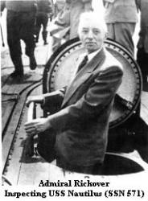
On January 17, 2005 it is 50 years ago that the first nuclear power reactor in the West became operational. At that time some nuclear reactors existed, but they were all test reactors and were used for scientific work or were used to produce plutonium for the Cold War efforts. On that day the United States submarine Nautilus departed under her own power for her test and trial period. On board was, in addition to her own crew under the command of Commander Eugene P. (Dennis) Wilkinson, the initiator and leader of the project which delivered this first operational nuclear reactor, Admiral Hyman G. Rickover. The man who converted the nuclear know-how into a working nuclear reactor was the Italian Enrico Fermi. In the Western part of the World (Cold War term) the nuclear reactor on board the USS Nautilus can be considered as the Mother of all nuclear reactors. After the successful departure Admiral Rickover sent the famous signal to the American Admiralty “underway on nuclear power”.

It is well-known that the first application of nuclear power was the two atomic bombs on Japan. It most likely shortened the Second World War in the Pacific with more than a year. Although these two explosions did cost many lives, it is also known that the battle with the Japanese Armed Forces, until the last island of the Japanese Archipelago would be won, would have cost many times more casualties on both sides. These two atomic bombs were developed under the highest secrecy. The project was called “the Manhattan project”.

By who and how was the power of these atomic bombs modified into controllable power? The man behind this idea was Admiral Rickover. His initiative was based upon the thought the nuclear power was going to make submarines much less detectable and logistically much more independent. In 1946 he got the chance to study nuclear power and decided more or less alone that the most desirable application would be as power plant in a submarine.

Admiral Hyman G. Rickover

He was born on January 27, 1900 in Makov, Russia and emigrated with his family to the United States of North America in 1906. The family lived in Chicago, Illinois. Hyman Rickover entered the U.S. Naval Academy in 1918 and was commissioned in 1922. He served on board the destroyer USS La Valette (DD 315) and the battleship USS Nevada (BB-36). His next step was to study electronics at the university of Columbia. He qualified for submarine service in the period between 1929 and 1933 and served on board the submarines S-9 en S-48. In June 1933 he became an Engineering Officer. During World War II he served at the office for electro-engineering at the Ministry of Defence. At the end of 1944 he asked for a appointment overseas and got the command of a repair base at Okinawa. The American Armed Forces were setting up such a plant for two major operations planned against Japan, operation “Olympic”, (November 1945) and operation “Coronet”, (March 1946). These two operations became unnecessary as a result of the two atomic bombs.
After the war he started his impressive and famous career, which ended with his retirement on January 29, 1982.

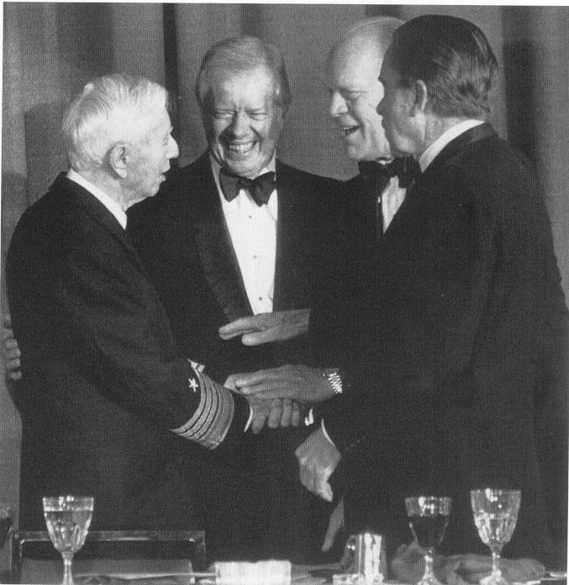
For his pioneering work Admiral Rickover received many honours, among others 64 civil honours such as the prestigious Enrico Fermi Award.
On January 31, 1982 he retired at the age of nearly 82. He had served for 63 years as an Officer in the United States Navy and so served under 13 Presidents. His name lives on in an attack submarine, the USS Hyman G. Rickover (SNN 709) and the Rickover Hall at the United States Naval Academy. He died on July 8, 1986 and is buried at the Arlington National Cemetery in Washington.

Admiral Rickover with
Three ex-presidents
Of the United States
Jimmy Carter, Gerald Ford
and Richard M. Nixon.
Admiral Rickover with three
ex-Presidents of the United States.
From left to right
Jimmy Carter, Gerald Ford and Richard M. Nixon

Rickover was very proud to be allowed and able to select the best people for his staff and for the crews of the nuclear submarines of the United States Navy. These interviews were often brutal and humiliating. Rickover judged the fitness of the candidates on the answers he received. Lieutenant James Carter was a 1947 Naval Academy graduate with aspirations to become the chief of naval operations. Carter judged the nuclear program could be a good career path. Rickover asked about his class standing. Carter proudly said he was 59th out of a class of 820. “Why not the best?” was Rickover´s response.
Carter had to admit he had not always done his best. He spent the next two years in the nuclear program. Carter rethought his goals and left the Navy in 1953. He would use Rickover as a model for self-discipline and work ethic´s. Carter would run successfully for President of the United States in 1976. “Why Not the Best” was the title of his campaign autography.

The development and the construction

For the project as mentioned the following dates and actions are of importance:
March 26, 1946 - The Atomic Energy Commission Laboratory at Oak Ridge invites the United States Navy and the American industry to send people to study nuclear power and technology. Rickover is one of them.
July 1946 - President Truman signs a law which establishes the Atomic Energy
Commission (AEC) of the United States.
- - Rickover starts the promotion of his ideas to construct a nuclear
submarine.
1947 - Rickover is appointed to the ship design offices of the United States
Navy.
August 4, 1948 - The United States Navy decides to establish a Nuclear Power branch.
August 8, 1950 - President Truman authorises the “Nuclear Ship Program”, target date
January 1955.
August 1950 - Start of the construction of the prototype of the nuclear reactor for the
USS Nautilus. (STR MK I).
August 1951 - The American Navy signs a contract with Westinghouse and the
Electric Boat Company for the construction of the USS Nautilus.
September 1951 - Rickover starts selecting the first crew for the USS Nautilus.
June 4, 1952 - President Truman lays down the keel for the USS Nautilus.
March 30 1953 - The nuclear power plant STR Mk 1 reaches criticality for the first time
and an extensive test program starts.
January 21, 1954 - The USS Nautilus is launched by Mrs. Mamie Eisenhower.
September 30, 1954 - The USS Nautilus is commissioned.
December 30, 1954 - The reactor (STR MK2) on board the USS Nautilus reaches criticality.
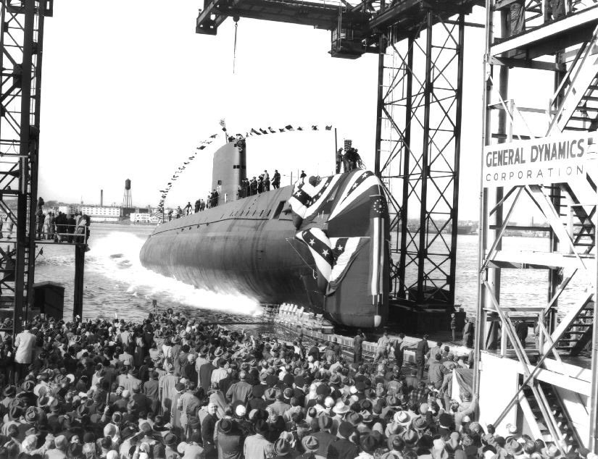
January 17, 1955 - USS Nautilus departs for sea for her first sea trials.

The USS Nautilus is launched by Mrs. Mamie Eisenhower and leaves the yard a year later and starts her famous career

The propulsion plant

The propulsion plant of the submarines of that time consisted of diesels, which were used while at the surface and electro motors for the propulsion during the time the submarine was submerged. During the usage of the electro motors the energy is supplied by a battery. These batteries are recharged during the sailing at the surface or at snorkel depth. Snorkelling allows the submarine to stay under the surface of the sea and sucking in the air for the diesels through a complicated system consisting of a pipe and valves. The electric power available is mostly very small in comparison with the available diesel power.
On board Nautilus this was all quite different. The nuclear power plant is in fact a standard Pressurized Water Reactor plant of the first generation and the system looks basically like this.
STEAM-
GENERATOR

CONTROL VALVES

GEAR BOX
REACTOR

STEAM TURBINES

SEA WATER COOLED CONDENSER

PRIMARY CIRCUIT SECONDARY CIRCUTE

CIRCULATION PUMP FEED WATER SATURATED PROPELLOR SHAFT PUMP STEAM SYSTEM

The test run

On January 17, 1955 the submarine USS Nautilus was ready to start her trial period. In addition to her own crew under the command of Commander Wilkinson, there were on board Rickover himself and several of his staff, several high ranking officers and some employees of the Electric Boat Company. At 11.00 hours the boat departed and steamed into the river. However, as many of us know, a test run rarely goes as planned and this test run of the first nuclear boat was no exception. The submarine was just a few hundred yards on her way when the engine room sent a message that port gearbox was making a screaming noise and decided to go for electric drive. A standard procedure. For the Commanding Officer this meant that his manoeuvring capabilities were very much reduced and became complicated in the fast flowing river. The Officers on the bridge were somewhat irritated by the crowd which had appeared on the jetty to see this historical departure. And so they did not like to show any indication that something was not completely right. Rickover raced to the engine room and assisted one of the engineers, Tom Reece, in trying to find what had gone wrong. 26 minutes long Commander Wilkinson struggled to keep the Nautilus on course with only starboard steam turbines and the electrical drive on starboard shaft. Then the problem was located. A bolt of an oil ring had come loose and caused the screaming noise while touching the gear box casing. The bolt was fastened and the starboard engine was reactivated. Ashore nobody had noticed anything!
The boat steamed on and then the conversation between Rickover and Wilkinson took place, which resulted in the famous signal sent from the USS Nautilus to the Admiralty of the United States Navy: “Underway on nuclear power”.

After arriving at sea the crew decided to bring the first dive forward in the planning. More then 50 dives were made during this first trial period. This was an absolute record in these days. In a conventional submarine a number of complicated valves have to be closed when diving and opened again when the boat is back on the surface. But the Nautilus could dive and surface without all this heavy work. Rickover returned to his offices, a happy and satisfied man.

Two stories from the career of the USS Nautilus.

1 - Stop Leak

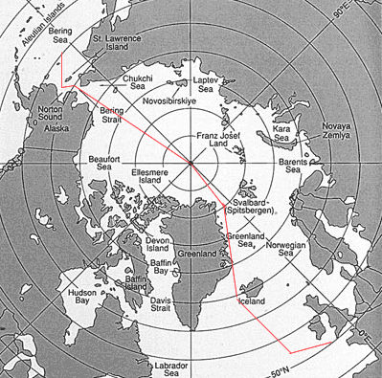
The USS Nautilus became a news item again three years later. On the 3rd August 1958, at 11.15 P.M. (Eastern USA Daylight Saving Time) she passed the North Pole, under water. There are several books and reports available of this spectacular and, from the military point of view, important voyage. In some of them a remarkable fact is described how an expensive propulsion plant is repaired with cheap means.
The voyage to the North Pole by the USS Nautilus
In the months before the trip to the North Pole the Nautilus suffered a leak in one of the condensor cooling systems. Salt water got into the steam system, which always leads to problems like scaling and a turbulent steam forming process. Many attempts were made to find and cure the problem, but they were all in vain. The Commanding Officer at that time, Commander William R. Anderson was worried that this defect could become the reason to cancel the voyage to the North Pole. Anderson then had a very remarkable idea. Some years before he had heard from his father-in-law about the repair of motorcar radiators by using a product called “stop leak”. After the boat had entered Seattle harbour he called his Chief Engineer and together they sent the ship engineers into the town to buy quarter drums of stop leak. This operation took place in civil clothes and the stop leak was bought at as many fuel stations as possible, all to make certain that nobody could find any connection between the Nautilus and this radiator repair agent. 140 quarter gallon drums were brought on board. Half of them were added to the system and the other half was stored in the steering compartment. It worked well! The problem never reoccurred. Indeed a remarkable fact that a propulsion installation costing hundreds of millions of dollars, is repaired using Sop Leak costing 1.80 USD per tin.

Finally there is another persistent rumour which connects the USS Nautilus with a common freighter, the Flying Enterprise.

2 - SS Flying Enterprise

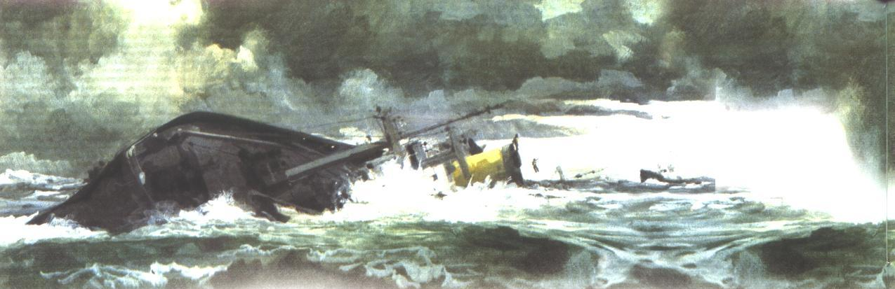
At Christmas 1951 there was a severe gale in the Approaches of the English Channel. An American freighter, the steam ship (SS) Flying Enterprise, steaming from Rotterdam to the United States, got into big trouble. On the day after Christmas a heavy noise was heard and a crack appeared in the hull. This crack grew due the movement of the ship in the heavy weather and water got into the holds. The pumps could not keep up and the ship listed on port side. On December 28, the Captain, Curt Carlsen, sent an S.O.S. Several ships answered this mayday signal and offered assistance. The 10 passengers and 40 crew members were ordered to jump overboard, two by two, into the very cold water. It is remarkable that they all survived this ordeal and were rescued by the ships, which had rushed to the scene. Sadly one passenger later died later from exhaustion. So far a more or less standard story of a shipwreck.
However it became news when it was noticed that the Captain refused to leave his ship. At the beginning of January 1952 the newspapers and radio stations gave this matter a lot of attention. Why was he so stubborn and did he refuse to leave his ship?
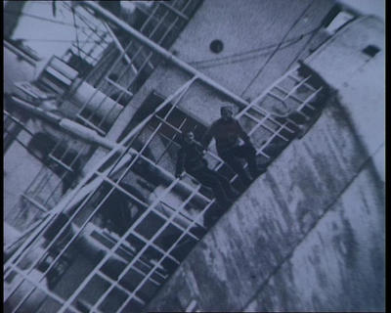
On January 4 the British Royal Navy) tug Turmoil finally arrived at the site. By that time Carlsen had been alone on his powerless and cold ship for a week. All attempts to take the ship in tow failed. There was no power left on the Flying Enterprise and Curt Carlsen was unable to handle the ropes on his own. Then suddenly the Turmoil and the Flying Enterprise got very close to one other and to his own big surprise the mate of the Turmoil, Kenneth Dancy, jumped on board the Flying Enterprise. “It just happened” he later said. The two men got the towing rope fixed and the tow for Falmouth began.
Carlsen and Dancy on board the
SS Flying Enterprise
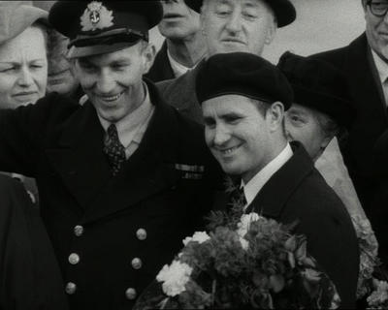
It is evident that this action by a stubborn Captain and a daring British mate got the maximum of attention from the press. It became world news.

The weather moderated and food, clothing and water was ferried to the ship. However, on January 8, a new gale hit the tow. The towing rope broke and the ship took on more water.

The list increased and the two men decided to abandon the ship. On January 10, Dancy jumped first and Carlsen followed and within an hour, safe on board the tug, they watched the SS Flying Enterprise sink into the Channel.
Carlsen and Dancy in Falmouth
The two men were given a very warm welcome when the tug arrived in Falmouth and were instantly famous heroes. Carlsen received many honours, among others a Dutch lifeboat carrying his name.

Both men went on with their lives. Carlsen went on sailing and so did Kenneth Dancy. Dancy later married a Dutch girl and lives near Rotterdam.
The fact that Curt Carlsen stayed on board was immediately the source of many rumours. What cargo had been in the holds of the ship? Was it important or valuable? The cargo paperwork did not show any remarkable facts. Some 1200 tons of iron, 2 Volkswagen motorcars, 6 Italian violins, some coffee, some post, etc. What had been noticed was the presence of three American destroyers when the ship ran into trouble and they never left the scene of the accident during the whole operation. For that reason a diving operation was organised later on. Some sacks of money were recovered from the wreck, of which Carlsen said he did not know. But nothing else.
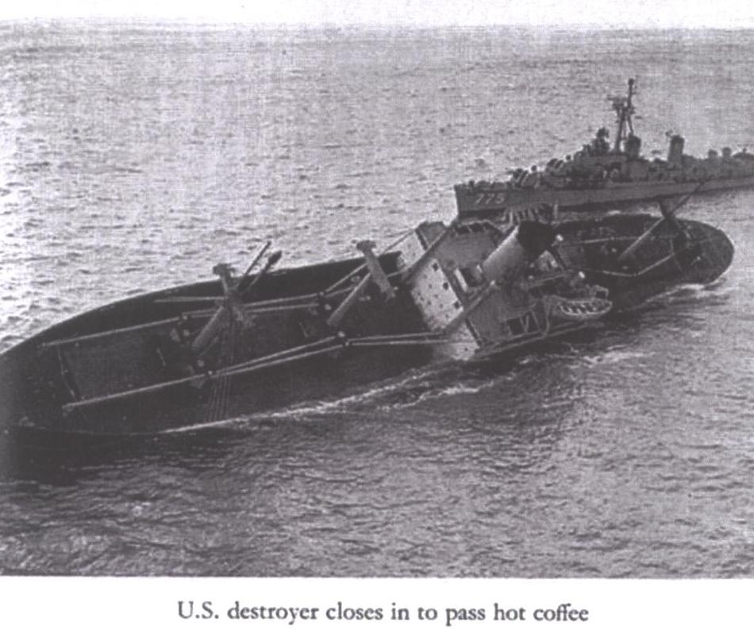
Later a new rumour was born. This rumour stated that on board the SS Flying Enterprise there was an amount of pure zirconium. Zirconium is a heat resistant ore, which is rare in its pure form and so expensive to procure (150 USD per kg). An alloy of zirconium and tin also called zirconium is used to construct the fuel rods of a nuclear reactor. This new rumour stated that the SS Flying Enterprise transported zirconium for the nuclear reactor of the USS Nautilus. It became clear a while ago that the 1200 tons of iron had been badly stowed due to the fact that the crew appeared to be in a hurry. So most likely this cargo has shifted as a result of the sea state and caused the crack, the list and finally the loss of the Flying Enterprise. However it is still strange that an American destroyer was constantly in the neighbourhood, that the attempt to start the recovery of the ship was delayed until a tug of the Royal Navy became available and that the assistance of the French tug Abeille 25, which was also close by, was not requested.

Nuclear power today

The nuclear technology has developed since the occasions mentioned in this article. This technology has not always been admired. One could divide the history of nuclear power into 6 periods.
The first period could be named “discovery” (This period started in 1896 with the discovery of “radioactivity”). As most important scientific achievement can be seen the first controlled fission process in the cellars of a baseball stadium in Chicago, on December 02, 1942, which was followed by the use of the two atomic bombs which ended World War II. Another achievement was the construction of the power plant for the USS Nautilus.
The second period was the “period of hope”. The first electricity was produced by nuclear power and the first civil nuclear power plant became operational in Russia in 1954 with a power output of 5 MWe.

The third period was full of enthusiasm. The program “Atoms for Peace” was launched by President Eisenhower of the United States The feelings during this period are best described by a statement made by Albert Einstein: “ If you succeed in using the nuclear-physical findings for peaceful purposes, it would open the way to the new paradise”.
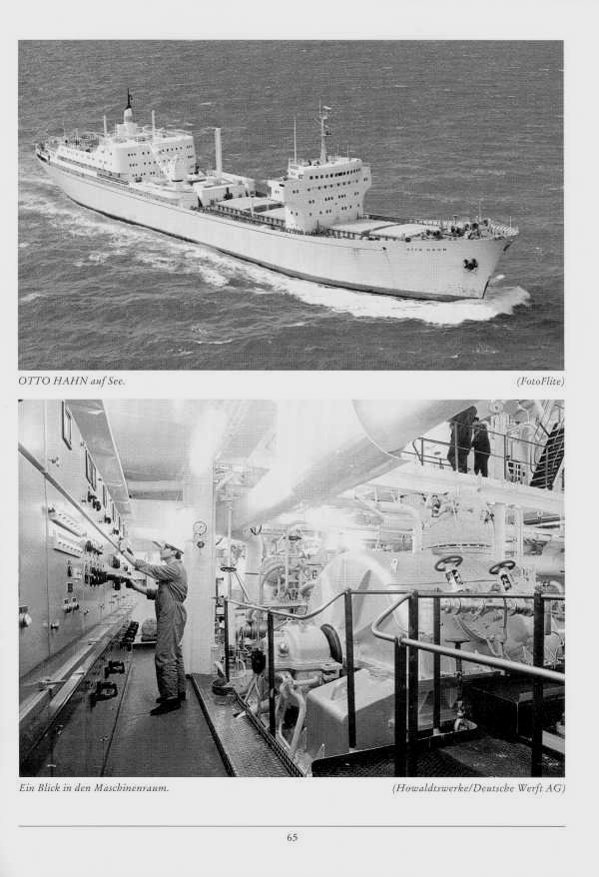
The fourth period (1965 tot 1975) saw an impressive industrial expansion. It is not commonly known that more nuclear power plants serve or have served at sea (more than 600) then ashore, producing electricity (440). The eldest nuclear reactors are the eight sisters of the reactor on board the USS Nautilus, which were put into the American aircraft carrier USS Enterprise in 1959-1960 and which are all still in service.
But merchant vessel were also built. The American ship Savannah and the German bulk carrier Otto Hahn.

The fifth period can be characterised by “confusion”. The acceptance of nuclear power by the public diminishes. There is a lack of openness, commercial reasons to decrease the role of nuclear power leave their mark, radioactive waste becomes a very important problem, the price and availability of fossil fuels and the relatively low investment for fossil fuel energy conversion units decrease the role of nuclear power even further.
NS Otto Hahn

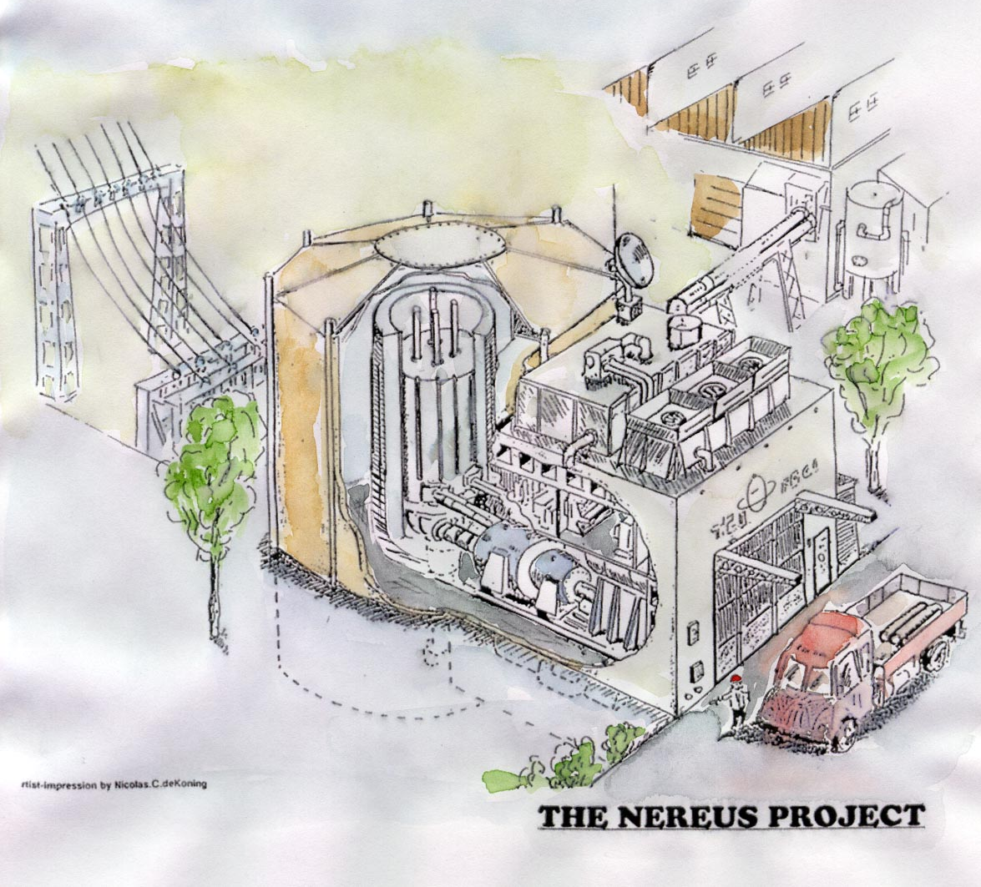
The sixth period can be called “shock and perspectives”. The shock was the explosion of the nuclear power plant at Chernobyl, Russia. It had an enormous impact on the public. The new perspectives are the developments which make nuclear power plants much more naturally safe, less complicated and leaves quantatively less long-living radioactive waste per produced kWh.
New applications were developed and extensive tested as well, such as the small inherently safe and well-proven pebble-bed reactor, suitable for the non-utility markets like shipping and the Combined Heat and Power market.
And finally but definitely the most important developments took place in the medical branches. Several drugs and radiation schemes were developed to diagnose and cure many forms of cancer.

References:
H. van Dam – On the history of nuclear energy. Nuclear Europe Worldscane, November 1992
John W. Simpson - Nuclear Power from Under Seas to Outer Space
Theodore Rockwell – The Rickover Effect, How One Man Made a Difference
William R. Anderson – Nautilus 90 North
www.teeships.freeuk.com

The first power nuclear reactor became operational in Obninsk (100 km from Moscow), Russia. The thermal power was 30 MWth and the electric power was 5 MWe.
War ships and merchant man are called ships. For reasons not totally clear submarines are called “boats”.
Mechanical Engineer, January 2004
Nautilus 90 North – CMDR William R. Anderson USN, page 134
Based upon the Arbeidsgemeinschaft Versuchreactor, tested and operated for 20 years in Julich, Germany.

