Originally published in the: International Journal of Environmental Studies
Vol. 62, No. 6, December 2005, 725–736

The solutions for nuclear waste

BRUNO COMBY*
Environmentalists For Nuclear Energy (EFN)
55 rue Victor Hugo, 78800 Houilles, France
eMail: efn@ecolo.org

The subject of nuclear waste is often discussed in public debates on energy, and is used by some
environmental groups to oppose nuclear energy. Such opposition has no solid scientific foundation.
This article proposes a new insight on the nuclear waste issue, from an environmental perspective.
Nuclear waste has undeniable environmental benefits. It is produced in relatively small amounts.
It is not disposed of in the biosphere and is almost totally confined. It is very easy to ensure protection
from identified sources of radiation. Unlike with other highly toxic stable chemical and industrial waste
matter, the toxicity of reprocessed radioactive waste decreases very rapidly in an exponential manner
with time, returning to the natural level of radioactivity of the original ore after only 5000 years. Safe,
simple and efficient solutions exist to make nuclear waste inert by vitrification and to isolate the waste
from the biosphere until it is no longer toxic. The natural nuclear reactors of Oklo in Gabon, which
self-ignited two billion years ago, are a source of essential information today. It shows that the waste,
after being left unconfined over a period of two billion years, has not migrated more than three meters.
The recurring question of nuclear waste therefore appears to be technically and ecologically solved by
a combination of reprocessing technology, confinement, vitrification and deep geological disposal.
However we still face the issue of social acceptance, which implies that we must provide better
information for the public, and especially to the environmentalists.

Keywords: nuclear waste; radioactivity; confinement management; reprocessing; environment; natural
radioactivity; Oklo; plutonium; transmutation; geological disposal.

Future is not imposed to us; we are building it.
Georges Bernanos (1888 – 1948)

1. Introduction

When we speak of nuclear waste, we distinguish between short-lived waste and weakly radioactive waste on the one hand, and high-level and medium-level long-lived radioactive nuclear waste on the other. Short-lived waste, poses no problem because it disappears quickly by radioactive decay, and weakly radioactive waste, with intensity comparable to the natural backgound is not dangerous because it emits very little radiation. Because short-lived waste and low-level waste already have satisfactory solutions, our focus in this document will be on high-level and medium-level long-lived radioactive nuclear waste, whose disposition is still undecided. Most of that waste is produced in nuclear power plants, and much of it is in temporary storage, often in the form of spent fuel elements recently removed from reactors, not yet reprocessed and held in cooling pools or dry surface storage. In addition there is an accumulation of smaller amounts of separated vitrified radioactive material, encased in stainless steel cylinders and held in dry storage at La Hague in France and at Sellafield in the UK, awaiting final disposal.

Scientific and engineering research in several countries, and notably in France [1], has identifed three complementary paths:
1/ temporary or long-term surface or sub-surface storage (especially in the first years);
2/ deep underground geological storage (in the long term), designed to be reversible or not;
3/ and (perhaps) transmutation of long-lived isotopes to stable or shorter-lived isotopes.
The only question is how best to implement each of these solutions, and perhaps how to combine these different solutions together in an optimal manner.

Greenpeace and other anti-nuclear organizations pretend there is NO solution to the disposal of long-lived nuclear waste. In fact, there is not only one, there are SEVERAL solutions available.

Spent fuel elements as they come out of today’s water-cooled and water-moderated reactors (PWRs, BWRs and CANDUs) are still rich in energy. The spent fuel consists of 95% unburnt uranium and 1% plutonium, as well as 4% fission products and transplutoniums (the latter are often called actinides). If the spent fuel element is reprocessed, then the uranium and plutonium can be recovered and exploited. Since the energy resources of our planet are limited, it would be a great shame and highly unecological, not to recover such large amounts of energy-rich materials. Reprocessing and recycling, as practised at the La Hague plant in France, at Sellafield in UK and at Rokkasho-mura in Japan, is ecologically sound, for it makes a much better use of natural uranium, greatly reduces the volume of the waste and confines the toxic material so that it is contained in a glass matrix where it is chemically inert and almost completely unalterable.

When vitrified, the highly radioactive nuclear waste produced per capita in a typical nuclear country during an entire lifetime has a volume no greater than a golf ball (figure 1).


Figure 1. © Photo credit IBC

2. A million times less waste.

The fission of one gram of uranium provides as much energy as burning one tonne of oil, whence the famous factor of a million. After fission there remains only a fraction of a gram of radioactive waste which is, in any case, not released into the environment but very carefully confined, eventually to be reprocessed and recycled. This small fraction, which is of no further use, is totally isolated from the environment. Nuclear energy has the virtue that its waste is completely confined and is of very small volume – small enough to be readily stored away.

Because radioactivity is unfamiliar to a great part of the population, nuclear waste is disturbing; and some people tend to exaggerate the dangers. And because nuclear waste is at first strongly radioactive, certain precautions must indeed be taken when handling it. But the radioactivity falls off rapidly with the passage of time.

Over 90% of the initial radioactivity of the spent fuel disappears spontaneously in the first ten years after leaving the reactor (see figure 2).

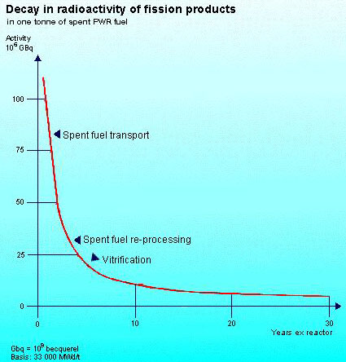

Figure 2. Radioactive decay of fission products in one tonne of spent fuel after it is discharged from the reactor

After about 5000 years – which is a very short time span on a geological time scale - the radioactivity of spent fuel is less than the radioactivity of the original uranium mineral from which it was obtained (see figure 3).

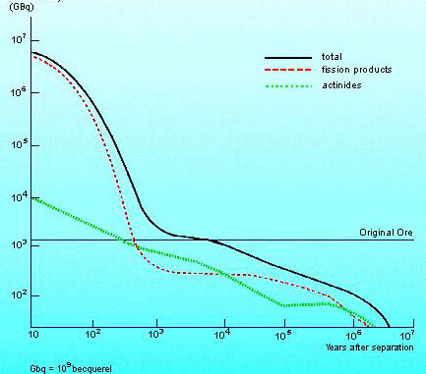

Figure 3. Radioactive decay in one tonne of spent fuel.

When we speak of high-level radioactivity, we should always say that it is INITIALLY highly radioactive. The high-level of radiation does not persist forever, but it diminishes rapidly, especially in the first years, because of the characteristic exponential decay. The elements which remain after a long while are only weakly radioactive. And these long-lived radioactive elements are alpha-ray emitters from which we can easily protect ourselves.

Furthermore, nuclear waste is in solid form – by nature easy to confine – and self-degrading, by reason of radioactive decay. In contrast, most chemical wastes are stable and do not degrade, and many of them are liquid or gaseous. From the point of view of public health and toxic waste, nuclear energy is by far the least polluting of all the industries and sources of energy we have [2].

Moreover, the relatively small volume of nuclear waste permits us to let decades pass without having to decide what to do with it. During this time, mankind continues shamelessly to release each year 23 billion tonnes of CO2, a greenhouse gas, as well as millions of tonnes of highly toxic industrial waste – in addition to sulfur dioxide, the source of acid rain, ashes, heavy metals, nitrogen oxides, pathogenic and cancer causing particles, etc. Our civilization also produces vast quantitites of household and industrial waste, some of which – so-called special wastes – are very poisonous and will be with us forever, since they are chemically stable [3]. The volume of these highly toxic industrial waste is about 100 times greater than that of highly radioactive nuclear waste, they last longer, they are not always confined, and they do not receive the same attention.

Although the danger due to nuclear waste decays rapidly and progressively, we cannot justify an indefinite delay in finding a final resting place for it. It would be irresponsible of our generation to ask future generations to deal with the problem of our unmanaged and badly packaged nuclear waste, even if it is not very voluminous. Especially since we already know that simple and effective solutions are at hand.

We can easily protect ourselves from radiation. We don't need to call upon sophisticated technology – simple shielding will do (see figure 4).
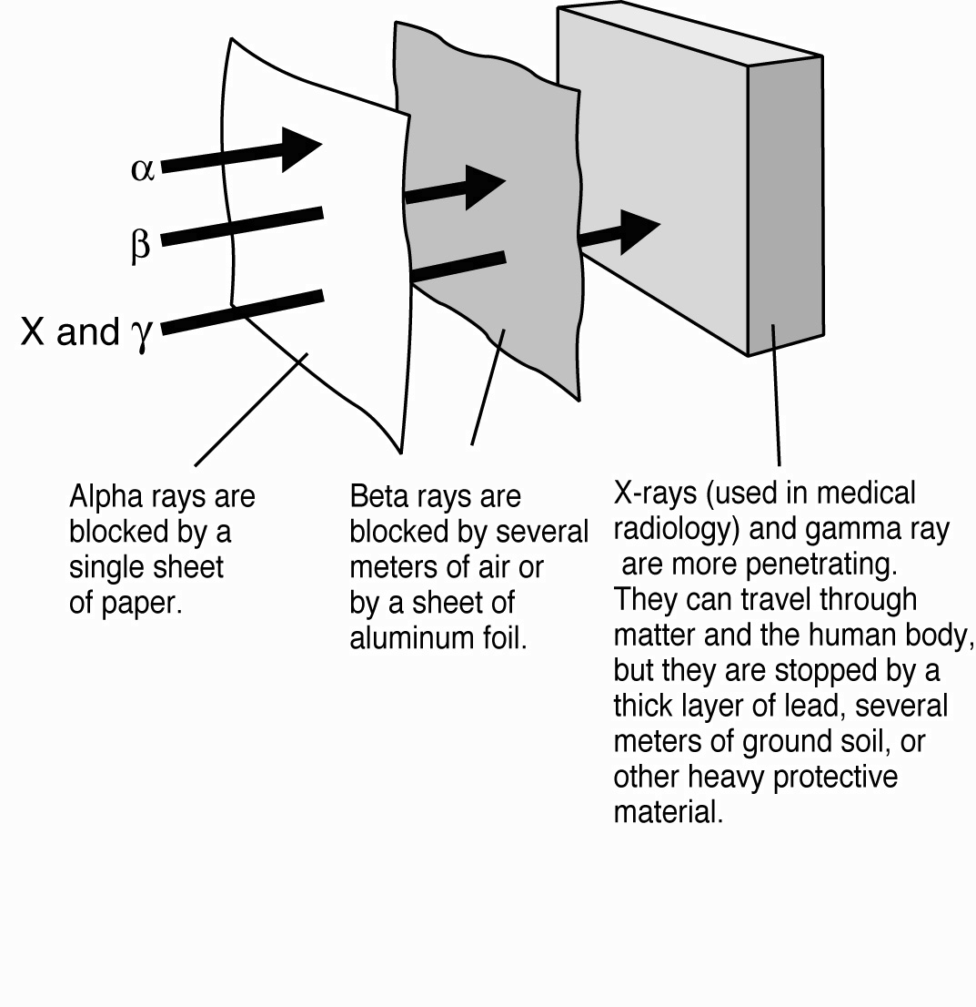
Figure 4. Protecting ourselves from radiation is easy with simple screens.
Source: “Environmentalists For Nuclear Energy”, TNR Editions (www.comby.org then click on “books” in the menu)

From an environmental point of view, an important advantage of radioactivity is that its activity diminishes spontaneously as time passes – the well known law of exponential decay. One need only wait for the radioactivity to fade away of its own accord. On the other hand, many toxic chemical wastes are stable and last forever; one might say they have an infinite life. DDT is a notorious example.

Mankind did not invent radioactivity. It is found in nature everywhere around us. The weak doses of natural radioactivity, to which we have been exposed since the dawn of history, are not dangerous. It is worth noting that this natural background radiation is highly variable, varying by a factor of nearly a thousand from one place to another. In certain places, for example in the city and on the beach and in the city of Guarapari in Brazil, one finds a natural background radiation which would be forbidden for workers at a nuclear reactor or at a nuclear waste storage site. Yet the inhabitants are perfectly healthy. This background radiation, mainly due to uranium and thorium, diminishes slowly in time as these elements decay, for their lifetimes are comparable to the age of the earth. Human activity on the surface of our planet has not increased the level of radioactivity of the planet, except very locally in few places. On the other hand, one might say that in burning uranium we accelerate (to a minuscule extent, of course) its natural disappearance from the environment. The Earth was much more (about twice) as radioactive as it is now when life first appeared, and natural radiation has not stood in the way of evolution and development.

About 2 billion years ago, at Oklo in south-eastern Gabon (see figure 5) nuclear chain reactions just like those which we produce in nuclear reactors occurred spontaneously in several deposits of natural uranium mineral.
Figure 5 The Oklo uranium mine in Gabon, central Africa.

For over a million years, about fifteen natural nuclear reactors operated with power levels of up to 100 kiloWatts [4]. None of the fission products remain radioactive today – they have completely decayed. However, one finds their stable (non-radioactive) descendents still in place.

The nuclear waste which we produce now is carefully confined, which was certainly not the case at Oklo. We observe that the plutonium and the fission products, left to their own, have migrated no more than three meters over the last two billion years. That "waste" remains in the sedimentary rocks, in or near each natural reactor, without being dispersed or carried away by the ground water which was necessarily present as the moderator to produce the chain reaction. The fission products form solid compounds and they are not at all mobile.

The radioactive fission products we produce today are to be stored under conditions much more restraining than was the case in Oklo 2 billion years ago. Cast in glass and encased in stainless steel, they will in the end be deposited in carefully selected underground strata, surrounded by clay impermeable to water. We have every right to feel reassured that they will not migrate much. Our knowledge of the natural reactors of Oklo goes far to ease our concern about the long term behavior of our radioactive waste. Elaborate simulations at Yucca Mountain in the United States, by the European Commmission in Europe, and various studies carried out in underground laboratories in Belgium, Finland, Sweden, Switzerland and the United States, have confirmed these conclusions, with a large safety factor.
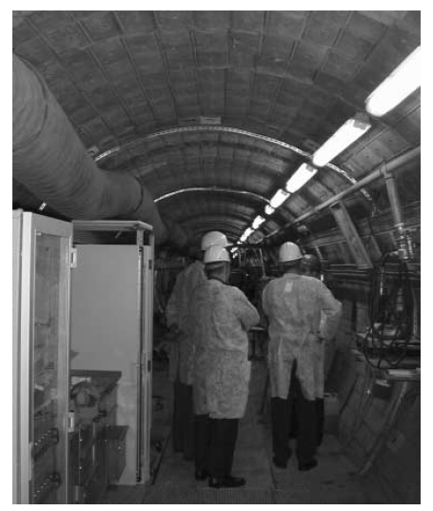
Figure 6. Experimental studies on nuclear waste storage at Mol in Belgium
(© Photo Bruno Comby Institute, www.comby.org)

Scientific and engineering research in several countries has demonstrated the feasibility and the safety of long-term geological storage of nuclear waste (see figure 6). The public would never be subject to significant doses of radiation. At the beginning, the waste would be well confined and inoffensive. After some thousands of years, most of the radioactivity would have decayed, but in case a tiny fraction should escape and migrate, Oklo shows that it wouldn’t go very far. Even in the worse case, and in the very long term, people living on the surface would be subjected to insignificant doses of radiation, much less than the natural radioactivity to which we are exposed all day long anywhere on the planet.

3. Radioactivity and ionizing radiation are natural.

When we speak of radioactivity, it is well to put things in perspective; radioactivity has existed since the beginning of time. Professor James Lovelock, who was in the 1960s one of the historic founders of modern ecological thinking, puts it this way :

"Perhaps the strangest thing about the Earth is that it formed from lumps of fall-out from a star-sized nuclear bomb. This is why even today there is still enough uranium left in the Earth's crust to reconstitute on a minute scale the original event.

There is no other credible explanation of the great quantity of unstable elements still present. The most primitive and old-fashioned Geiger counter will indicate that we stand on the fall-out of a vast ancient nuclear explosion. Within our bodies, half a million atoms, rendered unstable in that event, still erupt every minute, releasing a tiny fraction of the energy stored from that fierce fire of long ago.

I hope that it is not too late for the world to emulate France and make nuclear power our principal source of energy. There is at present no other safe, practical and economic substitute for the dangerous practice of burning carbon fuels." [5]

We even find some (very small) amounts of plutonium in nature. It appears spontaneously in the crust of the Earth as a consequence of the continuous bombardment of uranium in the rocks beneath our feet by cosmic radiation arriving from space. Thus several million atoms of plutonium in a pot of flowers or in a kilogram of earth taken from our garden, or anywhere else in the crust of our Planet. Which has led Jacques Pradel to say "Plutonium is natural!" [6].

One gram of plutonium 239 contains as much energy as one gram of uranium 235. In view of this high energy content, we ought to consider plutonium not as waste, but as a first-class source of energy. In this respect, as an environmentalist, I fully support the operation of the MONJU in Japan (a fast neutron reactor) and express my sorrow at the premature closing (for purely political reasons) of the Superphenix fast neutron sodium reactor in France which was working very well until the newly elected green Minister suddenly decided to sacrifice it in the name of political ideology, in spite of its scientifical, economical, energy potential (1350 MW) and many ecological benefits. At this very moment, a number of industrial countries, including the United States, France, Japan, Korea, Switzerland and Canada are engaged in the development of future nuclear reactors in the Generation IV International Forum (GIF). The environmental virtues of fast neutron reactors (FNR – sometimes called the breeder reactor) are recognized by GIF and its program includes sodium-cooled reactors such as Superphenix and MONJU.

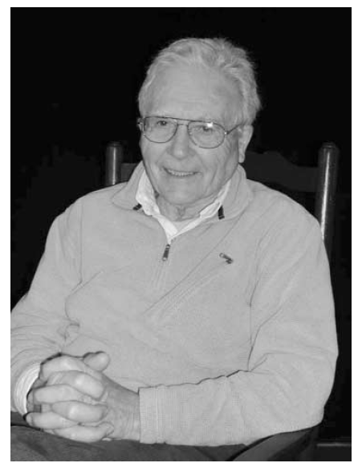
The actinides are another source of fission energy. At present they are considered waste, but they can be separated and burned in the FNR. In this case there is nothing left but the fission products whose life-time is much shorter. Furthermore, the FNR produces up to 100 times more energy from a given quantity of natural uranium. This fact is well appreciated in China, in India, in Japan and in Russia, countries which are actively developing reactors which produce much less waste than today’s already very clean, safe and ecological water reactors.

Figure 7. Professsor James Lovelock (© Bruno Comby Institute, www.comby.org)

4. Nuclear waste requires good management

After several decades of billion dollar studies of the three paths mentioned above in numerous countries, it seems to us that the ecological management of long-lived high-level and medium-level nuclear waste is well demonstrated and consists of the following:

4.1. To confine and reprocess spent fuel, as has been done industrially in France, in the UK, in Russia and in Japan for several decades, in order to recover and recycle the unburnt uranium (95%) and the plutonium (1%). The remaining 4% (the ultimately non-recoverable waste) is to be vitrified to render it inert and insoluble in water, then encased in copper containers (as Sweden proposes) or stainless steel containers (figure 8). This would render it immune to chemical deterioration for a period of time extending far beyond the life of the radio-toxic elements.

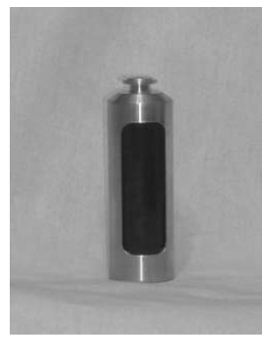
Figure 8. Stainless steel container for the containment of radioactive waste
(© Bruno Comby Institute www.comby.org)

One might eventually also separate the minor actinides (americium, curium, neptunium) thereby further reducing the volume and shortening the length of time during which the waste is radioactive. It would be advisable to continue research on the transmutation of these transplutonium elements.

The direct disposal in geological repositories of used nuclear fuel without reprocessing, as was until now envisaged by several countries, including the USA, Sweden and Finland is not an ecological approach; these countries should seriously reconsider their position (the USA has moved in this direction since the first publication of this paper in 2005, and it is now considering reprocessing). Some options can be discussed and should be left open for the moment, such as which technology of reactors should be developed, the development of new reprocessing technologies in addition to PUREX (UREX+, etc.), the duration of temporary storage before reprocessing and before deep underground geological disposal (to let the waste cool down before final disposal), the recycling or not of transplutonic elements (americium, curium, neptunium).

4.2. To reduce the quantity and volume: new fuel cycles might lead to reduced quantities of waste and even to some transmutation. Research in this direction should therefore be continued. Just as the Russians have built BN600 and are preparing BN800 and the Japanese continue their work at MONJU, the United States should catch up and consider the construction of Generation IV reactors, and Europe should prepare the construction of a fast neutron reactor inspired by the Superphenix reactor. EFR – the European Fast Reactor – an advanced and fully industrial sodium reactor could be in construction rapidly; the design studies were completed years ago and need only be brought up to date.

  - To store nuclear waste temporarily on the surface or in shallow repositories, as practiced at La Hague, Sellafield and Rokkasho-mura, for a few decades or half-a-century at most. This solution is not as safe as long-term disposal in a deep repository. Temporary storage on the surface or in shallow repositories is suitable for spent fuel awaiting reprocessing, and to allow freshly produced vitrified waste to cool before being transferred to permanent storage.

4.4 To store the final waste in deep geological strata. This relatively simple, useful and ecologically necessary procedure will ensure that these radioactive substances are isolated from the biosphere long enough for their radioactivity to decay to a level below that of the mineral from which they were originally extracted. This solution has been constantly recommended by all international authorities as the preferred solution since the 1970s. Life on Earth (the biosphere) is concentrated in a very thin layer on its surface and in the atmosphere surrounding it. Just a few meters beneath our feet lies an entirely mineral world which is unaffected by radiation, and cannot be affected in any manner by deep underground disposal of nuclear waste in the future. Such storage might be designed to be reversible, at least for a certain period of time – some decades, say. But we must certainly not bury spent fuel elements before they are reprocessed; they will constitute a highly valuable strategic energy resource for the following generations.

5. Conclusion

Since these safe solutions are now all available and demonstrated, we have no right to transmit unprocessed nuclear waste to future generations in an open-ended way. On moral grounds, the interval between the service provided to our citizens – that is, a supply of clean, abundant and inexpensive electricity – and the reprocessing and underground storage of the waste should remain well below our lifespan, say forty or fifty years. In other words, the generation which benefits from nuclear energy should bear the burden of reprocessing the corresponding spent fuel and storing the waste in a safe manner. This is all the more imposed upon us by the fact that the funds to implement these solutions are available today, and you never know if they still will be in the future. Even though we could wait longer before deciding and acting, given the relatively small volumes of waste considered, it is our moral duty to solve the issue of nuclear waste NOW.

If we put off such action, we run the risk that the funds may be diverted to other ends. It is thus imperative that the countries now using nuclear energy decide TODAY upon a definitive solution to the question of nuclear waste and rapidly open the necessary storage sites.

In public debate, an essential aspect is that the public be informed. And the information provided must be as complete, straightforward and objective as possible, avoiding the usual clichés. Toward this end, our association of Environmentalists For Nuclear Energy, which gathers over 8000 members and supporters in more than 56 countries, will continue its work of providing better information to the public on the question of nuclear waste. It is our purpose to construct, collectively and with the participation of every one of us, a world offering the best of opportunities and a clean environment to all, and especially to the developing countries where demand for energy is increasing.

To summarize, there is not one solution, but rather several complementary solutions to the problem of managing high-level and medium-level long-lived radioactive nuclear waste. We must pursue research on transmutation, continue to reprocess spent fuel and immediately begin work on underground storage. If we fail to act, our children will be right to blame us for our negligence.

References

[1] CNE, (French National Evaluation Committee on the future of nuclear waste) report, 2005.
[2] National Academy of Medicine, 2003, Energy Choices and Public Health, 2003.
[3] Thus we shall still find DDT and other very toxic chemicals in the polar ice caps (as long as they exist) as well as everywhere else on the surface of the Earth, for millions of years, well after nuclear waste has completely decayed.
[4] Cowan, G. A., 1976. Oklo, A Natural Fission Reactor, Scientific American 235, 36–47.
[5] Comby, B. 2003, preface to Environmentalists For Nuclear Energy, Editions TNR, www.comby.org
[6] Pradel, Jacques, 1991, Le plutonium, c’est naturel!, Radioprotection 26,1, 89–90.

_______________________________________________

English translation from the French original by Berol Robinson (2006).

