Wake clouds at Danish offshore wind farm (Horns Rev)

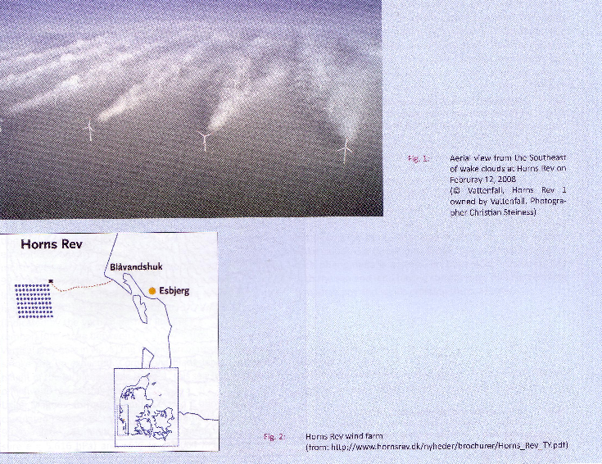
Photo taken from DEWI Magazin N° 37, AUGUST 2010

« Meteorological Explanation of Wake Clouds at Horns Rev Wind Farm », by S. Emeis (Research institute on meteorology and climate, Karlsruhe Institute of Technology) ; the summary of the article is :

The occurrence of wake clouds at Horns Rev wind farm is explained as mixing fog. Mixing for forms when two nearly saturated air masses with different temperature are mixed. Due to the non-linearity of the dependence of the saturation water vapour pressure on temperature, the mixed air mass is over-saturated and condensation sets in. On the day in February 2008, when the wake clouds were observed at Horns Rev, cold and very humid air was advected from the nearby land over the warmer North Sea and led to the formation of a shallow layer with sea smoke or fog close above the sea surface. The turbines mixed a much deeper layer and thus provoked the formation of cloud trails in the wakes of the turbines.

