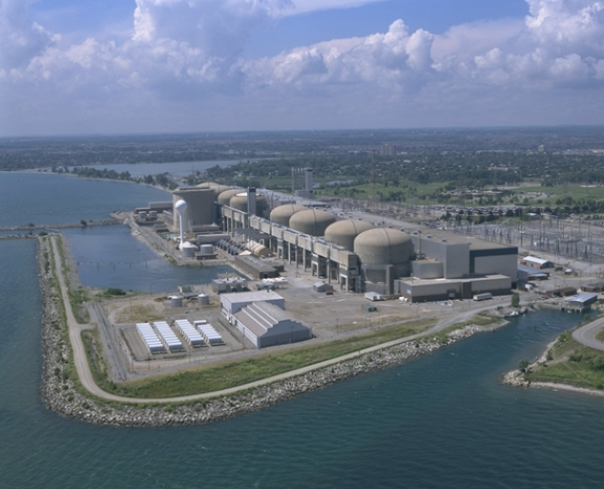
Pickering Station
8 CANDU reactors
Near the city of Toronto, Ontario, Canada

