Test of MEGA-e-CITY electric car

Test report by BRUNO COMBY
Founder and President of EFN : www.ecolo.org
Founder and president of SAVE THE CLIMATE www.sauvonsleclimat.org

(translated by Berol Robinson)

This test report is also available in French here:
http://www.ecolo.org/photos/visite/mega-e-city_09/ electric-car-MEGA-E-CITY-fr.doc

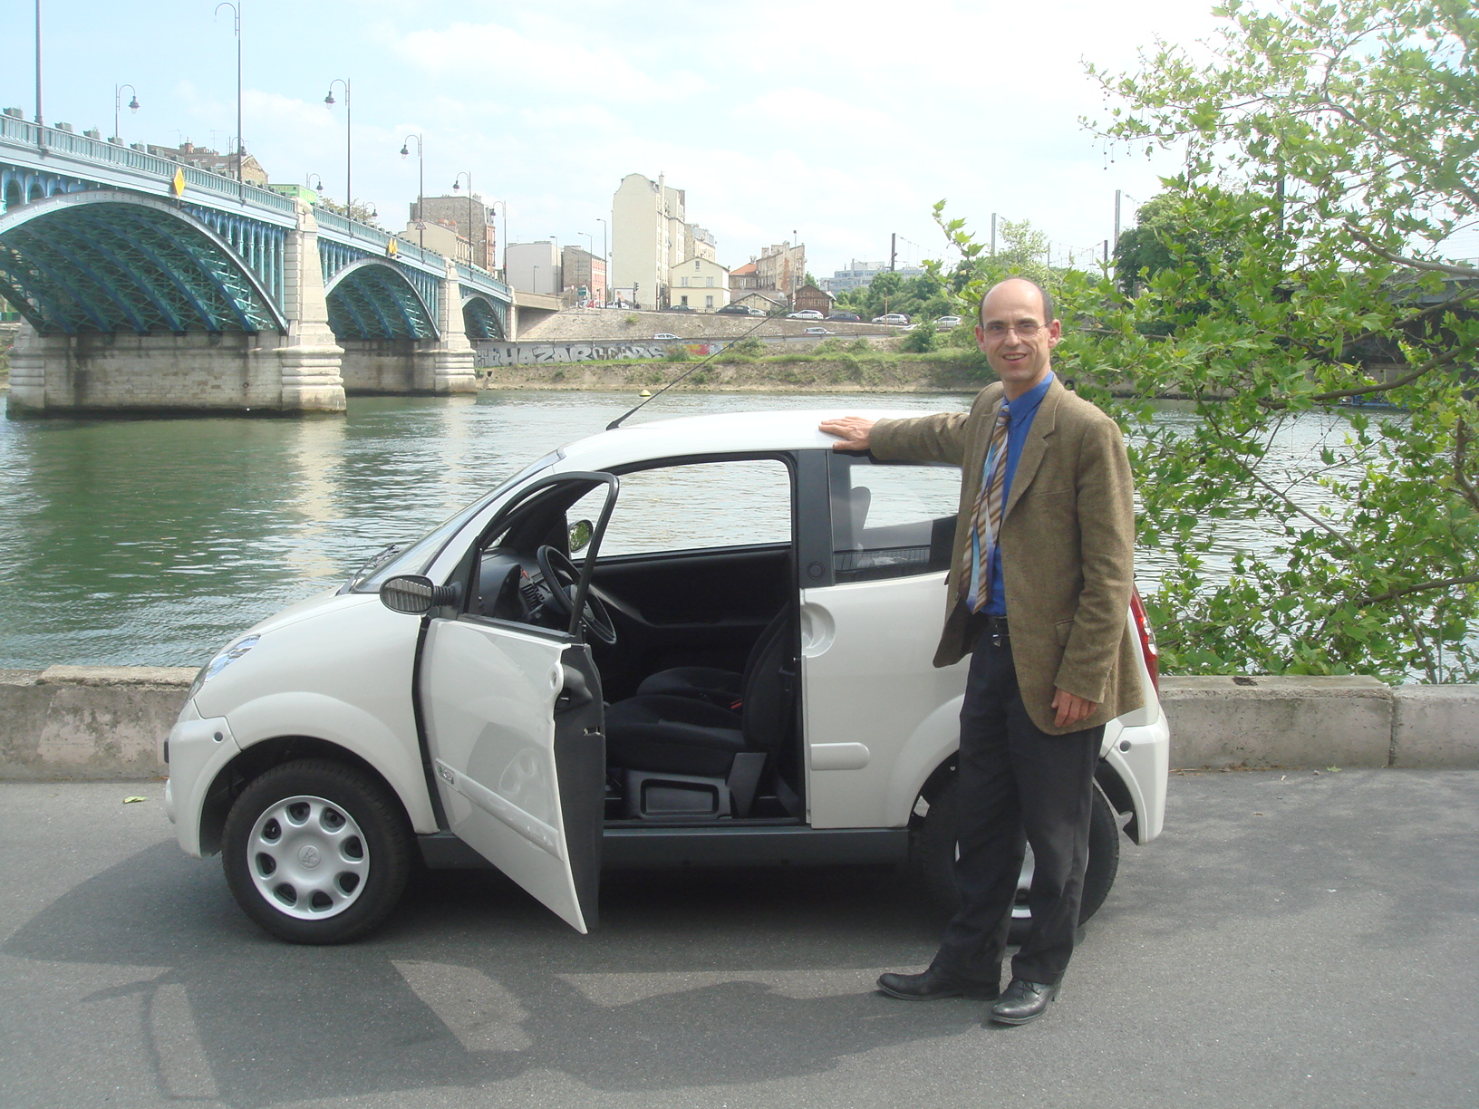

There are very few electric cars on the market today. But the little Mega-e-City is available; it is made in Savoy, in south-eastern France, by the firm AIXAM-MEGA, specialist in the fabrication of small sized cars and trucks.

I had a test drive in the Mega-e-City on 7th May 2009.

You can find some pictures of the test drive at:
http://www.ecolo.org/photos/visite/mega-e-city_09/

Here are our first impressions:

Even though it’s a small car, the Mega-e-City (like the Smart) must be driven with a driving license in France because it weighs over 350 kilograms (in fact over 700 kilogram because of its lead batteries). Cars below 350 kilos require no driving license (this is the case for non-electric cars of same size manufactured by AIXAM-MEGA).

The car handles well; it is pleasant to drive and of course it makes practically no noise. It can be recharged overnight from a standard 16-ampere 240- volt electric outlet in your garage. The cable comes with the car.

One quickly gets used to driving such an electric car. There’s no clutch pedal (only the accelerator and the brake, so your left foot is idle). The speed control is like any automatic transmission - it switches between “Forward”, “Reverse” and “Neutral”

The brake pedal is a bit stiff (no power braking). This is at first surprising, but it will likely be corrected in later versions.

The price of this little car is quite affordable; about 13,500 Euros (plus taxes), and in France one would get a rebate of about 3500 Euros from the national agency ADEME and from the local government.

So with the MEGA-e-CITY we have an electric car available TODAY at a much more modest price than the TESLA electric Roadster.

In my humble opinion, the electric MEGA-e-City is:

- ideal for moving around within a city or from suburb to suburb in the same metropolitan area, as a second family car for short runs to the supermarket, to take a child to school (but not two), to visit friends and for any short trip.

- it will be especially appeal to the ecologically minded for its silence (one can even hear the birds singing while driving through the country-side) and of course for the absence of CO2 emission.

- appearing at a moment of economic crisis, it is a bit dearer than an ordinary little motor car like the Renault Twingo, but with large scale production AIXAM-MEGA might be able to reduce the price. In any event, the price is not that much higher and the car is especially convenient and economical - no maintenance - no need to go fill up with over-taxed fuel.

- ideal for older folks who don’t want to drive a big car, or who can no longer do so, who don’t make long trips, who are too old to drive fast, and who want to make an ecological statement.

This vehicle is ideally adapted on a day-to-day basis for short trips in and around urban centers or from suburb to suburb (which equals to about 90% of most modern urban citizens’ driving journeys), and it is the ideal complement as the second car of each household, in addition to keeping your old gasoline-powered traditional car for occasional long distance driving journeys (i.e. for holidays or to visit your family on the other side of the country during summer or Christmas).

Here are a few features of this electric car:

TECHNICAL :
- the body is plastic (ABS) with an aluminum frame
- the DC motor is air-cooled and needs no maintenance
- the lead gel battery is not expensive and no maintenance is required
- the batteries should last five years, according to the manufacturer, provided you drive in a sober way and follow their recommendations; it will be much shorter if you are a sports car driver.
- replacement of the batteries: about 2500 Euros, much cheaper than lithium batteries, although they would provide a longer range.
- Front wheel drive
- Length 2.96 metres (116 inches)
- Width 1.49 metres (59 inches)
- Turning circle 4 meters (13 feet), so it’s easy to park
- Number of seats two (soon to be available in a four-seat model)
- Weight (empty) 750 kilograms (1650 pounds) (heavy for such a small car, because of the lead batteries)
- Weight (loaded) 1025 kilograms (2250 pounds)
- Brakes front wheels disc, rear wheels - drum
- Reasonably comfortable for a small car: wipers before and behind (windshield wiper two speeds plus intermittant), wired for radio, seat belts on rollers, the trunk is large for such a small car, laminated windshield, head rests, rear-view mirrors adjustable from interior, back-up light, rear window de-icer, anti-theft, danger lights go on automatically in case of sudden deceleration, etc .
- On sale in France since January 2009.

SOME ADVANTAGES:

- It’s the only electric car now on sale to the public in France; orders are accepted delivered in 7 weeks)
- At 13 800 Euros (plus excise tax) the price is reasonable
- The national energy agency offers a rebate of 2000 Euros
- Regional agencies offer may offer another 1000 or 2000 Euros, but it depends on region and rebates or subsidies are sometimes more generous for commercial users than for private owners.
- Cost of fuel (electricity) very small - just a few Euros/100 km
- Easy to park
- Free parking in many public parking lots in Paris
- We may have favorable turnpike tolls and other parking privileges
- Choice of driving style - switch between “Eco” and “Hi” (faster, better acceleration, but faster battery discharge and greater wear-and-tear on the battery).
- CO2 emission virtually zero, especially in France where electricity is mostly nuclear and hydro.
- About ten times cheaper than the sporty TESLA Roadster (bottom of the line at 100 000 Euros - see http://www.teslamotors.com )
- Buying a MEGA-e-City today is still for the pioneers; about a dozen have been sold in the Paris region since January 2009, even though it is designed and built in France but this is only the beginning of sales in France. On the other hand it sells much better in London because electric cars are exempt from the toll fee for entering central London.

SOME DISADVANTAGES:

- For the moment only the two-seater is available.
- The range is limited to 60 to 80 kilometers (40 to 50 miles)
- Can’t be driven on superhighways because it won’t go over 70 km/h (45 mph)
- No dynamic braking: unlike the Toyota Prius and Bollare’s electric car, the battery of the MEGA-e-City is not recharged by dynamic braking. Later models such as the BOLLORE-Pininfarina BLUE CAR have this feature but they are not yet available and the price is expected to be more than twice that of the MEGA-e-City.
- No power brakes: like in the old RENAULT 4L, you have to push hard on the brake pedal. In future versions of MEGA-e-City it would be well to add power braking.
- No airbag!

SUMMARY: A nice little electric car, not very fast, but very agreeable to drive and not expensive. A bit like the Citroën 2CV or the Renault 4L in their good years. It’s virtue is that it is here, now; to clean up our trips around town, to take the kids to school and to go shopping.

SOME SUGGESTIONS :

- a few options would be welcome: a four-seater with two places behind, roll bars and choice of colors. AIXAM’s other small cars have elegant roll bars and offer a variety of colors.

- a model with cadmium or lithium batteries: it would add one or two thousand Euros to the price but it would still be reasonable; meanwhile the range would be doubled and at the same time weight would be reduced and the load less limited.

- a little motor-generator might be made available to be installed in the trunk/boot to recharge the battery and thus extend the range - for vacations and for a long trip. When it’s not needed it could be removed and kept in the garage. It would be worthwhile to study this concept : “pure electric but hybrid on demand”.

TO CALCULATE your CO2 foot-print visit our website:
http://www.ecolo.org/documents/documents_in_english/CO2-calculator-EFN.xls

To move about by public transportation (especially by rail) or in your electric car is one of the four principal ways to make a spectacular reduction in your CO2 foot-print: the others are
(1) to live in an ecological house emitting little CO2,
(2) to travel less by air and
(3) to live in France or in Sweden where electricity is mostly nuclear and hydraulic.

Bruno Comby
President of EFN www.ecolo.org

Environmentalists For Nuclear Energy

55 rue Victor Hugo, 78800 Houilles, France
Phone: + 33 1 30 86 00 33 - Fax: +33 9 55 29 00 22

E-mail: efn@ecolo.org
Web site: http://www.ecolo.org (click on a flag)

____________________________

EFN is a not-for-profit international organization
gathering 9,000 members and supporters, and a network of
similar organizations and of local correspondents in more than
60 countries, to inform the public on energy and the environment.

EFN-USA is the American branch of EFN, a 501(c)(3) tax-exempt
not-for-profit organization incorporated in the State of Delaware
E-mail : nuc-usa@ecolo.org
Web : http://www.ecolo.org (click on the stars and stripes)
President : Berol Robinson

EFN-CANADA is the Canadian federally incorporated branch of EFN
E-mail : nuc-ca@ecolo.org
Web : http://www.ecolo.org (click on the maple leaf)
President : Rod Anderson

EFN-UK is the branch of EFN in the United Kingdom with headquarters in Cambridge
E-mail : nuc-uk@ecolo.org
Web : http://www.ecolo.org (click on the Union Jack)
Organizer : Stephen Stretton

EFN-FRANCE is the French branch of EFN incorporated in the Paris area
E-mail : nuc-fr@ecolo.org
Web : http://www.ecolo.org (click on the French flag)
President : Bruno Comby

EFN-POLAND is the Polish branch of EFN incorporated in Warsaw
E-mail : nuc-pl@ecolo.org
Web : http://www.ecolo.org (click on the Polish flag)
President : Zbigniew Jaworowsky (former UNSCEAR President)

EFN-JAPAN is the Japanese branch of EFN
E-mail : nuc-jp@ecolo.org
Web : http://www.ecolo.org (click on the Japanese flag)

Thank you for supporting clean nuclear energy !

________________________________

